Agriculture Expert Panel Report
Technology Foresight Exercise

Pakistan Council for Science and Technology
Ministry of Science and Technology
Government of Pakistan

Table of Contents
Chapter# | Title
 | Executive Summary
1.0 | Introduction
1.1 | Foresight Exercise in Pakistan
1.2 | Methodology Adopted
2.0 | Natural Resources Management
2.1 | Soil Chemistry and Environment Management
2.2 | Management of Soil Fertility
2.3 | Management of Soil Salinity Problems
2.4 | Soil and Water Conservation
3.0 | Agricultural Crops
3.1 | Wheat
3.2 | Cotton
3.3 | Rice
3.4 | Sugarcane
3.5 | Maize and Millet
3.6 | Pulses
3.7 | Oilseed Crops
3.8 | Fodder Crops
4.0 | Agriculture Technology
5.0 | Horticulture
5.1 | Fruits
5.2 | Ornamental Crops
5.3 | Constraints in Horticulture Sector
5.4 | Research and Development Strategies
6.0 | Vegetables Farming: Nutritional Source
6.1 | Kitchen Gardening
6.2 | Hydroponics-New Arena in Vegetable Production
6.3 | Tunnel Farming
7.0 | Plant Diseases Management
8.0 | Pests Management
9.0 | Crop Biotechnology
10.0 | Livestock and Poultry Management
10.1 | Livestock Production and Management
10.2 | Poultry Production and Management
11.0 | Fish Production and Management
11.1 | Major Problems and Constraints in Fisheries
11.2 | Prospective Steps in Fisheries
12.0 | Climate Change and Global Warming
13.0 | Food Processing and Value Addition
13.1 | Post-Harvest Losses and Wastes
13.2 | Food Wastes Within Food Supply Chain
13.3 | Reasons of Food Supply Chain Losses
13.4 | Sanitary and Phyto-Sanitary Measures
13.5 | Wider Implications of SPS Measures for Pakistan
13.6 | Synoptic Steps for Future Interventions
14.0 | Agricultural Economics and Good Governance
14.1 | Agriculture Economics
14.2 | Good Governance
15.0 | Intellectual Property Rights
15.1 | Patenting and Market Concentration
15.2 | Public-Private Collaboration
15.3 | Importers
 | Bibliography

List of Tables
Table # | Title
1 | Last Five year’s Land Utilization Statistics of Pakistan
2 | Average Yield (Kg/ hectare) of Selected Crops (2005)
3 | Extent of Water Logging and Salinity
4 | Yield Reduction in Various Crops due to Problematic Soils
5 | Germplasm of Different Cultivar to be established in Saline Sodic Soils
6 | Yield Potential of Field Crops Influenced by Salinity of Irrigation Water
7 | Yield Potential of Vegetable Crops Influenced by Salinity of Irrigation Water
8 | Yield Potential of Forage Crops Influenced by Salinity of Irrigation Water
9 | Yield Potential of Fruit Plants Influenced by Salinity of Irrigation Water
10 | Crops/ Plants Suitable for Salt-Affected Soils
11 | Future Ideotype Characteristics of Wheat
12 | Numbers of Current and Expected GM Traits Worldwide
13 | Milk and Meat Production Till 2025
14 | Expected Production and Availability of Milk and Meat Till 2025
15 | List of Drought Tolerance Related Genes
16 | List of Heat Tolerance Related Genes
17 | Generic FSC and Examples of Food Waste in Different Forms in Pakistan

List of Figures
Figure # | Title
1 | Forecasted Population of Pakistan in 2025

List of Annexures
Annexure # | Title
1 | Wheat Production (Million Tones) in Pakistan from 1947-2010
2 | Forecasted Requirements of Wheat in 2025
3 | Cotton Production (Million Tones) in Pakistan from 1947-2010
4 | Forecasted Requirements of Cotton in 2025
5 | Rice Production (Million Tones) in Pakistan from 1947-2010
6 | Forecasted Requirements of Rice in 2025
7 | Sugar Production (Million Tones) in Pakistan from 1947-2010
8 | Forecasted Requirements of Sugar in 2025
9 | Forecasted Requirements of Pulses in 2025
10 | Forecasted Requirements of Gram in 2025
11 | Maize Production (Million Tones) in Pakistan from 1947-2010
12 | Forecasted Requirements of Vegetable, Ghee and Cooking Oil in 2025
13 | Forecasted Requirements of Mango, Apple and Other Fruits except Citrus in 2025
14 | Forecasted Requirements of Banana in 2025
15 | Citrus Production (Million Tones) in Pakistan from 1947-2010
16 | Forecasted Requirements of Citrus in 2025
17 | Potato Production (Million Tones) in Pakistan from 1947-2010
18 | Forecasted Requirements of Potato in 2025
19 | Forecasted Requirements of Vegetables in 2025
20 | Forecasted Requirements of Milk Requirement till 2025
21 | Forecasted Requirements of edible oil by 2025
22 | Forecasted Requirements of Mutton and Beef in 2025
23 | Forecasted Requirements of Poultry in 2025
24 | Forecasted Requirements of Fish in 2025
25 | Soil Type and Value Added Products of Different Fruits
26 | Soil Type and Value Added Products of Different Vegetables
27 | Key Activities in Supply Chain Management
28 | Flow Chart of supply Chain Management of Fruits and Vegetables

Disclaimer
The approach we are taking relies upon consulting a wide range of expertise, with the expectation that through our collective experience, imaginative abilities and interactive knowledge of technological development pathways, we can begin to construct a coherent view of some of the major developments that can be anticipated within a 10-25 year time horizon. Foresight is therefore research which can inform the reality of planning, policy and strategic choice amidst uncertainty. This is the nature of foresight - creating a range of plausible future elements that in their diversity should alert readers to the kinds of issues and perspectives they may not have initially considered in longer term research planning and contingency thinking. Accordingly, this report reflects the combined views of the participants, and the best wisdom, and creative thinking that we could stimulate with the tools of foresight, but it clearly does not represent an official view of the Government of Pakistan or any of its Departments and or Agencies.
Prologue
This research report is part of a series of several reports that have been produced for the benefit of sponsors, participants and professionals interested in how emerging and prospective developments in global science and technology might impact Pakistan's future.
The Technology Foresight Exercise (TFE) originated with a proposal made by Pakistan Council for Science and Technology (PCST) to the Ministry of Science & Technology in March 2008, offering PCST's support for a collaborative Exercise to explore the application of foresight tools. Goals of the Exercise were to help stimulate longer term thinking, and to build shared R&D awareness and capacity for engaging broad challenges for which the federal S&T ministry should be better prepared.
Public and Private sector joined together to create a limited duration (i.e. six months) partnership that held five visits to different locations and four panel meetings. The partners and their colleague networks of scientists and industry-academic collaborators contributed over 120 days of professional time to developing the Project's methodology, panel and workshop events and in drafting and reviewing the Technology Foresight Exercise findings.
It is useful to recall the definition of Technology Foresight that was used to define the scope and focus for this Pilot Project:
Technology Foresight involves systematic attempts to look into the longer-term future of science and technology, and their potential impacts on society, with a view to identifying the emerging change factors, and the source areas of scientific research and technological development likely to influence change and yield the greatest economic, environmental and social benefits during the next 10-25 years.

Executive Summary
Foresight is considered an appropriate tool to bring together business, the science base and government in order to identify and respond to emerging opportunities in markets and technologies. Foresight should contribute to national innovation strategy based on a comprehensive analysis of:

• World market opportunities (new markets and market niches).
• Trends in technological development.
• Strengths and weaknesses of the Pakistan economy and R&D system.

These objectives can only be achieved if researchers, business people and government machinery join and assess Pakistan’s current competitive position and the impacts of likely global market and technological trends. Hence their realigned and reinvigorated relationships can be regarded as a means of principal goal. The experts with different backgrounds communicate and share ideas about long term issues, generate consensus, and cooperate with commitment in devising and realizing a suitable national strategy.

There are many drivers that can lead to current trends in agriculture and related entities in Pakistan. Some of these are:
      - Biotechnology and gene revolution
      - Changes in consumer demand
      - Competition with other countries and issues in globalization
      - Climate change and changing demographics
      - Government policies and regulations
      - Energy, technology, demand, use and prices
      - New agriculture technologies
      - Human resources, availability of labor
      - Low productivity and poor resource use efficiency
      - Problems in dairy, livestock, poultry and fisheries sectors
      - Increasing fragmentation of farms
      - Issue of value chain and poor agriculture marketing and storage
      - Food safety requirements

Pakistan has diverse agro-climatic conditions, good natural resource base (land and water) and large network of irrigation system suitable for diversified and intensive agriculture production system. Agriculture sector, which comprises 45 percent crops and 55 percent livestock, provides livelihood for 60 percent of country’s population living in rural areas. It also contributes 21 percent to GDP, 60 percent to exports and 45 percent to employment of the labor force.

In the last three decades of the 20th century, Pakistan witnessed an unprecedented technological and economic transformation. It was able to achieve food self sufficiency, tripled its agricultural exports, reduced poverty, increased income levels, and improved quality of life for its people. The transformation started in the late sixties with the advent of green revolution. The key elements in improving food production since green revolution were the combination of technology package; high yielding varieties, input intensiveness (irrigation and fertilizer); improved policy measures; incentive in the form of input subsidies and investment in agriculture infrastructure (irrigation, research and extension). Consequently by the end of 20th century, almost all of the irrigated area was cultivated under high yielding varieties irrespective of farm size which resulted in sustained increase in the yield of various crops.

In spite of an impressive increase in agriculture production, it did not improve the living standards of the rural population to the desired level. One of the factors is the relationship of the rural population with land. Since 1947, Pakistan has tried thrice to implement land reforms by limiting land ceilings and giving land to the tillers. All these efforts had very limited effects on redistribution of land.

Pakistan’s average national crop productivity (yields) is at par with the world’s averages, with much higher yields on progressive farmer’s farms. However, a major part of the arable land is cultivated by small farmers. This constitutes 86 percent of the total number of farms comprising less than 12.5 acres of land. The small farms are continuously increasing because of land division due to inheritance affecting agricultural productivity, as small farmers are generally resource poor.

Several challenges that have now emerged are being addressed:

These include increasing water scarcity, degradation of land resources (water logging and salinity), inefficient use of agricultural inputs (specially unbalanced application of fertilizer and inefficient water application), ineffective transfer of technology to the farmers, post-harvest losses, poor marketing infrastructure, etc.

Pakistan will need to increase its production of major agricultural products (food, feed, fiber, sugar, edible oil, meat, milk, poultry, and fish) to feed its growing population and also generate some modest surpluses for export by 2025. This would need to be done with lesser land and water resources than are available for agriculture today. This presents several challenges for agriculture in the 21st century, which are listed below:

- Accelerated increase in production of crops, horticulture, livestock and fisheries exclusively through increase in per unit productivity.
- Diversification into high value agriculture and value added products.
- Private sector-led growth through investments in value added products both for the domestic and export markets, such as floriculture using hydroponics technology for export oriented high value vegetables/flowers.
- Export competitiveness and globalization
- Sustainable management of natural resource base and protection of environment;
- Public investments in rural infrastructure and institutions including water management, research and extension, education, health, water supply and sewerage
- Improving the nutritional quality of staple food to provide essential nutrients such as iron, vitamins, amino acids and proteins;
- Production of renewable biomass suitable for production of bio-fuel that could be used as a substitute for fossil fuel (biomass from wastelands, castor and jatropha);
- Mitigating the impact of climate change.
- Improving relevant laws and their effective implementation.

Moreover, technology foresight is a holistic programme which will help create a sustainable economic drive. The session like this will help generate the most brain-based future oriented solutions to help giving profound stability to our country.

TECHNOLOGY FORESIGHT

What is Technology Foresight?
Technology Foresight (TF) can be described as a systematic approach in which various methodologies and techniques are combined in order to create a better preparedness for the future.
Technology Foresight is neither about delivering probabilistic predictions of the future technologies (Technology Forecasting) nor is about anticipating the impacts of future technologies in today’s society (Forecasting Assessment), rather Technology Foresight is a Systematic Process to visualize Science, Technology, Industry, Economy and society in the long run, with the purpose of identifying technologies that can generate economic and social benefits. Pakistan is the 25th country which has undertaken Technology Foresight program.
The methodologies used and exercises conducted were framed by six fundamental pillars of future studies – mapping, anticipating, timing, deepening, creating (alternatives) and transforming the future.
Foresight is by nature multi-disciplinary, requiring the expertise of disparate groups in order to combine scientific and technological expertise with an understanding of society, economy and environment. It is usually intended to have a major impact, and often includes controversial issues where there are lots of vested interests. This is especially true of priority setting for the allocation of resources, which is a common application of foresight.
Foresight’s role is
- to help government think systematically about the future.
- to give ownership of decisions to all stakeholders for adoption of policies and their implementation.
- to promote culture of future oriented thinking.
- to promote networks between ministries, departments, institutions and companies.

Project Objectives
Based on a decision taken by the Pakistan Council for Science and Technology, a sectoral and nationwide Technology Foresight exercise was proposed. This approach aims at enabling the Government’s intention of uplifting key sectors through improved operation of limited national resources. It results in selecting public policies needed to align scare resources for supporting assimilation of technology by the industry. Additionally, Technology Foresight fosters increased rate of national innovation. This is achieved through the rigorous application of those Technology Foresight strategies, techniques, and methodologies that have proven successful in other countries, and are also conducive to our country’s milieu.
Specific Objectives
According to the United Nations Industrial Development Organization (UNIDO), Technology Foresight is the systematic process of visualizing science, technology, society, and economy in the long-term, with the purpose of building consensus to identify technologies, which will cause the greatest social and economic benefits.
Technology Foresight in Pakistan has been implemented to provide valuable inputs to strategy and policy planning as well as to mobilize collective strategic actions. It aims at doing so by:
- identifying potential opportunities for the economy or society from new science and technologies, and
- considering how future science and technologies could address key future challenges for the Pakistani society.
Pakistan’s Foresight program involves constructively bringing awareness of long-term challenges and opportunities into more immediate decision-making. It looks beyond normal planning timescales to identify potential opportunities from new science and technologies. It, then take actions to help realize these opportunities. It brings together scientists, technologists, businesses and consumers, with those who can help deliver benefits. This leads to a systematic process for discussions on the future.
The consultations facilitate identification of policies and projects. The starting point for a policy or a project recommendation is a key issue where science holds the promise of solutions (e.g. information and communication technologies, in which Pakistan has already invested considerably). In addition, it may be an area of cutting edge science where the potential applications and technologies have yet to be considered and/or articulated more broadly (e.g. biotechnology, nano-technology). Foresight policies and projects will:
- Encourage the creation of new networks between science, business and society
- Have the support of at least one of the interested communities (Government, research funders, business, etc)
- Add value to existing activities and initiatives – with the scope to deliver outputs that would not otherwise be achieved.

Methodology Adopted

Technology Foresight experts all over the world use different methods and tools to conduct this activity. These methods and tools are adopted according to the availability of resources. Since this project at PCST was launched at a time when severe economic crunch was being faced by the government, therefore budget and manpower was not provided according to the envisaged plan as per PC-I.
Keeping in view the limited resources at hand, expert panel method was used by the project team. However in order to find out the priority areas on which the foresight study needed, a mini Delphi Survey was carried out. As a result of this nationwide survey, ten sectors were identified, namely, ---- Energy, Agriculture, Industry, Education, Environment, ICT, Health, Materials, Transportation and Management.
Expert panels were formed on each of the above sectors, comprising of all the stakeholders. These panels held their meetings in which brainstorming sessions using STEEPV and Scenario Planning methods were invariably used. During panel meetings presentations by other experts were also arranged. Subgroups to handle specific tasks were also formed.
As a result of the meetings, recommendations pertaining to policy, projects, along with roadmaps were produced.

TERMS OF REFERENCE

The Terms of Reference of the Expert Committee were:
- The panel will work as a Think Tank, in a particular field, for the Government of Pakistan using Technology Foresight process.
- The panel shall review the issues related to development in the respective fields, suggest short, medium and long term strategies, to be undertaken by the government of Pakistan, for strengthening S&T activities required towards industrial and economic progress in Pakistan.
- The panel shall identify and prioritize R&D projects of high national importance by considering short, medium and long term development that need to be supported by the Government of Pakistan.
- The panel will work for duration of six months, at the end of which a comprehensive report, indicating the current status vis-à-vis strengths, weaknesses, opportunities, and threats of the sector under study.
- Recommendation of implementable policies and projects will be the final tangible outcome of the exercise, in addition to more desired intangible outcome i.e. process benefits.

CHAPTER 1
1.0 INTRODUCTION
1.1 Technology Foresight Exercise in Pakistan
Technology Foresight (TF) can be described as a systematic approach in which various methodologies and techniques are combined in order to create better awareness for the future. It is neither about delivering probabilistic predictions of the future technologies (Technology Forecasting) nor is about anticipating the impacts of future technologies in today’s society (Forecasting Assessment). Rather it is a Systematic Process to visualize Science, Technology, Industry, Economy and society in the long run, with the purpose of identifying technologies that can generate economic and social benefits. Pakistan is the 25th country which has undertaken Technology Foresight program.

The methodologies used and exercises conducted were framed by six fundamental pillars of future studies mapping, anticipating, timing, deepening, creating (alternatives) and transforming the future.

Foresight is by nature multi-disciplinary, requiring the expertise of contrasting groups in order to combine scientific and technological expertise with an understanding of society, economy and environment. It is usually intended to have a major impact, and often includes controversial issues where there are lots of vested interests. This is especially true of priority setting for the allocation of resources, which is a common application of foresight.
Foresight’s role is

    - To help government think systematically about the future.
- To give ownership of decisions to all stakeholders for adoption of policies and
their implementation.
- To promote culture of future oriented thinking.
- To promote networks between ministries, departments, institutions and
companies.

Project Objectives
Based on a decision taken by the Pakistan Council for Science and Technology, a sectorial and nationwide Technology Foresight exercise was proposed. This approach aims at enabling the Government’s intention of uplifting key sectors through improved operation of limited national resources. It results in selecting public policies needed to align scanty resources for supporting assimilation of technology by the industry. Additionally, Technology Foresight fosters increased rate of national innovation. This is achieved through rigorous application of those Technology Foresight strategies, techniques, and methodologies that have proven successful in other countries, and are also conducive to our country’s milieu.

Specific Objectives

According to the United Nations Industrial Development Organization (UNIDO), Technology Foresight is the systematic process of visualizing science, technology, society, and economy in the long-term, with the purpose of building consensus to identify technologies, which will cause the greatest social and economic benefits.

Technology Foresight in Pakistan has been implemented to provide valuable inputs to strategy and policy planning as well as to mobilize collective strategic actions. It aims at doing so by:

- Identifying potential opportunities for the economy or society from new science and technologies, and
- Considering how future science and technologies could address key future challenges for the Pakistani society.

Pakistan’s Foresight program involves constructively bringing awareness of long-term challenges and opportunities into more immediate decision-making. It looks beyond normal planning timescales to identify potential opportunities from new science and technologies and take actions to help realize these opportunities. It brings together scientists, technologists, businessmen and consumers, with those who can help deliver benefits. This leads to a systematic process for discussions on the future.

The consultations facilitate identification of policies and projects. The starting point for a policy or a project recommendation is a key issue where science holds the promise of solutions (e.g. information and communication technologies, in which Pakistan has already invested considerably). In addition, it may be an area of cutting edge science where the potential applications and technologies have yet to be considered and/or articulated more broadly (e.g. biotechnology, nano-technology).

Foresight policies and projects will:

- Encourage the creation of new networks between science, business and society
- Have the support of at least one of the interested communities (Government, research funders, business, etc.)
- Add value to existing activities and initiatives – with the scope to deliver outputs that would not otherwise be achieved.

1.2 Methodology Adopted
Technology Foresight experts all over the world use different methods and tools to conduct this activity. These methods and tools are adopted according to the availability of resources. Since this project at PCST was launched at a time when severe economic crunch was being faced by the government, therefore budget and manpower was not provided according to the envisaged plan as per PC-I.

Keeping in view the limited resources at hand, expert panel method was used by the project team. However, in order to find out the priority areas on which the foresight study was needed, a mini Delphi Survey was carried out. As a result of this nation-wide survey, ten sectors were identified, namely, Energy, Agriculture, Industry, Education, Environment, ICT, Health, Materials, Transportation and Management.

Expert panels were constituted on each of the above sectors including Agriculture, comprising of all the stakeholders. These panels held their meetings in which brain-storming sessions using STEEPV and Scenario Planning methods were invariably used. During panel meetings, presentations by other experts were arranged. Subgroups to handle specific tasks were also formed.

As a result of these meetings, recommendations pertaining to policy, projects, along with roadmaps were produced.

The outcomes may or may not be very different or innovative from the earlier studies or ideas presented by some sole experts. But the outcomes based on Foresight process provide confidence and self belief that their implementation will bring definitely positive changes. It gives self assurance that budget being spent will not be wasted.

Technology advancement and its application for the well being and development of humanity have no alternative to be decided. Most of the developed countries are very proactive in their planning and have set their goals to achieve economic and social sustainability in this regard. Continuous planning, objectivity and result-oriented approach are their desired standards and milestones to match with. Pakistan, being an agriculture country with great potentials to expand the scope and capacity in application of advanced technologies, can utilize and extend benefits of agriculture and other natural resources more proficiently and professionally through the use of these technologies. Table 1 shows the land utilization of last five years (2005-06 to 2009-10) of the four provinces. These statistics show that total geographical area of Pakistan is 79.61 million hectares out of which only 7.42 million hectares area sown in 2009-10. Whereas a significant culturable waste of about 8.10 million hectares is enough to attract the policy makers and functional resources to transform it into net sown area so that vertical cultivation pressure may be shifted to horizontal ones for food surplus and threat of food security could be managed on sustainable basis.
Provincial agriculture research organizations are already busy in developing future oriented research strategies and also devising various projects in this regard to generate cumulative effects. However, in order to grow on sustainable basis, there is a need to knit long term balanced strategies with zeal of commitment.

In Pakistan, the major physical factors increasingly threatening the crops are biotic and abiotic stresses, looming water sources, climatic changes, etc. Heat is a potent threat, with unusually hot crop cycles being experienced more frequently. For example terminal heat stress is one of the major reasons of yield decline in wheat, cotton, rice, oilseeds, pulses, etc., which may cause cause 40-50% yield losses. Crops in arid areas damaged particularly by forced maturity due to prolonged dry spell, high temperatures and wind storms. These effects become worst when crops are planted late. Climate changes associated with global warming will further threaten the crops in future.

Table-1: Land Utilization during the last five years(Area Million Hectares)
Year / Province | Geographical area | Culturable waste | Current fallow | Net area sown | Area sown more than once | Total cropped area
2005-06
Punjab | 20.63 | 1.63 | 2.16 | 10.41 | 6.27 | 16.68
Sindh | 14.09 | 1.36 | 3.08 | 2.64 | 0.88 | 3.52
KPK | 10.17 | 1.22 | 0.57 | 1.32 | 0.52 | 1.84
Balochistan. | 34.72 | 4.00 | 0.91 | 1.02 | 0.07 | 1.09
Total | 79.61 | 8.21 | 6.72 | 15.39 | 7.74 | 23.13
2006-07
Punjab | 20.63 | 1.60 | 1.44 | 10.98 | 5.75 | 16.73
Sindh | 14.09 | 1.49 | 2.86 | 2.74 | 0.99 | 3.73
KPK | 10.17 | 1.21 | 0.56 | 1.34 | 0.55 | 1.89
Balochistan | 34.72 | 4.00 | 0.86 | 1.10 | 0.11 | 1.21
Total | 79.61 | 8.30 | 5.72 | 16.16 | 74.40 | 23.56
2007-08
Punjab | 20.63 | 1.56 | 1.39 | 11.10 | 5.86 | 16.96
Sindh | 14.09 | 1.44 | 2.01 | 2.87 | 1.00 | 3.87
KPK | 10.17 | 1.21 | 0.61 | 1.30 | 0.57 | 1.87
Balochistan | 34.72 | 3.98 | 0.92 | 1.07 | 0.09 | 1.15
Total | 79.61 | 8.19 | 4.93 | 16.34 | 7.51 | 23.85
2008-09
Punjab | 20.63 | 1.56 | 1.39 | 11.10 | 5.86 | 16.96
Sindh | 14.09 | 1.42 | 2.06 | 2.81 | 1.01 | 3.82
KPK | 10.17 | 1.24 | 0.56 | 1.30 | 0.57 | 1.87
Balochistan | 34.72 | 3.93 | 0.92 | 1.13 | 0.07 | 1.20
Total | 79.61 | 8.15 | 4.93 | 16.34 | 7.51 | 23.85
2009-10
Punjab | 20.63 | 1.56 | 1.39 | 11.10 | 5.86 | 16.96
Sindh | 14.09 | 1.38 | 2.08 | 2.81 | 1.02 | 3.83
KPK | 10.17 | 1.23 | 0.63 | 1.21 | 0.47 | 1.68
Balochistan | 34.72 | 3.93 | 0.92 | 1.13 | 0.07 | 1.20
Total | 79.61 | 8.10 | 5.02 | 16.25 | 7.42 | 23.67

Similarly, there are some other associated colossal factors such as improper and under-manipulation of molecular genetics (Poor pace from Green to Gene Revolution), low productivity, inconsistent availability of certified/healthy and quality seed to farmers, insects/pests threats, inefficiency in utilization of natural resources, poor agriculture marketing and storage, etc., result in non-resilient capacity towards productivity and future sustainability. These factors enhanced inappropriate national policies mounting a great threat for the economy of our country. In Vision 2030, reported by Planning Commission of Pakistan in 2006, it has been described (Table 2) that average yield of various major crops in Pakistan is far below than other competitive countries of Asia and Europe.

Table-2: Average Yield (Kg/ ha) of Selected Crops (2005) in different countries.
Country | Wheat | Cotton | Rice (Paddy) | Maize | Sugarcane
World | 2,906 | 1,949 | 4,019 | 4,752 | 65,597
China | 4,227 | 3,379 | 6,266 | 5,153 | 66,063
India | 2,717 | 850 | 3,007 | 1,939 | 61,952
Egypt | 6,006 | 2,603 | 9,538 | 8,095 | 12,1000
Mexico | 5,151 | - | - | 2,563 | 70,070
France | 6,983 | - | - | 8,245 | -
Pakistan  - National Average  - Progressive farmer | 2,586  4,500 | 2,280  2,890 | 1,995  4,580 | 2,848  7,455 | 48,906  10,6700

The above production gaps in all the main crops in the country’s, is the main reason of low productivity and realizing the potential in these crops. Narrowing these production gaps need concerted, revolutionary and immediate steps both by government and research organizations.
Government of Pakistan (Economic Survey of Pakistan, 2008-09) has already structured the following plans to combat the prospective painful situations, which include:
- Sustainable agriculture
- Macroeconomic stabilization
- Social development including social protection
- Industrial competitiveness
- Human capital development
- Energy
- Capital markets
- Public-Private partnership for infrastructure
- Institutional/ Administrative reforms

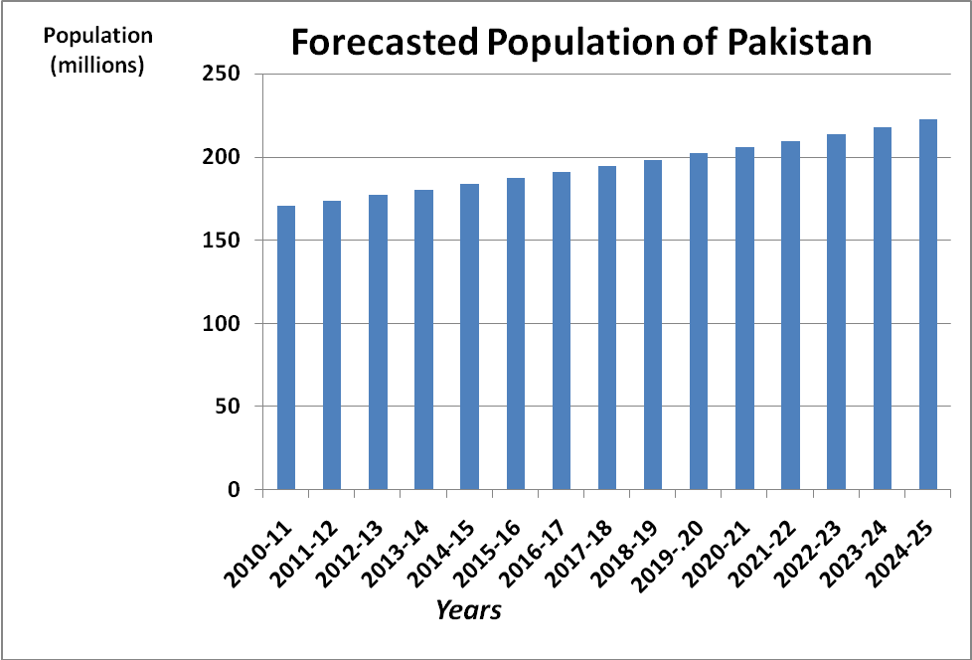
Figure-1: Forecasted Population of Pakistan by 2025.

In order to realize these plans and tackle with the needs of the forecasted giant population, i.e. 225 million (Figure 1) and fight the food security issues till 2025, there is a dire need to make advanced technology based site/region specific revolutionary and more directed research and cultivation approaches for all crops in Pakistan.

The Technology Foresight Exercise carried out for the first time will help pave the ways for sustainable, proactive and very profound steps in putting the country in the right and appropriate solution based direction to meet the challenges till 2025. This technology foresight exercise in the fields of agriculture, natural resources, livestock and poultry and fisheries resulted in brain-based program laid down after many meetings and long discussions of expertise at national level, for the policy makers to transform Pakistan into more competitive and compatible nation. These foresights have been detailed in the following text.
CHAPTER 2
2.0 NATURAL RESOURCES MANAGEMENT
Pakistan is facing numerous challenges including poverty alleviation, high food inflation and food security for a population of more than 180 million that is likely to swell to 250 million by 2030. It means that the number of people to be fed from one hectare of arable land will increase from 7 to 14 by 2030. Limited availability of additional arable land and water resources and the declining trend in crop yields, globally making food security a major challenge in the 21st century.

The problem of food security will be many folds in future due to the increasing rate of population, shortage of canal water, energy crisis, climate change and urbanization of fertile land around the big cities. These challenges can be met by efficient use of precious inputs, bringing more area under cultivation and increasing the cropping intensity. The crop production can be increased by developing new varieties, use of adequate and balance fertilizer and by adopting proper plant protection measures.

During the last two decades substantial increase in crops yield has been made by developing new varieties of wheat, cotton, rice and sugarcane, oilseeds, etc., refinement of fertilizer use, formulation of fertilizer recommendation for specific cropping system and use of micro nutrients. But still our yields are less than the actual potential of our varieties due to low organic matter, alkaline pH and low inherited fertility. The continuous mining of food nutrients lead to depletion of macro and micro nutrients. In Punjab, nitrogen is deficient in all soils whereas due to high fixing capacity of our soil the phosphorus is deficient in 90 percent area. The deficiency of potassium is not wide spread however; it is deficient in 40 percent area. In case of micronutrients, zinc and boron are deficient in 57 and 50 percent soils respectively. Presently, in general the farmers are using only nitrogen and skip the use of phosphorus, which is limited to some major crops such as wheat, cotton, sugarcane and rice whereas minor crops are totally ignored. In case of major crops, the use of balance fertilizer is not practiced. The ratio of N to P is wide which not only affects the yield but also reduce nitrogen use efficiency and narrow the N to P ratio (2:1 or 2:1.5).

The main constraints in the use of phosphatic fertilizers are its non-availability at sowing time and high prices. The hiking prices of fertilizers (both nitrogen and phosphate) urged the integrated use of fertilizer and organic sources. The limited availability of canal water is another yield limiting factor. The under-ground water which is used is brackish and creating salinity and sodicity problems. Around big cities the sewage and industrial water is being used for growing vegetables and crops. The use of such water may cause health problems of masses because of heavy metals. Like fertilizer, plant protection measures play a key role in increasing crop production. The use of pesticides has increased tremendously during the last decades. Ensuring the supply of quality pesticides to the farmers will increase the yield of crops by the use of effective plant protection measures. It will also help reduce the environmental pollution and pesticide residue in crops, fruit and vegetables.

2.1 Soil Chemistry and Environment Management
Soil Chemistry and Environment Management help maintain the natural resources and ultimately soil health. It can only be possible if the soil scientists move forward and accept the challenges which are creating some desolate situation for our agriculture. In future the situation will become worser which can be countered and avoided by managing the soil and environment through the following foresights:
    - Balanced and efficient use of plant nutrients.
    - Assessment of environmental impact of fertilizers use in agriculture.
    - Crop residue and farm waste management for plant nutrition.
    - Organic matter dynamics and quantification of changes in soil carbon and nitrogen.
    - Impact of cropping system on carbon sequestration.
    - Monitoring the impact of sewage/industrial effluent irrigation on soil /plant health and environment.
    - Phyto-remediation of heavy metals and pesticides from soil.
    - Efficient quality control mechanism of pesticides.
    - Monitoring of pesticide residues in crops, fruits, vegetables and food chain.
    - Manipulation of the soil biota for sustainable production
    - Coping with Migration caused by New Aspects of Environmental Change

2.2 Management of Soil Fertility
Harsh climatic conditions, population pressure and the decline of traditional soil management practices have often reduced soil fertility. Agriculture is a soil-based industry that extracts nutrients from soil. Effective and efficient approaches to slowing that removal and returning nutrients to the soil will be required in order to meet the food demands of the rising population and self sufficiency in 21st century. Farmers must also manage nutrients and soil fertility in an integrated way. Required yield increases of major crops cannot be attained without ensuring adequate and balanced supply of nutrients. This balance will not be achieved until "nutrient cycles" are better understood, an issue that government should address through establishing testing and monitoring systems. Genetic engineering can also contribute to better nutrient balancing by helping plants provide some of their own nutrients for enhanced growth. Government and extension services will need to facilitate adoption of nitrogen- fixing species among farmers.

Government will also need to facilitate the widespread and responsible use of organic and inorganic fertilizers. As fertilizers use is low, more use will help improve crop production and benefit the environment by limiting soil mining and reducing land degradation. Nutrient depletion through soil mining is an acute problem and special steps are required to combat it. These efforts include soil testing for nutrient depletion, cooperation between farmers and researchers, promotion of more productive use of organic nutrients, and strengthening of extension services to pay attention to soil-related issues. Government should also support studies which should help in enhancing soil fertility.
Integrated nutrient management (INM) can address many of the problems besetting poor and small land holders. But the success of INM ultimately depends upon the timely and concerted efforts of extension programs, government, researchers, and the farmers themselves. The sources of increased agriculture production and productivity growth in Pakistan have been more intensive use of land and water resources in combination with new interventions from research. The growth in agricultural productivity is important in assessing the direction of future agricultural production. The soil fertility organization focuses on processes controlling the cycling and utilization of plant nutrients and inorganic contaminants in terrestrial economy.
Whereas, there is a need of profound research to counter the future challenges in the use and management of fertilizers. In this regard the strategic steps to pave the future directions must be:
    - Avowing by the compatible balanced use of fertilizer for the sustainability of soil fertility
    - Incorporation of regenerative technology which make the best use of locally available resources.
    - More reliance on local management skills and knowledge.
    - Soil fertility enhancement and maintenance and precision farming.
2.3 Management of Salt Affected Soils or Salinity Problems

Soil salinity is one of the most colossal issues and a carcinogenic and dissipates the potential of cultivated soils in many areas of our country. In the arid and semi-arid regions, low rainfall coupled with uncertainty of its occurrence has been the major limiting factors in crop production. This is particularly true for Pakistan because most of the agriculturally productive regions (Sindh & Punjab) lie in hyper-arid to sub-humid regions where evaporation far exceeds the rainfall. The introduction of irrigation in these areas has been considered as the most effective way of controlling the other production factors and therefore, the government took necessary steps to develop irrigated agriculture in the arid and semi-arid regions most extensively. Large scale irrigation development in association with high yielding varieties and inorganic fertilizers increased production and productivity and brought stability. However, introduction of irrigation has often been followed by salinity and Pakistan is no exception to it.

The salt affected soils are an important ecological entity in Pakistan. According to agricultural statistics (2006), geographical area of Pakistan is 80 million ha. Total cropped area is 22 million ha, surveyed area is 69 million ha, irrigated area is 18 million ha, while saline and saline- sodic soils cover an area of 6.68 million ha. Out of 6.68 million salt affected area, 2.22 million ha lies in Punjab, while 2.11, 2.31 and 0.04 million ha lies in Sindh, KPK and Baluchistan, respectively. The problem being dynamic in nature, the area keeps on changing. The salt affected soils that occur in different climatic regions have been classified into alkali or sodic and saline categories.
Tube-wells contribute 34 percent of the total water availability (2008-09). Increase in number of tube-wells is among the major reasons in expansion of salt affected soils. According to Compendium on Environment Statistics of Pakistan 2010 developed by Federal Bureau of Statistics, the numbers of tube-wells in 1996-97 were 507,000 which increased to 921,000 in 2008-09.

Table-3: Water Logging and Salinity position in Pakistan
(000 Hectare)
Year / Month | Province
Year / Month | Total | Balochistan | KPK | Punjab | Sindh
2000 June | 544 | - | 32 | 228 | 284
October | 3215 | 95 | 51 | 280 | 2789
2001 June | 174 | - | 15 | 114 | 45
October | 2854 | 95 | 20 | 211 | 2528
2002 June | 1401 | Not observed | 19 | 114 | 1268
October | 2472 | 399 | 25 | 184 | 1864
2006 June | 453 | 11 | 16 | 187 | 240
October | 4014 | 398 | 19 | 563 | 3035
2007 June | 1170 | - | 15 | 475 | 680
October | 3558 | - | 18 | 596 | 2944
2008 June | 853 | 5 | 16 | 313 | 519
October | Not observed | Not observed | Not observed | Not observed | Not observed
2009 June | 1108 | 5 | 16 | 388 | 698
October | 3915 | 148 | 14 | 476 | 3277
0 to10 Feet or 300 C939m Water Table Depth
2000 June | 6536 | 95 | 183 | 1719 | 4539
October | 6778 | 95 | 203 | 1856 | 4624
2001 June | 4079 | Not observed | 136 | 1062 | 2881
October | 5939 | 95 | 152 | 1294 | 4398
2002 June | 3629 | Not observed | 150 | 878 | 2601
October | 5217 | 399 | 165 | 1186 | 3467
2006 June | 5587 | 327 | 135 | 1374 | 3752
October | 5173 | 15 | 146 | 1795 | 3216
2007 June | 6312 | - | 144 | 1850 | 4318
October | 7072 | - | 153 | 2209 | 4710
2008 June | 6209 | 118 | 156 | 1728 | 4206
October | Not observed | Not observed | Not observed | Not observed | Not observed
2009 June | 6649 | 118 | 156 | 1980 | 4395
October | 7249 | 253 | 150 | 1930 | 4916
Source: - Scarp Monitoring, WAPDA, Lahore
In southern Punjab, major salinity hit districts are Bahawalnagar (130.4 m ha), Rahim Yar Khan (119.8 m ha), Muzaffargarh (92.9 m ha), Khanewal (61.2 m ha) and Multan (59.8 m ha). In Northern Punjab major districts which are affected by salinity include Faisalabad, Jhang, Sheikhupura, Gujranwala and Sargodha with salt affected areas of 90.3, 109.0, 70.6, 52.1 and 59.5 million ha, respectively.

According to an estimate there is net yearly addition of 0.98 to 2.47 tons salts ha⁻¹. The annual losses because of salinity under rice-wheat rotation were estimated as Rs. 10 billion .The losses per annum in the irrigated lands in Indus plain were computed as Rs. 20 billion.

In Punjab according to the standards laid by WAPDA, 30 percent water is unfit (contains> 3000 ppm salts), 25 percent is marginally unfit (containing 1500-3000 ppm salts) while 45 percent is fit (as it contains <1500 ppm salts). In Sindh- 60 percent water is unfit (contains> 3000 ppm salts), 15 percent is marginally unfit (containing 1500-3000 ppm salts) while 25 percent water is fit (as it contains <1500 ppm salts). In KPK, 15 percent water is unfit (contains> 3000 ppm salts), 25 percent is marginally unfit (containing 1500-3000 ppm salts) while 60 percent water is fit (as it contains <1500 ppm salts). In Baluchistan, 65 percent water is unfit (contains> 3000 ppm salts) , 15 percent is marginally unfit (containing 1500-3000 ppm salts) while 20 percent water is fit (as it contains <1500 ppm salts). If we look at groundwater quality in the country, 45 percent water is unfit (contains> 3000 ppm salts), 20 percent is marginally unfit (containing 1500-3000 ppm salts) while 35 percent water is fit (as it contains <1500 ppm salts).

Losses in Crop Yields due to soil Salinity in Different crops
EC_{e} (dSm⁻¹) | Wheat | Cotton | Sugarcane
< 4 | - | - | -
4-8 | 36 | 41 | 38
8-15 | 68 | 73 | 71
>15 | 84 | 100 | 100

Tolerance of wheat to brackish water
Yield | 100% | 75% | 50% | 0%
EC_{w} (dS m⁻¹) | 4.00 | 6.30 | 8.70 | 13.00

Table-4: Yield Reduction in Various Crops due to Problematic Soils.
Field Crops
S# | English/Common Name | Botanical name | 50% Yield Reduction  EC_{e} ESP
1 | Millet | Panicum miliaceum | 19.5 | 20-25
2 | Sorghum | Sorghum bicolor | 16.0 | 15-40
3 | Sesbania | Sesbenia microcarpa | 15.4 | 50-60
4 | Soybean | Glycine max | 7.5 | 16-20
5 | Maize | Zea mays | 8.6 | <15
6 | Sunflower | Helianthus annuus | 6.3 | 30-50
7 | Cotton | Gossypium hirsutum | 17.1 | 30-50
8 | Mash | Vigna mungo | 10.0 | 10-15
9 | Rice | Oryza sativa | 7.4 | 60-70
10 | Barley | Hordium vulgare | 15.7 | 50-60
11 | Sugar beet | Beta vulgaris | 15.0 | >40
12 | Lentil | Lens culinaris | 12.0 | 10-15
13 | Oat | Avena sativa | 11.7 | 30-50
14 | Berseem | Trifolium alexandrium | 10.3 | 20-25
15 | Safflower | Carthamus tinctorous | 9.9 | 10-15
16 | Wheat | Triticum aestivum | 9.9 | 30-50
17 | Sugarcane | Saccharum officinarum | 9.9 | 15-40
18 | Canola | Brassica napus | 8.16 | 30-50
19 | Alfalfa | Medicago sativa | 8.8 | >40
20 | Flax | Linum ustiatissimum | 5.9 | 25-30
21 | Mustard | Brassica campestris | Tolerant | 30-50
22 | Kharchia-65 | Triticum aestivum | Tolerant | 30-50

Table-5: Germplasm of different cultivars to be established in Saline Sodic Soils.
- Forages
S# | English /Common Name | Botanical Name |  | 50% Reduction in Yield  EC_{e} ESP
1 | Kallar grass | Leptochloa fusca |  | 22.0 |  |  | >70
2 | Sudan grass | Sorghum sudanense |  | 14.4 |  |  | -
3 | Tall fescue | Festuca elatior |  | 13.3 |  |  | <15
4 | Garden cress | Lepedium sativum |  | 10.0 |  |  | -
5 | Rhodes grass | Chloris gayana |  | 8.0 |  |  | >70
6 | Australian grass | Diplachne fusca |  | 22.0 |  |  | -
7 | Fodder beet | Beta vulgaris |  | 19.0 |  |  | <55
8 | Guar | Cyamopsis tetragonoloba |  | Salinity/Sodicity tolerant |  |  | 25-30
9 | Tall wheat grass | Agropyron elongatum |  | 19.4 |  |  | >40
10 | Bermuda grass | Cynodon dactylon |  | 14.7 |  |  | 70
11 | Triticale | Secole cereale X Triticum durum |  | 13.5 |  |  | -
12 | Wild rye | Elymus triticoides |  | 11.0 |  |  | 5-15
13 | Mott grass | Pennisetum purporium
14 | Para Grass | Brachiaria mutica |  | 11.0 |  |  | 60-70
- Vegetables
S.# | English/Common Name | Botanical Name |  | 50% Reduction in Yield  ECe ESP
1 | Asparagus | Asparagus officinnalis |  | 13.0 |  | 5-15
2 | Cantaloupe | Cucumis melo |  | 9.1 |  | 5-15
3 | Pumpkin | Cucurbita pepo |  | 7.9 |  | 5-15
4 | Okra | Abelmoschus esculentus |  | Salinity tolerant |  | -
5 | Brinjal | Solanum melongena |  | Salinity tolerant |  | -
6 | Cauliflower | Brassica oleracea |  | 10.1 |  | 5-15
7 | Broccoli | Brassica oleraceaitalica |  | 8.2 |  | 5-15
8 | Spinach | Spinacia oleracea |  | 8.6 |  | 15-40
9 | Tomato | Lycopersicum esculentum |  | 7.6 |  | 30-50
10 | Cabbage | Brassica oleracea |  | 7.0 |  | 5-15
11 | Onion | Allium cepa |  | 4.3 |  | 20-25
12 | Coriander | Coriandrum sativum |  | Salinity tolerant |  | 5-15
13 | Garlic | Allium sativum |  | Salinity tolerant |  | 25-30
- Fruit Plants
S.# | English/ Common Name | Botanical Name |  | 50% Reduction in Yield  EC_{e} ESP
1 | Date palm | Phoenix dactyliferia |  | 17.9 | -
2 | Fig | Ficus carica |  | 7.4 | -
3 | Olive | Olea europaea |  | 7.4 | -
4 | Grapes | Vitis spp. |  | 6.7 | 5-15
5 | Guava | Psidium guajava |  | Salinity tolerant | 5-15
6 | Jawa plum | Eugnia jambolana |  | Salinity tolerant | -
7 | Ber | Ziziphus mauritiana |  | Salinity tolerant | -
8 | Sapodilla | Mnilkara zapota |  | Salinity tolerant | -
9 | Falsa | Grevia asitica |  | Salinity tolerant | -
- Medicinal Plants
S.# | English/Common Name | Botanical Name |  | 50% Reduction in Yield
1 | Hina | Lasonia spp. |  | Salinity tolerant
2 | Sweet basil | Ocimum basilicum |  | Salinity tolerant
3 | Parsley | Portulaca oleracea |  | Salinity tolerant
4 | Mint | Mentha veridis |  | Salinity tolerant
5 | Liquorice | Glycerrhiza glabra |  | Salinity tolerant
6 | Fenugreek | Tigonella foenumgraceum |  | Salinity tolerant
- Bushes
S.# | English/ Common name | Botanical name | 50% reduction in yield
1 | Atriplex | Atriplex amnicola | Salinity/Sodicity tolerant
2 | Blue salt bush | Marreana aphylla | Salinity/Sodicity tolerant
3 | Kochia | Kotchia indica | Salinity/Sodicity tolerant
4 | Sajji | Salsola soda | Salinity/Sodicity tolerant
5 | Lana | Suaeda fruticosa | Salinity/Sodicity tolerant
6 | Kareer | Capparis aphylla | Salinity tolerant
- Trees
S.# | English/ Common name | Botanical name | 50% reduction in yield
1 | Eucalyptus | Eucalyptus camaldulensis | Salinity/Sodicity tolerant
2 | Frash | Tamarix aphylla | Salinity tolerant
3 | Arjun | Terminala arjuna | Salinity tolerant
4 | Baid | Salix baby lonica | Salinity tolerant
5 | Sukhchain | Pongamia pinnetta | Salinity tolerant
6 | Acacia | Accacia nilotica | Salinity tolerant
7 | Salt Wattle | Accacia ampliceps | Salinity tolerant
8 | Mesquite | Popis juliflora | Salinity/Sodicity tolerant
9 | Leucaena | Leucaenia leucocephala | Salinity tolerant
10 | Wan | Salvadora oleiodes | Salinity tolerant
11 | Jand | Prosopis spicigera | Salinity tolerant
12 | Neem | Azadirachta indica | Salinity tolerant
13 | Siris | Albesia lebbeck | Salinity tolerant

Table-6: Yield Potential of Field Crops affected by Salinity of Irrigation Water
Field Crops | Yield Potential
Crops | 100 % | 90% | 75% | 50%
Barley | 5.3 | 6.7 | 8.7 | 12.0
Cotton | 5.1 | 6.4 | 8.4 | 12.0
Sugar beet | 4.7 | 5.8 | 7.5 | 10.0
Sorghum | 4.5 | 5.0 | 5.6 | 6.7
Wheat | 4.0 | 4.9 | 6.2 | 8.7
Soybean | 3.3 | 3.7 | 4.2 | 5.0
Cowpea | 3.3 | 3.8 | 4.7 | 6.0
Groundnut | 2.1 | 2.4 | 2.7 | 3.3
Rice | 2.0 | 2.6 | 3.4 | 4.8
Sugarcane | 1.1 | 2.3 | 4.0 | 6.8
Corn | 1.1 | 1.7 | 2.5 | 3.9
Flax | 1.1 | 1.7 | 2.5 | 3.9

Table-7: Yield Potential of Vegetable Crops affected by Salinity of Irrigation Water
Vegetable Crops | Yield Potential
 | 100 % | 90% | 75% | 50%
Tomato | 1.7 | 2.3 | 3.4 | 5.0
Cucumber | 1.7 | 2.2 | 2.9 | 4.2
Spinach | 1.3 | 2.2 | 3.5 | 5.7
Cabbage | 1.2 | 1.9 | 2.9 | 4.6
Potato | 1.1 | 1.7 | 2.5 | 3.9
Pepper | 1.0 | 1.5 | 2.2 | 3.4
Lettuce | 0.9 | 1.4 | 2.1 | 3.4
Radish | 0.8 | 1.3 | 2.1 | 3.4
Onion | 0.8 | 1.2 | 1.8 | 2.9
Carrot | 0.7 | 1.1 | 1.9 | 3.0
Turnip | 0.6 | 1.3 | 2.5 | 4.3
Bean | 0.7 | 1.0 | 1.5 | 2.4

Table-8: Yield Potential of Forage Crops affected by Salinity of Irrigation Water
Forage Crops | Yield Potential
 | 100 % | 90% | 75% | 50%
Bermuda grass | 4.8 | 5.6 | 7.2 | 9.8
Barley | 4.0 | 4.9 | 6.4 | 8.7
Rye grass | 3.7 | 4.6 | 5.9 | 8.1
Sudan grass | 1.9 | 3.4 | 5.7 | 9.6
Cowpea | 1.7 | 2.3 | 3.2 | 4.8
Sesbania | 1.5 | 2.5 | 3.9 | 6.3
Alfalfa | 1.3 | 2.2 | 3.6 | 5.9
Corn | 1.2 | 2.1 | 3.5 | 5.7
Berseem | 1.0 | 2.2 | 3.9 | 6.8
Wheat grass tall | 5.0 | 6.6 | 9.0 | 13.0

Table-9: Yield Potential of Fruit Plants affected by Salinity of Irrigation Water
Fruit plants | Yield Potential
 | 100 % | 90% | 75% | 50%
Date Palm | 2.7 | 4.5 | 7.3 | 12.0
Grape fruit | 1.2 | 1.6 | 2.2 | 3.3
Orange | 1.1 | 1.6 | 2.2 | 3.2
Peach | 1.1 | 1.5 | 1.9 | 2.7
Apricot | 1.1 | 1.3 | 1.8 | 2.5
Grape | 1.0 | 1.7 | 2.7 | 4.5
Almond | 1.0 | 1.4 | 1.9 | 2.8
Plum | 1.0 | 1.4 | 1.9 | 2.9
Strawberry | 0.7 | 0.9 | 1.2 | 1.7

Table-10: Varieties of Crops/Plants Suitable for Salt-Affected Soils
Crops | Varieties
Wheat | Faisalabad–08, Pasban-90, Inqlab-91,Johar, Sarsabaz (Grow up to EC_{e} 12 dS m⁻¹)
Rice | Coarse rice: NIAB-IRRI-9, KS-282 (EC 5.6 dS m⁻¹)
Rice | Fine Rice: PB-95, Shaheen rice, Basmati-385 (EC 5.5 dS m⁻¹)
Cotton | CIM 473, CIM 496, VH- 148, FH-901 and FH-113
Sugarcane | CP 43-33, HSF-240, CPF-236 and COJ-84
Raising Fruit Trees | Guava, Dates, Ber, Jaman, Fig and Olives (on moderately salt affected soils)
Salt Tolerant Trees and Shrubs | Eucalyptus, Kikar, Atriplex, Moringa and Acacia ampliceps
Salt Tolerant Grasses | Kallar grass, Sudan grass, Para grass and Mott grass
Fodders | Oats, Barley, Berseem, Sesbania, Bajra, Ipil Ipil
Unconventional Crops | Castor bean, Saunf, Ajwain, Qulfa, Ispaghol, Sugar beet, Garlic, Spinach, Okra

2.3.1 Situation Analysis of Problematic Soils and Suggestion for Next 25 Years

Sustainable management of soils, water and crops and the basic resources of agriculture, call for a holistic and visionary approach to plan for the future. The pace of technology introduction and its absorption in recent years has been so rapid that in the 21st century, agriculture in Pakistan will be practiced under quite different ecological, technical and socioeconomic. Water and not land would be the major constraint in producing enough food at that time but soil management concerns such as physical, chemical and biological degradation would also become increasingly relevant. Agricultural development in the future will have to be sensitive to social needs but at the same time will have to take care of environmental issues.

Important unfinished agenda include development of:
- Alkali soil, reclamation technology for areas underlain with poor quality waters, and in areas with resource constraints.
- Effective prevention strategies for arresting the further spread of soil salinity and water logging.
- Low-cost drainage technology for saline and water logged soils for implementation in participatory mode.
- Methods for eco-friendly use of saline effluents, waste waters assess impacts on soil quality and human health.
- Salt tolerant, high yielding varieties of crop plants and assess salinity effects on plant quality.
- Technologies for salt and water management, and alternate cropping systems in coastal saline soils.

A national working group on salinity management should be established with the mandate to take stock of what had been accomplished in the past, discuss the likely future scenario and prepare a Salinity Vision-2025 and set the agenda for identifying future needs in different thrust areas.

The following may be the brief outlines of the foresight studies to be undertaken.
2.3.1.1 Resource inventories on waterlogged salt affected soils and poor quality waters for land use planning
- Preparation of legends for identifying salt affected soils through remote sensing for preparing reliable estimate of waterlogged and salt affected soils in selected areas.
- Generation of database on poor quality waters
- Linking of the resource base of salt affected soils to their effective management options

2.3.1.2 Reclamation and management of alkali soils
- Sustenance of crop production in post-reclamation phase
- Refinement of existing technology to address emerging and anticipated issues
- Development of technology for soils underlain by high RSC/saline waters

2.3.1.3 Integration of Irrigation and Drainage Management in Saline Soils
- Development of technology for areas with limited access to irrigation
- Development of agro-forestry systems for salt affected soils
- Developing strategies for agro-forestry interventions in waterlogged saline soils and for recycling saline drainage effluent
- Enhancement of biological nitrogen fixation in agro forestry systems in salt affected Soils

2.3.1.4 Management of waterlogged saline soils
- Evolving strategies for reducing drainage volumes
- Development of drainage technology for various agro-climatic zones
- Studies on drainage water disposal alternatives
- Evaluation of socio-economic and institutional mechanisms for increasing adoption of drainage technology
- Studies on brackish water fish culture for disposal of saline drainage effluent

2.3.1.5 Management of poor quality waters, domestic, drainage and agro-industrial
effluent
- Investigation on regional surface and groundwater interaction and modeling water balance
- Development of strategies for conjunctive use of surface and groundwater to optimize their use
- Establishment of tolerance limits of crops to saline/sodic/toxic waters
- Development of appropriate strategies and technologies for utilizing poor quality waters in raising crops and forest species on sustainable basis.
- Studies on impact of poor quality waters and effluent on crop and soil quality, groundwater pollution and human health.

2.3.1.6 Crop improvement for salinity, alkalinity and water logging stresses
- Generation of stress tolerant and high yielding breeding lines/varieties in crops and physiological indices
- Field evaluation of suitable crop varieties for use in biological reclamation technology

2.3.1.7 Coastal salinity management
- Management of water resources and agricultural drainage for sustainable crop production
- Development of improved crops and cropping systems and cultural practices
- Development of alternate farming systems

2.3.1.8 Management of salt affected vertisols
- Refinement of existing technology to address emerging and anticipatory issues
- Development of technology for soils underlain by RSC/saline waters
- Development of technology for areas with limited access to irrigation
- Management of soil physico-chemical environment in salt affected vertisols.

2.3.1.9 Technology transfer and impact assessment
- Approaches to accelerate adoption of alkali soil reclamation technology
- Approaches to encourage adoption of subsurface drainage technology
- Implementation of first line transfer of technology programs in different agro-ecological regions
- Assessment of impact of salinity and water logging on agricultural production, farm income and employment
- Evaluation of alternate economic activities for sustaining farm production and income in salt affected environments.

2.3.1.10 Human resources development
- Organization of training programs of various kinds for personnel involved in reclamation work at various levels in all the provinces
- Degree-related and post-doctoral training programs
- International training for developing countries
- Faculty improvement programs.

2.3.1.11 Linkages with International Organizations
Keeping in view the nature, dimension and geographical spread of the problem of soil salinity, the agriculture research organizations will have to develop very effective linkages with several national and international organizations detailed below, for effective implementation of its research programs in order to address the problem of salinity. These linkages will prove very rewarding and helpful to acquire requisite knowledge and technical skill in overcoming the problem. In future programs, these linkages will assume more significance because of a perceptible shift in the role to solve these problems.

Linkages Needed with International Organizations
Program | Possible Collaborating Organizations
Drainage and water management in irrigation commands | CSSRl - ILRI, Netherlands
Breeding for salt tolerance | CSSRl - Univ. of Sussex, UK
Breeding for salt tolerance in rice | CSSRl - IRRI, Philippines
Breeding for salt tolerance in wheat | CSSRl - Univ. of N. Wasles, Bangor, UK
Irrigation management | CSSRI- EU
Nutrient management | CSSRI- IRRl
Socio-economic issues | CSSRl - ClDA

2.4 Soil and Water Conservation
Soil and water are critical natural resources that sustain human life and life of all other creatures on our planet. Careful husbandry of these natural resources is essential for food security and environmental protection. Moreover, sustainable use of these resources is imperative to socially, economically and ecologically viable communities. Huge losses of soil due to water erosion in hilly and semi-hilly areas, has caused frustration among the inhabitants of the region. The problem is further accentuated with uncertain behavior of rainfall. Similarly, arable land in the country is also experiencing a looming threat of water availability for irrigation cultivation and drinking. Therefore, there is a need to conduct need based research and develop technology for different climatic zones for conserving the soil and water for consistent utility in future.

The initiatives required are:
- Development of low cost soil and water conservation technologies in collaboration with international Soil Conservation Organizations such as ICARDA, NRSP, etc. for dissemination to farmers on large scale.
- Testing and up-scaling of low cost soil and water conservation technologies on watershed scale involving the community organization.
- Assessment of the degree of soil erosion through satellite processing and focus on GIS based research planning.
- Standardizing gullies structures (vegetable and loose stone check dams.) to arrest soil erosion.
- Standardization and development of rain water harvesting techniques for the rain-fed areas of the country.
- Water productivity should be enhanced using green manure, gypsum application, crop rotation and cropping pattern.
- Adoption of water saving technologies such as laser land leveling, furrow irrigation (drip/sprinkler and bubbler irrigation system) for cultivating traditional and high value crops.
- Spreading of grasses like mott grass in the barren lands in Pakistan.
- Ponds can be developed where excessive rain water could be stored for different agriculture purposes.
- Gully erosion and sediment load can be controlled by means of plugging with different check dams forest trees or mott grass.
- Gypsum source is available within the country as a gift of nature and must be popularized as a cheap source for moisture conservation in whole barani tract.
- Development of public and private partnership and capacity building of agriculture extension staff, NGOs and farming community are the ultimate solutions to popularize the latest water saving technologies to farmers in country.
- Integrated weed control under soil conservation tillage.
- Strict control of direct discharge of industrial effluents in natural streams, through incentives and punitive measures.
- Technology based emphasis is highly required to use brackish water for irrigation.

CHAPTER 3
3.0 AGRICULTURAL CROPS

The population of Pakistan is expected to reach about 225 million by the year 2025. Feeding this population, it will need about 32 million tons of wheat, 8 million tons of rice and 20 million bales of cotton to sustain food and economic security. The strategies required to achieve some of these targets are detailed below:-

3.1 Wheat
Wheat is one of the major staple foods in Pakistan. Its area was 8666 thousand hectares in 2011-12 showing a decrease of 2.6 percent over last year’s area of 8901 thousand hectares. The yield per hectare registered a negative growth of 4.2 percent as against 11 percent growth last year. The crop contributes 12.5 percent to the value in agriculture and 2.6 percent to the GDP. Currently, our population is more than 180 million which is expanding at the rate of 2 percent annually. Though, we are producing surplus wheat for the last few years, but this surplus is comparatively less than the population growth. This imbalanced situation may lead to food security issues in future. Current wheat varieties evolved by AARI, Faisalabad, NARC, Islamabad, NIA, Tandojam and available production technology package cumulatively has the potential to produce yield of 8.0 t ha⁻¹. This shows yield gap of more than 62.5 percent over the potential yield. This gap is the result of the following factors:-

- Late planting after cotton, sugarcane, rice, etc.
- Low fertilizer use.
- Drought stress
- Terminal heat stress
- Soil salinity
- Weed infestation
- Climate changes
To match our wheat requirements by 2025, there is a need of knowledge based improvement in wheat productivity through breeding and crop management practices. Technology advancement in the near past has opened new vistas. Wheat breeding and crop management are the two strategies which can play a pivotal role in developing potential varieties and bridging the gaps in future as reported earlier. Now it is possible to introgress genes beyond phyto-logical barriers which will make possible understand genetic mechanism controlling the diseases resistance and tolerance to abiotic stresses.

Being the major crop and with embedded economic support, the foresights required for the development of wheat crop have been framed into following two components:

    - Wheat Breeding
      - Gene identification for biotic and abiotic stresses and its transfer to high yielding locally adapted material.
      - Evolution of new transgenic wheat varieties resistant to heat, drought, disease (especially rust race Ug-99) and nutrient stresses.
      - Evolution of wheat germplasm with improved quality i.e. protein, gluten etc. to be utilized in chapatti, bread and pizza, etc.
      - Marker assisted breeding for specific traits.
      - Development of fertilizer use efficient wheat genotypes.
      - Physiological traits based breeding.
      - Development of leaf, stripe rust, powdery mildew and foliar disease resistant material in wheat.
      - Studies on yield depression in slow rusting wheat genotypes

Table-11: Future Ideotype Characteristics of Wheat
Plant Height | 100 cm
Days to Heading | 70
Days to Maturity | 120
Flag Leaf | Erect Long 30cm, Narrow, Thick, V shaped, 2cm wide when flattened, stay green
2nd leaf | 5 cm longer than flag leaf
Plant type | Moderate tillering, compact erect head, erect leaved canopy
1000-grain weight | >45g
Number of heads per ha | 2 million
LAI ratio of leaf area to grain (upper 3 leaves) | 100 cm 2 :2.2-2.3g
Harvest Index | >50%
Root System | Strong with aerial roots originating from 1st above ground node to prevent lodging
Pubescence | Present on whole plant to prevent aphid
    - Wheat Management
      - Adoption of conservation agricultural techniques.
      - Integrated weed management by using chemicals, cultural and biological control.
      - Popularization of farm machinery such as, combine harvester, bed planter, zero-till drills, etc.
      - Modeling the impact of climate change on production of crops
      - Use of remote sensing and GIS Technology

3.2 Cotton

Cotton is also one of the major crops of Pakistan contributing more than 1.6 percent to GDP. During 2011-12, cotton crop was cultivated on an area of 2835 thousand hectares. It has shown unpredictable production pattern over the last many years due to its vulnerability to abiotic and biotic stresses. However, the cotton varieties developed by various research institutions has the potential to face these stresses for better yields and quality.
Being an integral part of our economy, the importance of cotton crop will continue to rise in future. Therefore, concerted efforts are needed to achieve sustainability in its production. To mitigate the unpredictable behavior, following foresight strategies can be realized in future.

3.2.1 CLCV Resistant Varieties
Cotton leaf curl virus (CLCV) is the major threat in Pakistan. Highest production of 12.8 million bales achieved in 1992-93 dropped to 8.0 million bales in 1993-94 because of CLCV. This geared the cotton breeders who were able to develop CLCV resistant varieties due to which production started increasing and reached 10-11 million bales. Moreover, in spite of the recommendations and management strategy of the scientists, the farmers continued to grow susceptible varieties. This resulted in the development of new strains of virus and all the CLCV resistant varieties became susceptible to this new strain. Besides, the germplasm used for development of CLCV varieties was of narrow genetic base and also susceptible to this new strain. Therefore, major focus should be on the use of wider genetic base to develop CLCV resistant varieties to achieve target production of 20 million bales. At present, cotton breeders are developing CLCV resistant varieties by transferring resistance from wild species and indigenous desi cotton through inter-specific hybridization and radiation as well as by using genetic engineering. The CLCV research program needs to be strengthened to develop breeding material and management strategy to face any eventual mutation in the virus.

3.2.2 Short Statured Early Maturing Cotton Suitable For Mechanical Picking
Due to continued shortage in the availability of cotton picking manpower, mechanical picking of cotton is increasing worldwide. According to estimate the number of cotton picker women are reducing in Pakistan due to rapid industrial growth in cotton zone and increasing literary rate in villages. Moreover, increase in the respiratory tract infections/cancer cases in cotton picking women is another reason for reduced availability of this work force. This situation necessitates to develop short statured early maturing cotton varieties suitable for mechanical picking.

3.2.3 Cotton Varieties Suitable for Rainfed Areas
Water resources and its availability are decreasing very rapidly in the country. It is expected that Pakistan will be soon in the group of water deficit countries. In India about 70 percent cotton is grown under rainfed conditions. Keeping in view the alarming situation of water resources and the increasing demand in the cotton availability, increased production will only be possible to develop cotton varieties to perform better in rainfed areas of the country.

3.2.4 Colored Cotton
Naturally colored cotton is unique and exceptionally different from white cotton as it does not need to be dyed. Dyeing is one of the most costly steps in fabric finishing. It is estimated that the elimination of dyeing can save up to one half of the manufacturing costs and disposal of toxic dye waste. Naturally colored cotton is also resistant to change as compared with the conventional dyed white cotton. Naturally colored cottons do not fade in laundering as is typical of most conventionally dyed cottons. After laundering, the color becomes stronger and more intense. Therefore, research on the development of colored cotton need to be initiated for overcoming the above problems.

3.2.5 Breeding for Long Staple Cotton
At present, 99 percent of cotton in Pakistan falls in medium, medium long and long staple that fulfills the requirement of the domestic industry. The major constraint in the development of extra long staple is the harsh temperature in the cotton growing areas of the country. However, there are areas for long staple breeding programs in Sindh (Lower Sindh) where climate is mild and suitable for long staple breeding program. The Sindh cotton research scientists may focus more attention to develop the long and extra-long staple cotton.

3.2.6 Heat Tolerant Varieties
Pakistani climate is too harsh while comparing with other cotton producing countries. No doubt a great break through has been achieved in the development of heat tolerant varieties. These varieties not only give higher yields but are also picked early to plant wheat on time after cotton thus result in increase in wheat production. These efforts should continue for the development of more heat tolerant varieties to help escape the cotton crop from Heliothis and pink bollworm attack which multiply more after mid-September.

3.2.7 Hybrid Cotton
There are two important aspects of hybrid cotton, one being the identification of good combiners which, when crossed, produce a hybrid that gives higher yield over commercial cultivars. India was the first country in the world to start commercial production of hybrid cotton. H-4, the first intra-hirsutum hybrid was released in 1970. As a matter of fact, the necessity of hybrid cotton in India was felt on account of much lower yields as almost 70 percent of the cotton cultivation was rainfed. It is pertinent to mention that a cotton hybrid ALSEMI-Hybrid-151/A developed by a progressive grower of Multan has already been approved by the Provincial Seed Council, Punjab. Other such progressive growers/breeders in private sector may thus be encouraged to enter in hybrid seed production. However, relatively, high cost of labour in Pakistan compared to India is the main hindrance in hybrid production in Pakistan.

3.2.8 GMO’s Roundup Ready Cotton (Cry 1Ac + Cry2A+ RR)
Inbuilt resistance against various pests and herbicides is vital in the coming years in Pakistan. These are environment friendly as well as less number of sprays would be applied for effective insects and weeds control.

3.2.9 Molecular Marker Assisted Breeding in Cotton
Along with conventional breeding tools for crop improvement, molecular assisted breeding is also very important aspect now-a-days. There is no chance of environmental condition related escape using this technique to select the most potential varieties of cotton.

3.2.10 Drip Irrigation
Drip irrigation of cotton is increasing throughout the world. Major benefit is the use of small amounts of water at high frequency intervals. Obvious advantages of drip irrigation include a smaller wetted surface area, minimal evaporation and less weed infestation and potentially improved water application within the crop root zone. The situation of available irrigation water resources is very much clear to us. Moreover, area like Thal, Cholistan would become culturable using this technology.

3.2.11 Efficient Nutrient Utilization
\High fuel prices, increased worldwide demand, and short supplies have driven fertilizer prices to record highs. Nonetheless, targeting high nutrient use efficiency by applying the right nutrient source in the right place at the right rate and right time allows growers to continue to strive for high cotton yields even in economically challenging times.

3.2.12 Organic Farming
The environmental costs incurred through modern, chemical- intensive farming are no longer acceptable. Excessive pesticide use, soil depletion and genetic homogenization of crops have threatened the air we breathe, the water we drink and the land we and other depend on for food and living. Organic, sustainable agriculture is a realistic and necessary alternative to these practices.

3.2 13 Zero Tillage Technology
In India and Pakistan on an average, there is a net benefit of US$150 per ha, through higher yields and less land preparation cost. The technology ensures timely sowing minimizes cost of production through land preparation, seed rate, labor and irrigation water and fertilizer use efficiency.

3.2.14 Contamination Free/Clean Cotton Production
There are various models which can be adopted to promote production of contamination free/clean cotton. This is possible through an integrated and collaborative approach by all the stakeholders of cotton sector.
      - Biological control of insects to activate organic farming
      - Introduction of exotic predators for effective biological control
      - Bio pesticide use to control insects
      - Pheromone traps for efficient control of insect population
3.3 Rice
Rice is another cash crop of economic importance not only to the farming community but also to the country. Along with prospective aspects of the various world’s known potential varieties developed by Ayub Agricultural Research Institute and other research organizations, there is a need of many foresighted steps to be taken to generate sustainability in its production and productivity. The production and the future requirements of rice crop till 2025 and the consistency in rice production can be attained if the following foresights be realized.

3.3.1 Conventional Hybridization

Modern Indica cultivars especially Basmati rice have a narrow genetic base for yield and other characters of interest. Rice gene pool can be widened through hybridization of varieties with wild species, weedy rice as well as inter-sub-specific crosses. In this regard the material (mostly land races available with the Plant Genetic Resources Institute, NARC, Islamabad) be utilized to identify genes for resistance to blast and/bacterial leaf blight and its introgression in the high yielding lines.

3.3.2 Ideotype Breeding (Modification of Plant Architecture) with the Characteristics of:

      - Low tillering (9-10 tillers for transplanted crop).
      - No of unproductive tillers.
      - 200-250 grains per panicle.
      - Dark green, thick and erect leaves.
      - Vigorous and deep root system.
      - NPT characteristics should be incorporated in Basmati and coarse rice varieties to break the yield barrier of these varieties. NTP in basmati background should also be developed.
      - Marker assisted selection (MAS) has also been employed for moving genes from pyramided lines into NPT as well as improved varieties in the world.

3.3.3 Development of Super Rice Hybrids
      - Rice hybrid with yield advantage of 10-15 percent over the best varieties were introduced in China in 1970s and planted over 50 percent of rice area. China has even developed super rice hybrids with the yield potential of 19 ton ha⁻¹. Whereas the yield potential of the locally developed and imported rice hybrids have the yield potential of 12 ton ha⁻¹.
      - Super rice hybrids should be developed in three and two lines system having excellent grain quality.

3.3.4 Development of Bacterial Leaf Blight Resistant /Tolerant Basmati Rice Varieties
Super Basmati and Basmati 2000 are very popular among farmers, millers, exporters and consumers for high yield and better cooking qualities. Super Basmati covers about 70 percent area in the Punjab. Unfortunately, both of these varieties are susceptible to Bacterial leaf blight (a major threat to basmati rice production). To overcome this problem, Marker Assisted Breeding is needed for the incorporation of resistant genes against blast and BLB. Marker assisted selection (MAS) is being used for pyramiding genes i.e., Xa4, Xal3 & Xa21 into a single breeding line for resistance to BLB.
3.3.5 Development of Bt Rice
      - Major targets of rice improvement through genetic engineering are diseases and insects.
      - A major target of Bt deployment in transgenic rice is the leaf folder and yellow stem borer. Bt rice has been tested under field conditions and has excellent resistance to diverse populations of yellow stem borer.
      - Besides Bt genes other genes for insect resistance such as those for proteinase inhibiter, ∞-amylase inhibitor (natural plant defense system) and lectins are also receiving attention.

3.3.6 Development of Aerobic Rice
      - One of the biggest constraints in maintaining rice productivity growth is a looming shortage of water as per capita water availability has decreased from 5660 m³ (1960) to 1400m³ (2006). This water shortage can be overcome by the developing drought tolerant rice varieties and/or improving water use efficiency in rice crop. Studying the minimum water requirement for rice i.e., only at critical stages without reducing yield.
      - Development of salt tolerant rice varieties.

3.3.7 Value Addition
      - Rice grain does not contain beta carotene, the precursor of vitamin A. Therefore, children who derive most of their calories from rice suffer from vitamin-A deficiency. By developing such varieties with beta carotene will help reduce child mortality (100 million) the world over.
      - Genes for beta carotene and high iron contents should be incorporated in to basmati varieties besides the work on quantification of aroma in basmati rice varieties.
      - Two million of the world's population suffers from iron (Fe) deficiency. High iron content (2 times more) variety has been released by conventional breeding and through genetic engineering in the world.

3.3.8 Need to Convert Rice from C3 to C4 Plant
      - Since independence, five times increased has been recorded in population (35 million in 1947 and 175 million in 2011). This increase in population will need 50 percent more rice by the year 2025 and more than 100 percent in next 50 years i.e. in 2060-61.
      - The C₄ rice would have the potential to out-yield the best performing rice varieties and hybrids by 15 to 20 percent. In order to meet this challenge, our country needs rice varieties with higher yield potential, which include population improvement, ideotype breeding, heterosis breeding, wide hybridization, genetic engineering and molecular breeding.

3.3.9 Improving Soil Health
Presently our soils are very low in organic matter and 0.5% organic matter level is consistently decreasing due to high cropping intensity and burning the crop.
      - There is a need to explore how many grams of soil organic carbon and N per Kg of rice straw can be incorporated in the soil?
      - How much yield will increase for rice-rice and for rice-wheat system through straw incorporation?
      - How much N fertilizer application will reduce by straw management?

3.4 Sugarcane

At present in Pakistan with a population of 180 million, approximately 4.1 million tons of sugar is consumed annually i.e. 23 kg/head per year. According to the population estimates for the year 2025 approximately 5.3 million ton sugar will be required to meet the need of 225 million people in the country. Means that about 1.2 million tones of extra sugar has to be produced. Presently, there is a little scope for horizontal expansion in area. The option left is to enhance yield and sugar recovery. In order to produce the desired quantum of sugar at the present sugar recovery of 9.37 percent, 68 million tones of more sugarcane will be required. If we manage to increase our cane yield from 56 ton ha⁻¹ to 70 ton ha⁻¹ and sugar recovery from 9.37 to 10.5 percent, we will not only produce the desired quantities of cane but also decrease cane area under cultivation from 1.00 million hectare to 0.7 million hectares. However, to get the desired targets, we have to plan and implement the sugarcane research and development activities as outlined below:

    - To establish sugarcane breeding research institute in lower Sindh (Coastal area)
    - To establish high-tech laboratories for sugarcane pathology and entomology for efficient control
    - To establish biotech laboratories for gene transfer against biotic and abiotic stresses
    - To develop site specific varieties for major agri. ecological zones
    - To establish quarantine and quality control laboratories based on international quality management standards
    - To establish R & D Wing for propagation of high yielding and high sugar recovery varieties through advance production technology

3.5 Maize and Millet

In the era of intense global competition, foresight for sustainable agriculture will ensure food security, rural livelihood and will contribute to the economic development. The Green Revolution has already run its course and its achievable potential has been realized. With the looming water shortages, it will be difficult to support an estimated population of 220-225 million in 2025 with current technology and best practices alone.

It is an encouraging phenomenon that maize yield is gradually increasing for the last five years in the country especially in the Punjab. The increase in per hectare yield is mainly due to adoption of hybrids by progressive growers during spring season as a whole and some shift in autumn season by small farmers as well. The availability of quality seed is around 54 percent of the total area planted in the province while its availability on Pakistan basis is about 35 percent. There is big gap to go further for better yields, particularly in autumn season by managing quality seed. Maize is a management responsive crop and adoption of its production technology by small growers is also important.

Sorghum and Pearl Millet are normally planted on marginal lands in Punjab and Sindh with low fertility and moisture under rain fed conditions. With the increase in population pressure and expansion of livestock and poultry industries, the importance of maize, sorghum and pearl millet crops have increased manifold. The province of Punjab shares a dominant proportion in area and production of the country in these crops.

Energy crisis is increasing day by day not only Worldwide but also in Pakistan. Many countries have developed infrastructures to produce bio-fuel (ethanol) from maize and sorghum as an alternate to meet these crises. In Pakistan, production of bio-fuel through promotion of such crops as maize and sorghum can contribute substantially to address this issue.
The technology foresight in this regard includes:-

    - Biotic and abiotic stress tolerant maize and millets hybrids/varieties
    - Development of maize inbred lines through doubled haploid technique for strengthening maize hybrid program
    - Breeding for development of hybrids specialty maize i.e. sweet, pop and baby corn keeping in view the growing world demand
    - Development of maize varieties/hybrids for silage production to meet the requirements of livestock sector round the year
    - Integrated approaches to ensure food safety and reduce post‐harvest losses of grains
    - Value addition in maize and sorghum i.e. high oil, protein and sugar content through identification and transfer of QTL’s for improving nutritive value
    - Promoting joint venture among small and medium‐scale public and private seed enterprises

3.6 Pulses

Pulses represent one of the most important protein crops and are considered the meat for poor. Pakistan is importing large quantity of pulse crops each year, creating a persistent burden on our economy. The diverse challenges and constraints as growing population, increasing food, feed and fodder needs, natural resource degradation, climate change, new parasites, slow growth in farm income and new global trade regulations are the challenging factors reducing the country’s own production.

Ensuring self sufficiency in pulses production and improve competitiveness through knowledge based technological interventions for improving nutritional security and sustainability of the production base, is the ultimate vision for 2025 which can be achieved through various technological foresights. These foresights are detailed below:-

3.6.1 Access to diverse genetic materials for broadening the genetic base of pulses
- Germplasm enhancement through various sources is required to create genetic diversity, which is a real need of time and could play a pivotal role in developing high yielding genotypes/varieties.

3.6.2 Enhancing genetic potential of yield and quality through conventional
breeding
- Development of high yielding plant types for different agro-climatic zones
- Breeding biotic and abiotic stress tolerant varieties
- Development of extra large seeded Kabuli varieties of chickpea and lentil
- Breeding for improved nutritional quality

3.6.3 Conservation agriculture for enhancing system productivity, conserve soil
moisture and sustainability
- Residue management, conservation tillage practices, intensification of cropping systems (intercropping and sequential cropping), rain water harvesting and recycling for pulse production and technological option to enhance water-use efficiency and availability can help develop sustainability in pulses production.

3.6.4 Nutrient management
- Use of technology for improving input use-efficiency
- Use of PGPR for enhanced pulse production
- Enhancing biological nitrogen fixation (BNF) and mitigating drought

3.6.5 Crop diversification in new niches for increasing total production
- Expansion of pulse cultivation and management practices in new niches e.g. rice fallows for increasing total system production.

3.6.6 Mechanization of pulses farming
Different farm operations such as sowing, harvesting, etc. of pulses crops are still not mechanized. Therefore, the mechanization is the needed to minimize post harvest loses and reduce production cost.

3.6.7 Enhancing resistant resources against major diseases and pests
Different plant pathological diseases of pulse crops results either in morality or low yield of the crops. To combat with insect/pest infestation, genetic means could be adopted to develop resistant varieties. In addition, a disease forecasting system through epidemiological modeling is very much required to combat this menace.
3.6.8 Assessment of nutritional and anti-nutritional components, bio fortification
and improving bio availability of iron and zinc
      - Nutritional/anti-nutritional profiling of pulses
      - Varietal screening for quality improvement
      - Identification of bio-fortified pulse genotypes and biochemical factors controlling bioavailability of Fe and Zinc.

3.6.9 Improve risk management
Screening and developing climate resilient pulses varieties using physiological tools and multi-location trials. Apply remote sensing technology, and weather monitoring to characterize climatically vulnerable regions under pulse belts of the country (drought and high temperature).

3.6.10 Assessment of consumer preference, marketability, cost-effective pulse cultivation &
policy support for stabilizing pulse production
- Exploring region specific market survey, consumer preference, factors controlling prices of pulses.
- Working out cost-benefit ratio of pulse-based cropping systems.
- Popularization of importance of pulses through media.

3.6.12 Intellectual Property Rights (IPR) and human resource development
- Developing pulse-based technologies competitive with WTO and IPR regimes implications.
- Enhanced pulse-based knowledge sharing,
- Teaching, training and skill development.

3.7 Oilseed Crops

Pakistan is chronically deficient in edible oil meeting only 30 percent of its total requirements. The remaining 70 percent is imported on spending huge foreign exchange. Cooking oils and banaspati ghee are one of the major kitchen commodities being used to help transforming different foods and food products. The demand of the cooking oils is increasing day by day, resulting in more and more export deficit of our country. By the year 2025, the edible oil requirements will be more than 4.0 million tones. The situation will get worse with the increasing population by the year 2025 if the present domestic production remain the same. In order to cope with the current demand and to get the sufficiency level, following strategic steps by various organizations are needed:

    - Horizontal expansion coupled with vertical increase in productivity will help narrow the production and consumption gap.
    - Adoption of Hybrid technology through developing high yielding and disease resistant hybrid of canola, sunflower and safflower
    - Exploitation of underutilized crop of marginal lands, such as safflower and olive
    - Converting the juncea type mustard into double low canola for successful cultivation in the dry areas of Sindh and Southern Punjab
    - Development of juncea type hybrids for increase in productivity in dry areas
    - Introduction of Oil palm in the coastal area of Sindh and Balochistan. But be supported by extraction facilities at the sites.
    - Promotion of olive cultivation on the hilly tracts of KPK, and Punjab with provision of establishing small extraction units
    - Mechanized farm operations need to be developed so as to reduce production cost and minimize post harvest losses.
    - Due to anticipated shortage of water for irrigation, breeding for drought tolerant oilseed crop varieties is highly recommended.
    - Glyphosate/ herbicide tolerant varieties in oilseed need to be developed to make oilseed crop cultivation more economical.
    - Site specific production technology for various oilseed crops need to be developed/adopted for higher crop production.
    - Capacity building of scientists engaged in oilseed crops research through modern training will prove to be beneficial for oilseed crops.

3.8 Fodder Crops

Pakistan is blessed with tremendous livestock wealth comprising about 34.28 million cattle, 29.41 million buffaloes, 27.76 million sheep, 59.86 million goats and 6.08 million equine (Agric. Statistic of Pakistan 2009-10). They provide milk and meat to masses and make a substantial contribution to export. Apart from this livestock play an important role in the subsistence farming of the country as they are used as cash at the time of emergency. The demand of milk, meat, butter and other by-products is increasing day by day as a result of continuous population pressure as well as rise in living standard. Shortage of fodder production is the major limiting factor for livestock production. At present in terms of Total Digestible Nutrients (TDN) we are short by about 27.29 million tones and in terms of Digestible Protein (DP) about 1.68 million tones. As a result, there is a shortage of milk, milk by-products and meat in the country and Government of Pakistan is spending huge amount of foreign exchange (Rs. 2911 million) on the import of milk and milk by products every year.

More than half of animal feed is coming from fodder crops and crop residues. The availability of livestock feed seems to sustain and even improve 2-3 times from fodder crops and crops residues in future. However the availability of forage from grazing lands will remain stagnant or even will further reduce, if sound programs of rangeland management are not started.

Suggestion for Future Improvement of Fodder Crops

Pakistan has necessary soil resource and climatic conditions on irrigated lands which are suitable for high production of quality forage crops. High yielding varieties/hybrids and their refined production technologies can play major role in its improvement. Already there is shortage of fodder crops for the present livestock population while every year 3-4% growth in livestock population occurs. Therefore fodder availability will be the main constrain in future.
- Main focus should be on major fodder crops such as in summer fodder maize, S. S hybrids for irrigated areas sorghum and millet for rainfed areas. In winter for irrgated area berseem, oats and lucerne while under rainfed conditions in high rainfall area oats should be given preference, barley will be the best option in low rainfall areas as fodder crop.
- Hybrid development in fodder maize, sorghum and millet.
- Fodder preservation (Hay& silage) in collaboration with Animal nutritionists.
- Production of sufficient quantity of nucleus/breeder seed of released crops and quality fodder seed production through participatory approach with private sector..
- On-farm demonstration of improved fodder production technology.
- Research equipment for high-tech research on fodders like LAI-2000 Plant Canopy Analyzer (For rapid, non destructive leaf area index measurement) and LI-1400 Data Logger, Refrectometer etc.
- Training programs for extension agents and farmers.
- Public seed corporations should be instructed to include fodder crop seed production to their mandate.
- Livestock farms areas should be reserved for growing fodder and fodder seed crops only.
    - Development of dual purpose (fodder cum seed) varieties.
    - Development of synchronization of heading in maize and teosinte to increase productivity of mazenta
    - Promotion of cultivation of multi-cut sadabahar (sorghum x sudangrass) and multi-cut bajra.

CHAPTER 4
4.0 AGRICULTURE TECHNOLOGY
It has been widely recognized that there is a vast scope for improvement in yield per unit area due to wide gap in national average yield, potential yields and progressive farmer’s yield. This gap is generally believed to be 50-60 percent in average yield and potential yield and 40-50 percent potential yield and progressive farmer’s yield. These gaps can be only narrowed using basic agronomic principles. The future agronomy which is also called "Precision Agronomy" is based on the following principals.
- Maximum productivity through intelligent use of water
- Use of balanced plant nutrients in most appropriate manner
- Improving water holding capacity of soil and reducing evapo-transpiration losses

Development of new varieties and agricultural technologies are closely interlinked with each other. Appropriate use of agriculture technologies can help growers to cultivate land for specific crops with appropriate inputs and crop management. In the future food security threats, cultivation must range from novel farming techniques to third generation crops. For this purpose the following foresights need to be adopted:

4.1 Varietal adaptation and suitability to agro ecological zone and efficient utilization of
land resources

In this foresight, screening/evaluating crop varieties will be initiated on the basis of growth and development aspects and their correlation to economic yield under different agro-ecological zones. This will help explore the profitable cropping systems for different agro-ecological zones. Similarly, application of advanced Technologies for crop improvement, product characterization and toxicological evaluation approaches will prove to be milestones for future needs. Further to attain consistent benefits, a comprehensive study must be initiated on formulating farming system with multi-directional approach of growing crops, rearing livestock, poultry, etc., for enhancing gross income along with meeting the daily necessities of farming family. Study of new combinations of intercrops with high economic returns is also required.

4.2 Physiological screening of varieties/lines
Screening of varieties of major field crops is required against drought, heat and salt tolerance for growing in particular areas. It is further needed that physiological screening of varieties/lines of different crops will be planned in such a way that the varieties with specific requirements will be recommended to grow in specific agro ecological conditions with specific recommendations.

4.3 Integrated and site specific use of nutrients
Integrated strategy will be aimed to: -
    - Identify alternate sources of nutrients to reduce the input cost due to highly expensive inorganic fertilizers.
    - Addition of organic matter in the soil and reducing the heavy depletion of organic matter and soil micronutrients.
    - Develop models for site specific information about use of balanced nutrients for various crops.

4.4 Efficient use of irrigation resources
Studies are required on following aspects:
    - Use of water conservation techniques using mulching techniques.
    - Irrigation water application scheduling with reference to evaporation rate.
    - Optimizing LAI/canopy structure (size) for optimum economic yield and finding correlation with irrigation water quantity.
    - Studying the effect of chlorophyll content on the productivity under water deficit conditions (high chlorophyll with more photosynthetic efficiency).
    - Evaluating the threshold levels for leaf water potential, leaf osmotic potential and stomatal conductance under water stress for optimum yield.
    - Growing crop varieties with high harvest index, efficient water and fertilizer use.

4.5 Manipulating Physiological Traits of Crops
Research on agronomic aspects supported by physiological studies will help exploit the actual potential of crop varieties under specific soil and climatic conditions, through manipulating the photosynthetic traits of crop, water relations, CGR, LAI, evapo-transpiration rate, etc.

4.5 Intercropping of legumes and minor crops
The focus of research will also be on inclusion of suitable legumes and other minor crops as intercrops with major crops to raise the farm income.

4.6 Mitigating the Effects of Different Biotic as well as Abiotic Stresses
There is a high need to find out different agronomic and physiological means to mitigate the effects of different biotic as well as abiotic stresses on major crops. Similarly, in order to combat the global warming, ozone depletion and also change in climate and seasons, plain and high land intensive plantation is needed.

4.7 Introduction of New Plants/Crops
To intensify the cropping and increase the income of the farming community, under-exploited crop such as medicinal herbs are needed to be inter-cropped with the major crops in the present cropping system.

4.8 Modeling the Impact of Climate Change on Production of Crops
Future research is required on modeling the impact of climate change with respect to different agronomic and physiological aspects, so that site specific recommendations be made available to farmers on the basis of model’s predictions.

4.9 Use of Remote Sensing and GIS Technology
Developments in Global Information Systems (GIS) and site-specific technology are being used by agronomists to precisely manage how, when, and where to apply soil amendments and fertilizers. GIS is also extremely useful in identifying type and extent of pest infestations. This helps reduce environmental pollution by pinpointing when and where to apply pest control and reducing the amount of pesticides use in crop production.

4.10 Conventional Agriculture
Climate change, water shortage and population growth has created enormous problems to food security. Current agriculture technology cannot help in facing these challenges. Therefore, innovative agriculture techniques need to be adopted. Conservation agriculture (CA) is a crop production system which emphasizes to make judicious use of land, water and natural resources to maximize crop yields and arrest their deterioration in order to make agriculture sustainable. It aims to increase input use efficiency, to reduce cost of crop production, harmful effects of chemicals and fossil fuel on our environment.

Conservation agriculture has sprung to forefront due to climate change. Industrial growth, expanding agriculture and massive energy use are all spewing out harmful gases and chemicals to the environment. The air composition is changing and water resources are being polluted. Accumulating carbon dioxide, nitrogen and sulphur dioxide and methane in atmosphere are causing global warming. The raising temperature is harmful to life and crops. Crop yields will suffer and current favorable crop production zones will be rendered as less favorable, glaciers feeding rivers will shrink, new insect pests and diseases will emerge. So humanity will face rising food needs and deteriorating food base.

Future agriculture, therefore, should produce abundant food at low rates, conserve natural resources, increase inputs use efficiency and reduce energy use to arrest environmental degradation. The available knowledge have been reviewed and put together to develop a production technology package that can go long way in adding efficiency, reducing energy and input use and making agriculture sustainable.
The following CA practices have proved their efficiency and are gaining popularity.
• Laser leveling
• Bed planting
• Zero tillage
• Direct seeding rice
• Crop residue management
• Alternate wetting and drying in rice
• Site specific nutrient management
• Balanced use of fertilizers
• Relay, inter and catch cropping

4.11 Use of Mulches, Soil Conditioners and Soil Amendments
Soil mulches are used to conserve moisture and check the weeds. Material for mulching should be selected on the basis of certain factors such as availability, cost, effect on soil and chemical reactions, durability, compatibility and rate of decomposition. The materials which are commonly used for mulching are organic, rubber, plastic mulch, rock, gravel etc.

Soil conditioners and soil amendments are basically applied to improve soil physical properties, add plant nutrients, water retention, permeability, water infiltration, drainage, aeration, etc. which may be in organic or inorganic form. A wide variety of fertilizers and organic material such as bone meal, compost, manure, green manure, straw, vermiculite and saw lust, etc. are used as soil conditioners and soil amendments.
CHAPTER 5
5.0 HORTICULTURE

Due to the high trend of health consciousness, horticulture sector has become the economy supporting sector for Pakistan. Continuous demand of fruits in national and international markets converge this business into new avenues, specifically to fulfill the needs of high end markets. Pakistan is producing large variety of fruits, which has the potential to enhance the exports to the maximum and can become a “Fruit Basket” for middle and far eastern countries, Central Asia and some European Countries.

Pakistan is producing 41 different types of fruits, which can pave the ways to Site/Region Specific mini revolutions and whipping contribution in GDP. In order to progress with this certain contribution and high pace of demands, the technology foresights till 2025 for these fruits are highly recommended. The realization of the prospective ingredients detailed below will certainly revolutionize this sector and will go a long in ameliorating the economic condition of the people besides keeping up foreign exchange earnings.

5.1 Fruits

5.1.1 Citrus
Pakistan is one of the largest producers of citrus (Kinnows and Oranges) in the world. The area under the crop is 198,380 hectares and production is 2.15 million tons per annum. Almost 95 percent of world’s Kinnow is grown in Pakistan. In 2009-10, a total of 366,133 tones of citrus was exported valuing more than Rs.8.5 billion. The major issues in this crop are monoculture and non-availability of seed free fruit and disease free plants. To further increase production and export seedless kinnow varieties need to be developed, with better quality for broadning the marketing windows.

5.1.2 Mango
Mango is the second important fruit crop grown in the country. Area under cultivation is 173,700 hectares and production is 1.845 million tones. Pakistan produces 5.86 percent of the world’s total production and is currently the third largest producer. Mango production faces challenges due to diseased nursery stock, sudden death syndrome of trees, short shelf life of fruit and lack of cold chain infrastructure.

To make Pakistani mango competitive in the world’s market, increased production with improved fruit quality and safety, reducing post-harvest losses and enhancing shelf life; are the parameters needed for increasing exports

5.1.3 Apple
Apples are grown primarily in Balochistan, followed by N.W.F.P., Gilgit Baltistan, and Azad Jammu and Kashmir. Its area is 111,600 hectares with a production of 366,000 tones. Barrier in achieving higher yields includes water scarcity, inefficient water usage, non-availability of disease-free and true to type plants and rootstock. Increased competitiveness can be achieved by adoption of scientific methods in production; adopting export market standards; reduction of post harvest losses; establishment of cold chain infrastructure and safe packing; comprehensive demand driven research that supports growers to adopt innovative management techniques; promoting value addition industry.

5.1.4 Grapes

Grapes in Pakistan are mainly grown in the province of Balochistan. It is cultivated on an area of about 15,312 hectares with a production of 64,700 tons during 2009-10. The crop is faced with several constraints including: lack of certified varieties; in-efficient irrigation system; non-existent cold chain infrastructure; primitive drying methods; absence of packing materials for export and maintaining quality standards.

In order to make this sector competitive and profitable, introduction of improved post-harvest management pracices; rational use of agrochemicals; integrated pest management; increased exports, especially of raisins and table grapes; increased shelf life; extended market seasons with early, mid and late varieties are needed.

5.1.5 Dates
Dates are produced in all the four provinces of the country. It covers an area of 90,584 hectares with production of 531,000 tones. The average yield is low compared to other date producing countries. Higher yields can be attained through high yielding varieties for different agro-ecological zones of the country, better crop management, based on improved technical intervention and reducing post-harvest losses.

Low yields, illegal importation of dates from Iran, poor infrastructure linking production centers to major markets and consumers, absence of cold store chains and packing houses, old pollination and harvesting techniques and non-availability of certified suckers are the main constraints to increased production and marketing.

In order to make this sector competitive, increased yield is vital through good agriculture practices; widespread use of high yielding varieties which are in demand in domestic and foreign markets; reduced post-harvest losses through cold chains and packing in presentable form and improved infrastructure for access to main markets.

5.1.6 Peach
Peaches are mostly grown in NWFP and Balochistan, while some early maturing varieties are grown in the upper region of the Punjab. Area under cultivation is 15,349 hectares and production is 53,994 tones. The main constraints facing peach production are a lack of awareness among growers regarding spray timings and improper usage of insecticides.

Peach can be made competitive and profitable by raising awareness among the growers regarding best practices and scientific methods of growing and harvesting to increase yields and returns, developing infrastructure to enable on time and cost effective transportation to market, encouraging and facilitating export, enhancing shelf-life and effective marketing

5.1.7 Guava
Guava is widely grown in Pakistan with an area of 62,052 hectares and production of about 509,204 tones. The major guava growing provinces are Punjab, NWFP and Sindh. The main problem facing Guava production is a lack of processing facilities. Other problems include lack of awareness about disease management strategies. In order to make this crop competitive, we need to increase production through expansion of production areas; improve storage systems and facilitate its increased availability over time; establish processing units for local and export products such as juices and nectars and jam and jellies.

5.1.8 Olive
The mapping of potential areas of Pakistan with suitable ecology for olive cultivation has been done with the technical assistance of the Italian Government. The study indicates that olives can be successfully grown in Khyber Pakhtunkhwa, FATA, Balochistan and the Potohar region. Experimental oil extraction unit has been installed in Khyber Pakhtunkhwa and the quality of oil produced is excellent. In order to make olive production commercially viable, and to reduce burden on foreign exchange consumed on imports, it is necessary to increase the production of olives for which plantation of trees should be promoted in the relevant regions; increase oil yields through the development of more oil extraction units using modern technology.

5.1.9 Other Fruits
Other fruits such as banana, persimmon, pomegranates, cherries and plums will be given due support for development. The awareness, access to market and inputs issues remains the same like other horticulture commodities.

5.2 Ornamental Crops (Nurseries and Floriculture)

Ornamental nurseries and floricultural crops are rapidly developing and hold significant economic potential. The private sector is exploring opportunities in this sector and has established considerable number of large and small. However, this sector does not have standardization and regulation from the government and operates as an informal industry ithout any stewardship. Traditional and low technology production, small scale and poor product quality remain the major issues.

There is a room to further develop this sector into a dynamic and commercially viable and profitable industry through adopting certain foresights as:
- Organize, modernize and formalize the nursery industry
- Diversify products, improve quality and establish export markets
- Establish green houses and tissue culture laboratories through public–private partnership;
- Add value to floriculture commodities for industrial uses e.g., scented rose, jasmine and tuberoses

5.3 Constraints in Horticulture Sector
This sector has a number of persistent constraints which are categorized as lack of policy and regulatory framework and institutional, production, post-harvest management, marketing and investment constraints.

5.3.1 Policy and Regulatory Framework Constraints

The constraints regarding policy and regulatory framework are as follow:
- Lack of clear policy for horticulture development and a supporting implementation framework
- The role of the public and private sector in the development of this sector remains unclear
- Inefficient, and often ineffective quarantine laws for the entry of plants, seeds, flower bulbs, time barred insecticides/pesticides, fertilizers and fruits and vegetables
- No participation of stakeholders in developing horticulture research program, policy and planning
- No system for monitoring and evaluation of research, extension and education in horticulture. Lack of compliance to quality control standards for export markets

5.3.2 Institutional problems
Following are the institutional constraints in the development of horticulture sector:
- Lack of coordination and linkages among agriculture research, education and extension
- Weak technical and professional capacities of the agricultural research institutions
- Inadequate research and development of infrastructure
- Lack of focus on value addition, diversification and market orientation
- Weak extension service in modern management techniques

5.3.3 Production Problems
The production problems in the development of horticulture are:
- Non-availability of healthy, disease free, true to type fruit plants and certified vegetable seed
- Lack of knowledge and skills in modern horticulture crops management
- Inadequate access to technical expertise for growers
- Mismanagement of supply chains
- Substandard, expensive seed and other inputs including pesticides, insecticides, fertilizer etc.
- Unskilled manpower in the sector

5.3.4 Post-harvest Problems
Post-harvest problems are as follows:
- Poor storage and handling facilities
- Limited focus on market standards and post harvest technologies
- Expensive packing and packaging, traditional methods increases transportation costs and adversely affects the quality of products
- Packing of commodities in un-hygienic conditions
- Poor condition of physical infrastructure, lack of link roads from farm to market
- Short shelf life of produce and the limited cool chain development
- Low volume; often geographically dispersed production

5.3.5 Marketing Problems
- Inadequate market information system
- Poor market regulation
- Lack of quality testing and certification facilities
- Cumbersome and time consuming export clearance procedures
- Lack of training facilities
- High freight charges
- Limited or no value-addition to produce

5.3.6 Socio–economic and Investment Problems

The socio economic problems in horticulture are:
- Small land holding
- Lack of financial resources
- The sector is informal and profit margin is low which has diverted investment to other sectors
- No facility of insurance of horticulture commodities
- High interest rates of available financial services

5.4 Research and Development Strategies
Research and development programs must focus on finding solutions for increasing productivity expand harvesting time of crops and increase farmer’s profitability.

New varieties should be introduced. Seedless varieties of some new horticultural crops such as persimmon, cherries, strawberry, lychee and others have already been introduced and established as commercial crops. Potential new crops should be identified; especially high value horticultural crops suitable for local climatic conditions.

Biotechnology as a tool for rapid multiplication of quality planting material, virus cleaning, genetic transformation, have significant potential but requires capacity building and safeguard procedures to be developed.

Skill development through in-service training at different R&D institutions will enhance capabilities of extension staff. Postgraduate programs in fruits, vegetables, floriculture, medicinal and spices crops and post-harvest management should help in providing skilled human resource for the horticulture industry. Such programs should be initiated in agriculture universities and research institutes in all provinces.

5.5.1 Post Harvest Handling Strategies

Farmers loose a large portion of their horticultural output in post-harvest handling and transport. Horticultural research institutes and extension organizations should run educational programs to provide information to the growers on post harvest technologies of fruits, removal of field heat, grading of the produce and appropriate packaging. Government should continue to promote infrastructure development for post harvest handling and management.

5.5.2 Infrastructure Development Strategies
Government must develop infrastructure for efficient and safe disposal of horticultural produce. The focus should be on developing airport facilities for wide bodied cargo planes to land at airports in the main production areas, improving handling facilities at ports providing one window operation and establishing effective and viable cold chain development.

5.5.3 Marketing Strategies
The marketing of horticultural products is supply based with producers being price takers and receiving lower prices during high supply periods. The Government should develop integrated value chains with producers and producer groups as an integral component of these value chains. The promotion of contract farming, collaborative marketing arrangements with processors, etc., will be prioritized. The following will be established to improve the marketing of horticultural produce:
- Value chain system especially for horticultural commodities to get sustainable national and export markets
- Market information system should be established including price-clearing houses in provincial/federal capital.
- Post harvest losses must be examined and programs planned to minimize when financially viable, through linking production to agro industrial transformation and through encouraging private sector to build cold storages.
- Flowers should be introduced as field crops through back-up technological support to the farming community.
- Branding, a defying policy, always helps to provide high income and also to manage the implications of Trade Related Intellectual Property Rights (TRIPS) in the international market.
- Government should adopt a facilitation role for the private sector to respond to market and investment opportunities
- Necessary legal, regulatory and administrative systems to promote development and growth of value chains should be implemented
- Government should promote environment friendly production and packaging practices
- Facilitate developing modern infrastructure (wholesale markets, pack houses, cold stores, reefer containers) under public-private partnerships led and managed by the private sector
- Government should, where feasible, promote fair price quality fresh produce retail shops/markets
- Government programs should actively seek to diversify production and value addition in the sector
- Only registered dealers should be eligible to purchase inputs from government depots; however, dealers will be allowed to purchase/ arrange supplies and from other sources that meet acceptable quality standards
- Government should take necessary regulatory and monitoring measures to ensure food safety and quality for domestic and export markets
- Government should facilitate the stakeholders involved in horticulture business to access commercial credit by reducing compliance and transaction costs
- All-out efforts should be made for the improvement of infrastructure such as roads for safe transportation
- Technical expertise must be made available to the private sector for the preparation of feasibility of any business related activities of horticulture sector

5.5.4 Technical Policy Measures

The technical policy measures which could help make the economy of our country highly sustained, consistent and compatible are discussed below:

5.5.4.1 Certified Nurseries, Rootstocks and Regulatory Measures
- Government should promote establishment of the horticulture cooperatives to promote cooperative horticulture farming
- Ensure production of disease free quality fruit plants through certified nurseries and inputs through approved legislation, thereby promote exports of quality horticulture products
- All nurseries must work according to the approved nursery protocol, developed in consultation with technical experts and stakeholders
- Only registered nurseries should be eligible for support and facilities offered by the government
- Nurseries of citrus will be in registered form and the role of GPUs will be very effective provision of clean/disease free bud wood. True to type plants will be available in the registered nurseries for the healthy flourishing of citrus orchards to give tenacity to the immense area of fruit culture.
- Advanced nursery structures, green houses, screen houses and suitable media will be taken into account in the envisaged vision
- Development of dwarf rootstocks and refining nursery management system specific to respective crops. Similarly, new rootstocks particularly dwarf ones will be developed as a separate recommended rootstock for the separate scion variety and also the separate rootstock for particular soil zones
- Standardization of various vegetative propagation techniques in guava, ber, and jaman.
- Collection of germplasm of guava, fig, falsa, grapes, jaman, litchi and its characterization and cataloguing.
- Maintenance and improvement of peach GPU at Nowshera and Khatwai.
- Identification of mango and apple rootstocks for problematic soils
- Necessary arrangements should be made to record the transportation of horticulture commodities and inputs
- Good Agriculture Practice must be implemented
- Enhanced quality should be enforced in accordance with WTO requirements
- Accredited quality control and testing laboratories be established to certify quality of the produce for exports.
- Strengthen agricultural extension services; covering horticultural field focusing on demand based production systems, improving productivity, IPM and harvest/post-harvest management practices and other disciplines of economic importance.
- A coherent sanitary and phyto sanitary (SPS) management system for strong coordination and effective interaction among various departments involved in inspection, testing and other related activities should be facilitated
- Regulations and procedures of export and import of horticulture commodities should be reformed to reduce compliance and transaction costs as part of achieving efficiency gains

5.5.4.2 Institutional Policy Measures
- Government should adopt a career-based service structure in agricultural research and extension and seniority-based promotion will be replaced with performance-based promotion
- Government should strengthen the existing research and development institutions
- promote demand driven quality based R&D and extension services by encouraging public-private partnerships linked to horticulture value chains
- Provide greater autonomy to research institutions and make them financially independent with strict monitoring and reporting systems
- Public sector research and development institutes should be excluded from commercial direct sales and marketing of consumer products
- Extension services should act as role models and educate farmers on value-addition
- Orientation towards entrepreneurship should be encouraged

5.5.4.3 Improved Production Technology Policy Measures
    - Development of production technology to produce exportable mango fruit
    - Production of seedless citrus (Mandarin/Oranges) will prevail in the citrus sector and it will rule over the world. This objective will be attainable employing biotechnological tools/methods, conventional breeding and irradiation techniques.
    - Viable techniques/ methodology for furtigation instead of conventional methods of nutrition are one of the objectives of envisioned plan
    - The interplay of best orchard management practices (Pruning, Canopy Management and Mechanized Irrigation) along with high density plantation has been identified as the envisaged foresight. This effort will also serve the objective of varietal diversification and fruit quality improvement
    - Developing high density planting systems in deciduous as well as ever green fruits
    - Standardization of different pruning levels in minor fruits

5.5.4.4 Enabling Environment Policy Measures
Government should take the following steps to provide an enabling environment for the development of horticulture sector.
- Facilitate soft loans for promotion of horticulture industry for a period of five years
- Skilled labor should be attracted and retained through competitive minimum wages for the agricultural labor and the development of industry vocational training programs
- Federal Government should exempt the duties and surcharge on import of horticulture machinery such as grading and packings, cold storage chambers, greenhouses and trickle irrigation accessories and bubblers
- Promote public-private partnerships and provide incentives/support for value addition and value creation through development of:
    - Environment-friendly packaging/ packaging industry
    - Cold chain infrastructure
    - Wholesale market infrastructure
    - Fruit and vegetable processing and dehydration industry
    - Integrated pest management industry and services.
    - Organic and herbal/ medicinal crop production and processing
    - Farmer friendly practices by extension services

5.5.4.5 Policy Measures for Developing New Areas
- Bringing additional areas under cultivation by expanding cultivation on marginal lands, degraded lands and problematic soils by identification of suitable rootstocks and standardization production technologies.
- Some new sites viz Layyah, Muzaffar Garh, Bhakar, Bahalwapur and Bahawal Nagar will emerge as new citrus sector with the interplay of varietal, ecological nexus, high density plantation and mechanized system of irrigation. In some new areas citrus cultivation is gaining ground most particularly in South and North Punjab, Citrus Research Institute, Sargodha has developed heat indices and most compromising varieties according to the climatic pattern, constitute our priority area of technology foresight.

5.5.4.6 Soil Health, Fertilizers, Organic Farming and Plant Protection
    - Standardize nutritional doses for minor fruits and its nurseries.
    - Standardization of fertilizer requirements and its critical time of application.
    - Survey to judge the nutrient status of the orchards.
    - Efforts to cultivate the waste and problematic land for the valuable fruit production i.e. guava, etc.
    - Standardization of organic fruit production modules and organic farming should be promoted for high end green consumerism
    - Standardization of water requirements and water use efficiency in fruit crops.
    - Developing integrated nutrient and water management system.
    - While selecting the site for citrus orchards there will be involvement of heat units of the concerned area. This will also act as forecast of climate at different phonological stages.
    - Laser leveling is the future oriented technique to come up with soil preparation issues/problems.
    - Development of irrigation budgeting, using latest techniques i.e. tensiometer, evapo-transpiration instruments will be the priority sector of the future research pursuits.
    - Citrus based organic farming to obviate the massive use of fertilizer
    - In order to overcome the reckless use of Insecticides and Pesticides, development of integrated approach of citrus based pest and disease control constitute to be the priority area of future strategy.

5.5.4.7 New Plants and Varieties Introduction Policy
    - Introduction of new medicinal and exotic fruit plants.
    - Introduction of early grapes varieties in Pothowar region.
    - Introduction and selection of fruit varieties with desired traits pertain to qualitative and quantitative characters of mandated fruits.
    - Standardization and promotion of different olive propagation methods.
    - Production of cut flowers in Pothowar region.

CHAPTER 6
6.0 VEGETABLES FARMING: NUTRITIONAL SOURCE
In Pakistan the challenges of more food are complicated due to limited available arable land. In fact, land resources for food production have been decreasing because of rapid urbanization and industrialization. It is therefore, imperative that technology and research be tapped to their most to address the challenges of global competition and most crucial issue of food security.

Pakistan is producing 20 types of different vegetables with annual production of more than 5 million tons and ranks 17th in area and 20th in total production in the world. Due to short production period and use of current agriculture technologies, the production of vegetables has been enhanced in the last few years. This pace in rise of production may be further enhanced both vertically and horizontally to fulfill the needs of the growing population in 2025.

Vegetables are integral part of daily human diet and except salt and meat everything we consume is vegetable. Mostly, vegetative parts of the plant which contains vitamins, minerals, carbohydrates, proteins, fats and necessary salts are termed as vegetables. Vegetables have very high medical value like Garlic, Ginger, Bitter Gourd, Cabbage, Cauliflower, Broccoli containing important chemicals either providing protection against or recovery from the major health issue such as Diabetes, Blood Pressure and Cancer. According to the international standards, average per capita daily consumption of vegetable should be 280 grams whereas, in Pakistan, it is only 140 grams which is very low. Due to low income, most of the Pakistani communities cannot afford raw use of vegetables as salad in their daily diet. Vegetables are being consumed in the form of salad like tomato, onion, cabbage, broccoli, carrot, radish, celery, etc. Major use of vegetables is in the form of cooking like carrot, peas, cabbage, broccoli, cauliflower, spinach, turnips, tomato, squashes, gourds, brinjals, okra etc. Vegetables are rich source of natural vitamins and minerals when consumed fresh and also provides reasonably good quantities of carbohydrates, proteins and fat in case of consumption as cooked or fresh. It is important to add that most of the vegetables consist of more than 90 percent water, close to human body composition. However, when vegetables are consumed in combination with chicken, meat and beef, food become more balanced. Commercially grown vegetables fetch three to five times more income as compared to field crops depending upon the method of cultivation, i.e. conventional method, vegetable forcing, green house, hydroponics and aeroponics. Unlike other field crops, vegetables can be grown successfully in urban areas on spare land or space catering partial or complete needs of the kitchen ending up in organic or near to organic vegetables.
In Pakistan, potato, peas, tomato, onion, radish, carrot, turnip, cauliflower, cabbage, garlic, lettuce, spinach and coriander are being commercially grown during winter season. Whereas, bitter gourd, bottle gourd, sponge gourd, tinda gourd, red gourd, ash gourd, arum, vegetable marrow, cucumber, okra, chilies, sweet pepper, brinjal, turmeric, sweet potato, mint and cowpeas are being grown during summer season.
French radish, rose marry, thymes, sweet basil, moringa, leek, celery, parsley, swiss chad, chalai, kulfa are being introduced to growers. Most of these are being consumed by innovators due to their high nutritive value and medical significance. Cultivation of these vegetables could be increased through projection of their extra ordinary food value. A number of plants such as bathu, chalai, kulfa growing as weeds but are highly palatable, nutritious and have medical significance. A number of vegetables commercially grown and consumed by west like celery, knol kohl, swiss chad can add the taste and quality of food in this region. With increase in population the present field crops alone will not meet the demand, hence increase in vegetable production is of prime importance.
Most of the production area in vegetables is occupied by potato, onion, garlic and green chilies. Potatoes are grown throughout the country. Punjab and KPK are the major growing areas. It is cultivated on an area of 138,538 hectares with production of 3.141 million tons. It is the fourth most important crop by volume of production, high yielding, having a high nutritive value and providing high returns to farmers. Major issues in this crop are imported seed and absence of grading and packing facilities.

In order to make this sector sustainable and globally competitive we need self-sufficiency in quality seed potato production; improved yield and quality.

Pakistan ranks 4th in potato production in the world and over the years, it has become an important crop for both farmers and consumers. Figure 18 show comparative difference in potato production in the years 1947-48 and 2009-2010, with gigantic production boost in the years 2000-2010 and difference in value of Rs. 31.12 billion at CFC base. From around 3,000 hectare in 1947, the area increased to around 149,000 hectare during 2009-2010 with total production of 3411.6 (000 tons) During the same period, the average yields rose from around 9.0 in 1947 to 22.9 MT per hectare in 2009-2010. However, there are still options available to increase production per unit and also concentrate on its value addition to make it more competitive in the international market.

Onions are grown in all the four provinces and AJK. It is cultivated on an area of 124,781 hectares with a production of 1.70 million tones. The province of Sindh has a share of 40.9 percent in production, followed by Punjab 26.3 percent, Balochistan 24.6 percent and KPK with 8.2 percent. The major issue of onion production includes non-availability of disease resistant varieties and limited access to export markets.

Garlic is the second most widely cultivated vegetable after onion. It is grown in all the four provinces over an area of 6,856 hectares producing 57,229 tones. Per hectare yield is high in KPK followed by Punjab, while Sindh and Baluchistan has comparatively low yield.
In 2009-10 chilies were cultivated on an area of 74,784 hectares producing 188,859 tons of chilies. Further expansion in area and production is possible provided post-harvest losses are controlled and fungal disease infestation is minimized.

Improvement in quality and quantity of a vegetable depends on the production technology adopted. Growing vegetables under hydroponic technology have a very high input cost because the controlled environment is produced artificially and optimum inputs i.e. seed with maximum production potential, conducive environments like soil, temperature and nutrients are provided. Growing vegetables in green house is also under controlled conditions but not super controlled, though the vegetables produced are of high quality but comparatively with lower yield and low production cost. Growing vegetables under plastic tunnels have semi-controlled conditions and need further improvements to make it more profitable through increase productivity. The vegetables grown under natural environment or conventional methodology are prone to all kind of biotic and abiotic stresses therefore, yields in comparison to hydroponics or green houses could not be expected but the quality of vegetables produced under natural environment definitely have longer shelf life and quality.
6.1 Kitchen Gardening

Vegetables are becoming more and more expensive due to a number of factors involved before it reaches the consumers especially transportation cost. Another factor which is becoming challenge to the consumers is the indiscriminate use of chemical fertilizers and protection measures applied to get yields making the product hazardous. Therefore, Kitchen Gardening is an viable option not only to produce organic or near to organic vegetable but also reduces the kitchen budget. However, personal interests of the habitants are of prime importance for such type vegetable production.
Kitchen gardening is an activity when one grows vegetables on a small area for its own use. The small scale growers can harvest health friendly vegetables with no or least application of pesticides. Availability of vegetables for the kitchen of the consumer will also be at minimum cost due to utilization of own labor from its free time. Vegetables can be successfully grown in the urban areas in the available spare land. Poor fellows in the rural or urban area could also grow their own vegetables of their choice in the earthen pots, used crates and other plastic pots. Plants should be kept at the place where sunlight is available for 6-8 hours and well aerated.
Government of the Punjab has launched a project for the promotion of kitchen gardening in the province. Seed kits prepared are gaining popularity and demand is increasing which shows the interest of growers in cultivation of their own vegetables. It is hoped that this activity will motivate private seed companies for the preparation and sale of seed kits for kitchen growers. Government of Punjab is also motivating the kitchen gardeners through electronic and print media and has extended trainings to the interested farmers.

6.2 Hydroponics: New Avenue in Vegetables Production
Hydroponics is an art of growing plants in water. The word comes from the Greek Hydro means water and ponos means work. The concept was re-discovered in 1930, at the University of Berkeley in California by Dr. Gericke but in reality this growing method has existed since the earliest times.
Hanging gardens of Babylon and of those people living at altitudes around mountain lakes like Titcaca in Peru and Inle in Myanmar, who cultivate their gardens on the water surface, over straw mats, water hyacinth beds or any other local substrata are the famous stories. In hydroponics, as in these mountain lakes, plants live over water with their roots hanging in the dynamic flow of a nutrient solution. Although plants such as rice, water lilies or carnivorous plants can adapt well in scarcely oxygenated, or even stagnant environments, most have difficulty in adapting to oxygen deficiencies.
Plants can grow in water, but not under all conditions. Water has to be "alive". One must be aware that, whatever the environment they are growing in, be it soil, air or water, plants absorb their food in the form of ions dissolved in oxygen. In water, when food and oxygen are absorbed, they must be replaced. This is the function of hydroponics: a soil less cultivating method which stimulates plant growth while controlling the quantities of water, mineral salts and most important, dissolved oxygen.
The basic concept is quite simple. When roots are suspended in moving water, they absorb food and oxygen rapidly. If the oxygen content is insufficient, plant growth will be slow. But if the solution is saturated with oxygen, plant growth will accelerate. The grower's task is to balance the combination of water, nutrients, and oxygen, with the plant’s needs, in order to maximize yield and quality.
For the best results, a few important parameter need to be taken into account; temperature, humidity and CO₂ levels, light intensity, ventilation and the plant's genetic make-up. Essentially this is what any conscientious gardener would do.
Hydroponics can be used by a wide range of people; plant lovers in general, private or professional plant collectors, small and large greenhouse growers, horticultural societies, research centers, schools and many more.
The advantages are outlined below:-
- Optimal utilization of the plant's genetic potential.
- Better control on the plant's nutrition
- A visible improvement in quantity, yields and efficient use of resources.
- A significant shortening of the growth / production interval for a large variety of species.
- Savings on fertilizers, and water, in a situation of ever increasing global scarcity.
- Absence of herbicides and also to replace pesticides and fungicides, hydroponic growers will often use IPM.
- Several countries already introduced it in their schools or universities programs, which result in better understanding of plants and especially their nutrition.

6.3 Tunnel Farming
In Pakistan, lack of cold storage facilities, infrastructure and processing industry has deprived the farmers from their expected share in profit margins. The farming community has not yet been able to en-cash the opportunity and is still following the traditional methods of cultivation, which results in unpredictable supply of fruit and vegetables. Therefore, not only in Pakistan, but also across the globe, the off-season cultivation method is the finest option that can overcome the problem by increasing the farmer’s income and decreasing the demand deficit.

The concept of plastic culture has recently been introduced in modern agriculture and Western advisors are urging to espouse this technology sagaciously. The structure consists of greenhouses hut like structures swathed in plastic for growing fruits and vegetables with an idea to cover the crops and trap the heat of the sun, extending the growing season and increasing the production in off season.

In farm tunnel, farmers can get more plants on per acre basis, by using hybrid seeds, pesticides, balanced fertilizers and irrigation; as a result plants get a constant flow of nutrients thus producing more and keeping quality. It also acts as mulch and retards weed growth. Most vegetables such as tomatoes, cucumbers and bottle gourd, are enforced to climb up on a string or spindle, which is attached to the overhead wires. This method can not only extend the growing season, but also improve the health, growth rate and nutritious values of the crops. Agricultural economists are of the view that by adopting this method, the farmers can get three to five times more production. In addition, this method is also suitable for small farmers by getting maximum production from small areas.

In Pakistan, in general and Sindh, in particular, acute shortage of irrigation water hinders the farmer’s ability to bring more land under cultivation and/or get the maximum output from their land under cultivation. Drip irrigation in tunnels can be used to overcome this problem. In the Pothowar region of Punjab, more than 50 percent of the farmers have small holdings, who are operating less than five acres of land. This area is also suffering from the shortage of irrigation water, as well as lengthy winter season. Further, this method can provide year round employment to skilled labor who might otherwise be jobless at the end of the traditional growing season.

The Government of Punjab is working on the Fruit and Vegetables Development Project (FDVP). The first phase of this project has been completed successfully, while the second phase is under process. Under the model tunnels are being established in the target districts of Punjab and also educating the farmers on cultivation of off-season vegetables.

Although this production technique has some disadvantages, like no break in the yearly work schedule, higher production costs and plastic disposal, yet, keeping in view its upcoming economic benefit. The introduction and use of tunnel technology is highly recommended. In addition, the government should provide the tunnels structures on subsidized rates.
The future threats of global warming, environmental pollution, significant decrease in availability of irrigation and drinking water etc. for vegetables can be expedited and confronted with the following foresights:

6.3.1 Use of hybrids
There is a significant increase in demand in the agricultural commodities with increase in population. Therefore, intensive cultivation of vegetable will not only increase the farm income but will also increase the availability of food to the global village. The use of hybrid in vegetables will increase the quantity and quality of vegetable and will be able to face the different challenges of the environment such as diseases, insect pests. The hybrids are efficient in the use of soil nutrients and transfer more nutrients from source to sink per unit area.

6.3.2 Mechanization
Industrialization in almost all disciplines has created more employment opportunities in urban areas. This has not only created labor problem in the urban areas but there is a shift of rural population to the urban areas thus putting more pressure on the vegetable demand. The vegetable production in a totally mechanized system will not only break this trend but will also incentivize the masses to a shift to the rural areas based on the high income and clean environment.
The installation of plastic tunnels, green houses, hydroponics and aeroponics are some of examples that are taking place of the conventional plantation of the vegetables. This mechanization in the vegetable production will take care of labor problem.
6.3.3 Vertical space
The use of vertical space will take care of reduction in the cultivated area under vegetables and growing of vegetable in stacks which are already short stature and root crops like cabbage cauliflower, tomato, potato and many other vegetable by using the hydroponic and aeroponics techniques will increase the area manifold and easy to manage with a minimum labor. Similarly some vegetable like tomato of indeterminate type can successfully use the vertical space and result in heavy production instead of stacking techniques.

6.3.4 Use of remote sensing technique
Use of remote sensing technique could be used for effective use of resources like fertilizer, weedicides, insecticides, fungicides and other plant nutrients and to monitor the total area under specific vegetables. This technique will be useful for future planning in planting the vegetables in the specific areas of high production and to access the exact quantities of the inputs timely and its timely application for reaping the maximum output.

6.3.5 Water use efficiency

Different techniques established to enhance the water use efficiency in vegetables during different seasons are also to be pointed out with their economic benefits. Drip and sprinkler irrigation system are hopes for the farmer but still require fine tuning for different vegetables and ecological areas. These techniques will enable the farmer in better use of the available water for growing more and quality vegetables.

6.3.6 Transfer of resistance genes against potato viral diseases

The majority of characterized pathogen resistance (R) genes from plants have provided monogenic dominant resistance. Those characterized at the molecular level mostly confer resistance to fungal or bacterial pathogens (Hammond Kosack and Parker, 2003), but there are currently 12 examples of such genes conferring resistance to viruses which have been identified from both crops (e.g. potato, tomato, tobacco, soybean and bean). Potato virus X (PVX; Potexvirus), which confers extreme resistance that inhibits virus replication without hypersensitive cell death being apparent. Therefore, studies on potato should be conducted on transfer of resistant genes against different viruses attacking the crop.

6.3.7 Stress Breeding

Global warming models predict erratic weather patterns making the impact of the stresses more severe and unpredictable. Changes in climate are also predicted to impact on the severity and incidences of plant diseases. Abiotic stresses (drought, cold, heat, excess water, salinity) result in losses in yield and quality of crops. In addition, these stresses limit the areas that can be cultivated because of yield instability and crop loss. Studies should be conducted on stress breeding to evolve varieties tolerant to biotic and abiotic stresses.

6.3.8 Drip Irrigation

The depleting water resources are a threat/warning to agriculture in Pakistan. To address this issue drip irrigation is quite beneficial as it increase yields, increase percentage of rate of return, reduce diseases and fungicide usage, improve water use efficiency, reduce irrigation water runoff, make spoon feeding of water & fertilizers, accelerate row closure and harvest, reduce fuel usage, reduce early vine die-off and easily automated.

6.3.9 Research Priorities in diversifying environment

Adoption of advance techniques such as micro propagation, micro-tuberization and hydroponic for production of pre-basic seed, usage of advance techniques like ELISA, NASH, Qrt-PCR etc, for virus diagnosis and seed certification is the need of the time. Moreover, adoptions of biotechnological tools such as somatic hybridization, genetic engineering, tissue culture, etc. to complement conventional breeding for the development of biotic and abiotic stress tolerance, quality improvement etc. consequently, preparation of data base on export, procurement grade standards, processing standards, consumer preferences and seed standards for the importers and vice versa not only to increase potato production but also to address the burning issue of poverty alleviation.

CHAPTER 7
7.0 PLANT DISEASE MANAGEMENT
Pakistan has the fastest population growth of the world with an expected mark of 33.3 million people by 2025. In future (2025) there will be increasing drive to move away from intensive farming practices towards a more sustainable and environmentally sensitive approach for food production. In the field of disease management, this trend will be supported by objectives aimed at minimizing chemicals usage, and encouraging research and deployment of more target specific, less environmentally harmful chemicals. To boost productivity in the presence emerging disease threats, a number environmental friendly control methods need to be adopted. These are given below:
7.1 Biological Control
Bio-control agents will be introduced to:-
- Replace chemical fungicides
- Reduce atmospheric pollution
- Disturb population dynamics of pathogens and pests
- Reduce the development of resistance in pathogens

7.2 Biotechnology and Genetic Engineering in Plant Diseases
- Marking resistant genes of major diseases and their incorporation in commercially grown crop varieties.
- Screening of vegetables, field crops and fruit plants against mycoplasma, viruses and viroides and its multiplication through tissue culture.
- Efficiency in use of biotechnology can also be enhanced through:
      - Molecular diagnostics
- ii. Biomarkers of disease
- Identification of new diseases
- Remote sensing
- Plant defense, signaling pathways and plant immunity through induced plant resistance and plant defense activators
- Accessing and exploiting genetic diversity through
- Genetic diversification
- GM approaches to crop resistance
- Understanding susceptibility
- Costs and benefits of durable resistance
- Conservation of genetic resources

7.3 Integrated Pest Management (IPM)
- Integrated diseases management strategies will be developed to minimize use of chemicals and to create epidemiological modeling under changing scenario.
- Evaluation/development of integrated plant protection/disease free techniques for various crops under changing climatic conditions

7.4 Bio-Informatics
    - Development of techniques for disease diagnosis and control on the basis of information technology, scientific data base and computer models and diseases models for the prediction/forecast to prevent from epidemics.

7.5 Establishment of Fruit Plant Nursery for:
    - Large scale production of virus free plant of different horticultural crops.
    - Studying resistant transgenic germplasm against virus and viroids.
    - Low cost generation of seed potato for cropping in field (supply of 3rd or 4th generation instead of Pre-Basic seed).
    - High light tunnel technology to farmers with advantages and disadvantages.
    - Projection of advance technology through print and electronic media, etc.
    - Use of bio-agent as fertilizer, etc.
    - Studying alternate host for viruses i.e. weeds, herb, etc.
CHAPTER 8

8.0 PESTS MANAGEMENT

Presently crop protection / production are major issues but it will be more difficult in future due to global warming which leads to rapid climatic change and affect the insect pest biodiversity. Consequently the new strains are developing and minor pests are becoming major pests. Likewise resistance in insects towards insecticides is also becoming a major issue in its controlling. Indiscriminate use of pesticides also creates resurgence of insect pests, health and environmental issues. To overcome these problems, the importance of new insect pests control technologies will increase significantly in future.

In the field of insect pest management, this trend will be supported by objectives aimed at minimizing pesticide use and encouraging the discovery and deployment of more target specific, less environmentally harmful alternatives to broad spectrum insecticides.

In order to meet the increasing food, we need to focus on modern/advanced research to develop new technologies to protect the food commodities from insect pests and boost up crop production. During the next 25 years, the following technologies are needed for effective and economical control of insect pests of field crops, fruits and vegetables, etc.

  - Integrated pest management strategies with emphasis on non chemical control measures will play a key role not only in minimizing insect pest's and increasing crop yield but also protect the environment from the adverse effects of pesticides pollution.
  - Biotechnology will also play a pivotal role to control the insect pest's population / infestation through genetically modified crops by introducing the insect specific toxic gene.
  - More emphasis will be made on the use of bio control agents, i.e. predators/ parasites for the control of insect pests of all the major field crops, fruits and vegetables, etc. Mass rearing laboratories will be established for augmentation in field area.
  - Bio-pesticides play a key role in minimizing the insect pests infestation/population. Emphasis will be concentrated on the identification of resistant plant material which has potential to control the insect pests without harming the beneficial organisms and also safer for our health.
  - Screen out varieties which have such physio-morphic characteristics that highly resistant to insect pests.
  - Pheromone traps, insect growth regulators, repellants, etc. will also play a key role in minimizing pest population.
  - Minimum use of insecticides be encouraged and only target specific insecticides will be used when deemed necessary.
  - Modern spray techniques will be evolved to hit high value targets effectively, giving encouraging results.
  - Remote sensing and geographic information system techniques will be used for developing predictive models used in surveillance and monitoring activities.
  - Ecological approaches are required to control pest through behavior modifying chemicals, pheromones and managing the ‘signal landscape’ of crop production systems.

CHAPTER 9
9.0 CROP BIOTECHNOLOGY
This part is a brief review of summarizing some of the important areas in crop biotechnology likely to be exploited over the medium term (10-20 years), with emphasis on agronomic traits. It encompasses details on various approaches of improving the tolerance of crops to abiotic and biotic stresses. Moreover, it describes recent advances in understanding the factors that affect the intrinsic performance of plants, for example in terms of their photosynthetic efficiency and genetic composition. The foresight also highlights the subjects that might be commercially exploited over next decades and so. It also contains a summary of the various predictions of the commercial development pipeline based upon a range of transgenics in major crop species.

Breaking of yield barrier can be achieved in two ways: Increasing "Operational yield" such as from insect resistance, etc. and from "Intrinsic yield" such as raising the base yield due to changes in physiological processes. Transgenic thus far appear to have raised operational yield'. The emphasis will be on agronomic (input) traits; however, there is also a wealth of important and interesting research being conducted on crop quality (output) traits, some of which are summarized below.

9.1 Water Use Efficiency, Thermal Tolerance, Nitrogen Utilization and Acidic Soils

There are multiple genetic and epigenetic mechanisms that control plant resistance to abiotic stress. Limited available water is the single most important factor that reduces global crop yields, with far-reaching socioeconomic implications. It was demonstrated recently that expression of related cold shock proteins (CSPs), such as CspA from Escherichia coli and CspB from Bacillus subtilis, promotes stress adaptation in multiple plant species. Drought-tolerant maize, based on a Csp gene, is under development and is expected to be launched commercially in near future. In addition, a private/public-sector partnership hopes to release the first biotech drought-tolerant maize by 2017 in sub-Saharan Africa, where the need for drought tolerance is greatest, which is required in similar conditions in Pakistan.

Field testing of 1161 genetically modified (GM) wheat (Triticum spp.) lines and 1179 GM barley (Hordeum spp.) lines, each containing one of 3S genes that will enhance tolerance to various forms of abiotic stresses are breakthroughs which will aid in the fundamental understanding of molecular mechanisms that underlie a plant's perception of the environment.

It has recently been shown that nucleosomes containing H2A.Z play a major role in the regulation of temperature related transcriptome in plants. Such information may be a key step towards breeding crops able to withstand climate change. Longer term approaches will also be based on an understanding of the signaling pathways affected by environmental stress. For example, one plant hormone, abscisic acid (ABA), co-ordinates responses to stresses such as drought, extreme temperature and high salinity, as well as regulating non-stress responses including seed maturation and bud dormancy. Because of its essential function in plant physiology, targeting the ABA signaling pathway has great promise for future application in agriculture.

Improved management of nitrogen in food crop production is of major significance, both directly because of increasing costs of supplying N fertilizers, and indirectly because of the implications for environmental pollution by reactive N, particularly nitrous oxide emissions, a major anthropogenic contributor to global climate change. There is already considerable commercial activity in transgenic crops that express a range of genes affecting nitrogen uptake and transport and this will continue. In addition, long term projects are targeting bacteria-mediated acquisition of atmospheric N₂ and the prospect of transferring this trait to non-legumes.

9.2 Improving the Tolerance/Resistance to Plant Pests/Diseases

The first generation of transgenic crops included those expressing insecticidal Bt proteins. Bt cotton has already occupied 80 percent area. Double or triple Bt gene may be required in next two decades to overcome mutation risk in single Bt gene. Although this approach will continue, with additional novel proteins being discovered on a regular basis, the next generation of crops will be based on a greater range of transgenes. For example, down-regulation of the expression of specific genes through RNA interference (RNAi) has been widely used for genetic research in insects. The method has relied on the injection of double stranded RNA (dsRNA), which is not possible for practical applications in crop protection. However, expression of dsRNA directed against suitable insect target genes in transgenic plants has shown protection against pests, opening the way for a new generation of insect-resistant crops.

When attacked by herbivorous insects, plants emit volatile compounds that attract natural enemies of the insects. It has been proposed that these volatile signals can be manipulated to improve crop protection. Recently, the potential of this strategy was demonstrated by restoring the previously suppressed emission of a specific below ground signal emitted by insect-damaged maize roots. This demonstrates that plant volatile emissions can be manipulated to enhance the effectiveness of biological control agents in a novel and ecologically sound manner.

Following the well-known example of virus resistant papaya, squash (Cucurbita spp.) and plum (Prunus spp.) (all now deregulated by the USDA), novel approaches such as those involving RNAi methods to generate lines of common bean (Phaseolus vulgaris) with resistance to gemini virus bean golden mosaic are now employed in cotton, potato, etc.

At a basic level, increasing the natural defenses of plants may reduce the impact of phyto-pathogens on agricultural productivity. Pattern recognition receptors detect microbes by recognizing conserved pathogen-associated molecular patterns (PAMPs) Encouraging recent results in controlled laboratory conditions suggest that heterologous expression of PAMP recognition systems could be used to engineer broad-spectrum disease resistance to important bacterial pathogens, potentially enabling more durable and sustainable resistance in the field.
9.3 Analysis and Exploitation of Heterosis (Hybrid Vigor)
The fundamental objective in the study of intrinsic yield was to exploit the phenomenon of heterosis, increased yield that can be obtained from hybrid between two selected inbred parents. Many projects, mostly on maize, are designed to understand the genetic basis of this process. For example, hybrids between maize inbred lines B73 and Mol7 exhibit heterosis regardless of the direction of the cross. These reciprocal hybrids differ from each other phenotypically and their genes are differentially expressed. Recently, a study described c. 4000 expression quantitative trait loci that allowed the identification of markers linked to variation in expression.
Heterosis is not only observed in adult traits such as yield or plant height, but can be detected during embryo and seedling development. Hence, the maize primary root, which is the first organ that emerges after germination, is a suitable model to study heterosis manifestation. Proteome profiling experiments of maize hybrid primary roots revealed non-additive accumulation patterns that were distinct from the corresponding RNA profiles and emphasized the importance of post-transcriptional processes such as protein modifications that might be related to heterosis. It is very likely that the underlying causes of heterosis will be revealed in the next few years and the existing methods for producing and exploiting hybrids will be greatly improved and extended beyond the existing crops such as maize and rice.

Concurrent with the study of heterosis are investigations designed to improve the isolation of haploids that act as the source of homozygous lines required as parents for the production of F₁ hybrids. Some of these novel methods, such as exploiting modified centromeric proteins involve the use of transgenic plants.

9.4 Improvements in Photosynthetic Efficiency
Theoretical models suggest that the yield increases required to match the projected population growth can only be achieved by increasing the efficiency with which photosynthesis uses solar energy. Many of the most productive crops in agriculture use the C₄ rather than C₃ photosynthetic pathway. As a morphological and biochemical innovation, the C₄ photosynthetic pathway is proposed to have been an adaptation to hot, dry environments or CO₂ deficiency and appeared independently at least 50 times during angiosperm evolution. Such multiple origins of the C₄ pathway within some angiosperm families imply that its evolution may not be complex, perhaps suggesting that there may have been genetic predisposition in some C₃ plants to C₄ evolution. This has led to the radical suggestion that the C₄ photosynthesis pathway should be introduced into rice.

Many studies have examined the theoretical maxima of solar energy conversion efficiencies and productivities in oxygenic photosynthesis. These are contrasted with actual measurements in a variety of photosynthetic organisms, including green microalgae, cyanobacteria and C₄ and C₃ plants. Light is necessary for photosynthesis, but its absorption by pigment molecules such as chlorophyll can cause severe oxidative damage and result in cell death. Data indicate that plants and algae use different proteins to dissipate harmful excess light energy and protect the photosynthetic apparatus from damage. This information may lead to novel transgenic strategies designed to improve photosynthesis in crop plants.

9.5 Ideotype
In addition to modifications to the process of photosynthesis, the modulation of plant hormones is a potential target for genetic improvement of plant stature, leaf orientation in the field. Gibberallic acid (GA) response pathway, through reductions in entire GA response which led to new varieties with short statures, lodging resistance, high seed yield and high harvest index. The reduced GA response in wheat is due to mutation of one of the reduced height loci (rht-1), which are orthologous of the Arabidopsis transcription factor GA insensitive (delta GAl) and associated with the GA signaling pathway. Transgenic rice plants containing the delta GAl gene possess morphological changes such as short stature. The semi-dwarf 1 gene (sdl) in rice is due to mutation of GA20 oxidase (GA200x), a key enzyme for GA synthesis.

Improved techniques for modeling the interactions between biochemical characteristics and ideotype will undoubtedly lead to novel transgenic approaches to optimizing the overall performance of crops. It is hoped that this process will be aided by research on model crops, such as the recent results on factors controlling the final number of cells in leaves.

9.6 Flowering and Apomixes
Control of flowering is also an area of great importance in research and the increased understanding of the genetic and epigenetic basis of this process will undoubtedly be exploited in the years to come.

Apomixes or asexual reproduction through seeds, results in progeny that are genetic clones of the maternal parent. Apomixes is thus of great interest because of its potential application in crop improvement. By introducing apomixes into sexual plants, any desired genotype, complex, could be perpetuated through successive seed generations. This notably different approach to utilization of heterosis and hybrids has been advocated for many years by researchers who propose the use of apomixes to generate self-reproducing maize hybrids. It was suggested that farmers who cannot afford to buy hybrid maize seed could instead plant apomictic hybrids and save part of their grain production as seed for replanting. Several different systems for making apomictic plant hybrids have been proposed; each has potential advantages, but to date none of them are ready for exploitation in practical agriculture.

In order to obtain apomixes, parthenogenesis will have to be introduced, in addition to apomixes and the problem of endosperm formation must also overcome. However, mutations that mimic early parthenogenesis or give rise to functional autonomous endosperm have been reported in Arabidopsis, suggesting that it should be ultimately feasible to introduce apomixes into a sexual plant species. It should be noted that a US Patent (7541514) entitled 'Methods for producing apomictic plants' was granted on 2 June 2009.

9.7 Gene Targeting and Directed Mutation Methods
The ability to produce complete genome sequences of plants at relatively low cost is leading to a revolution in the ability to identify and then to manipulate specific genes. Central to this process is the concept of targeted silencing or mutation of specific gene(s). To date, crop biotechnology is limited by the inefficiencies of conventional random mutagenesis and transgenesis. Because targeted genome modification in plants has been intractable, the introduction of transgenes remains a laborious, time consuming and unpredictable undertaking. Recently, considerable progress has been reported in the utilization of designed zinc-finger nucleases (ZFNs) that induce a double-stranded break at their target locus. These results therefore establish a new strategy for plant genetic manipulation in basic science and agricultural applications.

Unlike ZFNs, the DNA-binding domains of most homing endo-nucleases are not clearly separated from the catalytic domains. This makes protein engineering procedures more complex but may confer greater selectivity for the desired target site than is possible with ZFNs. Therefore, there is great interest in re-engineering natural homing endo-nucleases to develop reagents for targeted genome modification. It has now been shown that rational re-design of an endo-nuclease can produce a functional enzyme capable of introducing double-strand breaks at selected chromosomal loci. In combination with DNA repair mechanisms, the system produces targeted mutations with sufficient frequency that dedicated selection for such mutations is not required. Such endo-nuclease-targeted genome modification could greatly accelerate the production of transgenic crop varieties.

An extension to this series of technologies is recombinase mediated DNA cassette exchange that has been successfully used for inserting transgenes at previously characterized genomic sites in plants. This procedure allows the 'stacking' of transgenes at a single site within the genome of the recipient plant and is likely to be useful in the increasing trend towards the commercialization of products with multiple transgenes. For example, SmartS tax TM, a maize line with eight transgenes, is being sold under the Genuity TM brand by Monsanto and the Mycogen brand by Dow.

Another related technology is the development of autonomous maize mini-chromosomes. This novel approach for plant transformation can facilitate crop biotechnology by (i) combining several trait genes on a single DNA fragment, (ii) arranging genes in a defined sequence context for more consistent gene expression and (iii) providing an independent linkage group that can be rapidly introgressed into various lines.

9.8 Biofuels
There are several examples of commercial companies that are currently developing and marketing biofuel optimized feedstock. For example, Syngenta has developed a GM maize variety that contains a thermo-stable amylase enzyme that rapidly breaks down starch and Monsanto plans to sell a transgenic maize variety with high starch content for ethanol production. Similarly, Monsanto, in a joint venture with Ceres, is also developing new switch grass (Panicum virgatwn) varieties with a higher yield. Exploitation of transgenic non-food crops may help to alleviate the pressures associated with using food crops for biofuel.

9.9 Product Quality Traits
Although genetically modified tomato with an altered processing characteristic was one of the first GM products on the market, there has been relatively little emphasis on product quality (output) traits until recently. Currently, there is much progress, particularly with efforts to modify the oil quality of soybean (Glycine max). On 8 June 2010, a high oleic soybean, developed by DuPont and under consideration by the US Department of Agriculture since 2006, was approved for 'deregulation', the process that allows unrestricted sale in the USA. Currently, Monsanto is also seeking approval for two varieties of GM soybeans with modified oil quality that are designed to eliminate trans fats and produce oil with omega-3 fatty acids for use in yogurt, granola bars and spreads.

Table-12: Numbers of Current and Expected GM Traits Worldwide
Trait category | Commercial in 2008 | Commercial  Pipeline | Regulatory  pipeline | Advanced  development | Total by 2015**
Insect Resistance | 21 | 2 | 11 | 25 | 59
Herbicide Tolerance | 11 | 5 | 4 | 13 | 33
Product Quality | 2 | 1 | 5 | 12 | 20
Virus resistance | 5 | 0 | 2 | 3 | 10
Abiotic stress Tolerance | 0 | 0 | 1 | 6 | 7
Others | 0 | 0 | 2 | 11 | 13
* Crops in commercial pipeline are already authorized in at least one country but not yet marketed by the developer; crops in the regulatory pipeline are submitted for authorization in at least one country but are not yet authorized anywhere; crops in advanced development are not yet submitted for authorization but it is expected that they will pass the regulatory process by 2015.
** Product quality comprises crop composition traits as well as improved shelf life; crop composition is optimized for maize, oilseed rape, soybeans, potatoes and rice, and the targeted compounds cover fatty acids, amino acids, starch, beta-carotene and enzymes (these crops are optimized for use as food, feed, bio-fuel or industrial inputs).
Other recent advances in this area include the production of tomatoes with greatly increased amounts of anthocyanin. It was reported that, in a pilot test, cancer susceptible mice fed a diet supplemented with these tomatoes lived significantly longer.

Another area of significant commercial activity is the use of plants for the production of high value pharmaceutical products. The most recent and well developed examples in this category are the field cultivation of safflower for the production of human pro-insulin used in the treatment of diabetes and the growth in culture of carrot (Daucuscarota) cells that produce the enzyme gluco-cerebrosidase, a product used in the treatment of Gaucher's disease.

9.10 Commercial GM Pipeline

While the analysis of patent databases is a valuable aid in determining longer term trends, extensive period of time required for the development of any new cultivar and the associated regulatory process for GM material, means that the pipeline of GM products for the next few years is already determined. Such global data, showing numbers of individual transgenic events for the period up to 2015, are summarized in Table 3. It is interesting to note the predicted increase in commercialization of rice (Oryza sativa) and potato (Solanum tuberosum) lines over this period. A more specific set of predictive data for soybean up to 2020, with an associated list of individual traits, is given in Table 4, respectively. The scale of commercial activity in this single crop can be estimated from the latest Monsanto APHIS application (10-091-101), submitted for field trials of GM soybean. This application covers various lines with a total of 28 phenotypic categories and an unknown number of transgenes, to be grown on 200 acres.

Another approach to the prediction of longer term trends is to examine the databases for GM field trial applications. A brief summary of trends for the USA over a period of 20 years is given in Table 5, which demonstrates how trials of virus and insect resistant material have declined, whereas trials of material with modified agronomic properties and product quality traits have increased substantially. Data for the EU in 2010 (up to 1st April) show a total of 70 trials from 11 countries: Czech Republic, France, Germany, Hungary, Netherlands, Portugal, Romania, Slovakia, Spain, Sweden and the UK. Among them are trials of maize with modified lignin, grape (Vilisvinijera) with resistance to grapevine fan leaf virus, cotton (Gossypium spp.) with insect resistance, apple (Malusx domestica) and pear (Pyrus spp.) rootstocks designed to modify scion growth and potato lines with modified starch, blight resistance (John Innes Centre, UK) or nematode resistance (University of Leeds, UK).

This brief review highlighted that biotechnology can help meet the challenge of sustainable agriculture through:
- Protection of crops from insect pests and fungal and viral diseases
- Weed control via herbicide tolerant crops
- Improvement in nutritional value and stress tolerant crops
- Generation of genetically superior livestock population via Embryo transfer
- Production of effective animal vaccines for infectious diseases
- Rapid diagnosis and detection of specific animal diseases

CHAPTER 10
10.0 LIVESTOCK AND POULTRY MANAGEMENT
A vision is not only a description of the transformed future but also a driving force that begins to have an impact upon the present. A powerful vision, therefore, has contemporary relevance. The following paragraphs present a foresight on livestock and poultry production and management in the country.

10.1 Livestock Production and Management
Livestock wealth of Pakistan is an integral part of the country’s economy contributing significantly to national GDP. At present there are 36.9 million cattle, 32.7 million buffalo, 28.4 million sheep, 63.1 million goats and 6.4 million other animals in the country. During 2010-11, this sector contributed approximately 55.1 percent to agriculture, about 11.5 percent to GDP and were a net source of foreign exchange earning contributing more than 11 percent to total exports (Pak Economic Survey, 2010-11). The livestock has shown 4.0 percent increase compared to previous year.

About 8.5 million small and landless families are engaged in livestock production for their livelihood in the rural areas. Livestock sector’s prospective role in rural economy can be well recognized from the fact that 35-40 million rural population is dependent on it rearing under different production systems.

The production systems have evolved naturally in the agro-ecological regions of the country. In a recent national survey it has been reported that the total income in urban and peri-urban areas is the highest one from livestock and livestock products (SEBCON, 2006).

Pakistan livestock wealth exceeds in its abilities and potential for maximum production but under the given circumstances it remains underpinned due to constraints in breeds and breeding, feeding, management, marketing, reproduction, health and internally higher temperature in plains. These hurdles are the main causes of low productivity syndrome in our animals. The potential to produce on its best and to overcome the food shortage in the country is a big challenge ahead to reduce the poverty to half in next decade. It can be made possible through political ownership, anti-hunger policies, programs and following the poverty indices in coming years (Masset, 2010). Some measures and suggestions are, therefore, recommended as future foresight to achieve these targets.

It’s expected that both sections of the livestock sectors viz: animal production and animal health, will do their job honestly with good speed and will complement each other in the coming years. Working of these two to yield positive effects on the survival, existence, endurance of the sectors which can boost the national economy and can make a difference in reducing the malnutrition, hunger and poverty. Few interventions have been made in the recent past in the establishment of dairy enterprises, milk collection, feedlots, SPUs, meat slaughtering, women trainings, etc. The demand of milk is increasing at the rate of 10-20 percent while the sector as 4 percent. Therefore, to match with future needs, a holistic approach is required in all areas of animal production (ACO, 2006).
Some immediate steps are needed in the next decade for developing the livestock industry to meet the need of increasing population of 225 million in 2025 and also to make a difference on situation of food security and safety. These steps and innovations are foresighted as follow:

10.1.1 Education
    - R&D in Livestock Sector: Augmentation of R&D in livestock sector in existing DAI with a clear vision and mission to produce the required number and type of graduates.
    - Livestock Data: Computerization of the Livestock data to get correct statistics enabling to make right and durable policies.
    - Objective Orientation: Livestock Production Institutes should be given calculated targets and be evaluated on year to year basis.
    - Farmers should Come First: Farmers education, training and capacity building needs to be strengthened.
    - New Trade in Vocational Training Institutes: Establishment of livestock management as a new trade in some site specific Vocational Training Institutes will help develop human resource in this field.
    - Legislation and Government Will: Legislative support and government will is required to back up the development of livestock sector.

10.1.2 Dairy Production
    - Livestock Count: Selection and culling of dairy animals to increase in number of high producing animals.
    - Culling Basis: Culling standards/basis is needed to finalize and propagate among the farmers.
    - Livestock Extension Services: There is a need to disseminate Livestock Extension Activities possessing recommended management practices (RMP) on war footings for small holders and large/commercial holders.
    - Farmer Friendly Policies: Establishment of pro–poor policies for small holders and encouragement of commercial ventures to match with the requirements of poor farmers.
    - Conservation of Indigenous Species: The indigenous and potential breeds like Sahiwal, Nili-Ravi, Kundi, etc. are being depleted. Therefore, conservation and propagation of these breeds requires immediate attention by the policy.
    - Cooperatives or Cooperation: To look for feasibility of dairy cooperatives for collection, handling, marketing, processing and even branding of milk and meat products.
    - Value Addition: Need to realize the milk losses during handling and to create a culture of value addition in milk and milk products.
    - WTO Standards: WTO standards propagation and preparation of farmers to meet the IPR needs.
    - Economic Losses: Adoption of prophylaxis to reduce economic losses due to diseases like Mastitis, HS, FMD, etc.
    - Poverty Reduction: To speed up the related measures towards white revolution and increase per capita availability of milk and milk products to reduce hunger indices among common man.
    - Peri-Urban Dairying: Reformation of peri-urban dairying and introducing decent norms as prescribed by ILO.
    - Export Surplus: Commercial ventures in dairying need to be encouraged to produce export surplus.
    - School Milk Programs: Initiation of school milk programs and milk vending machines.

10.1.3 Meat Production
    - Calf Fattening: Establishment of calf fattening and feedlot.
    - Meat Value Chain: Assurance of meat quality and its standards through value addition in slaughtering, processing and marketing
    - Disease Free Zones: Create disease free export zones.
    - Cold Meat Chain: To create a culture of value addition in meat and meat products to ensure meat quality.
    - Halal Market: To explore the Halal Meat markets and to take a lion share of export to ME and other countries.
    - Branding Meat: Encouragement of branding meat and its accreditation.
    - State of the Art Abattoirs: Establishment of modern abattoirs for meat production which can be exported under WTO scenario.

10.1.4 Small Ruminants and Camel
    - Breed Conservation: Disseminate the need for breeds characterization, genetic diversification and conservation.
    - Farms and Societies: Establishment of breed specific farms in public sector and breed societies for each species.
    - Rangelands Improvements: Investment is required to improve rangelands and increase small ruminant production and their export to ME and for Hajj slaughtering.
    - Cholistan and Balochistan: Improvement in the rangelands of Cholistan and Balochistan for camel and small ruminant production.
    - Prophylactic Measures: Country wide vaccination (de-worming and prophylaxis) and dipping programs for sheep and goat.
    - Breeding and Trade Policy: Ban on export of sheep and goat without proper consultation and cross breeding under certain legislation.
    - Camel: An Animal of 21st Century: Realization of camel potentials for dairy, meat, racing and dancing.
    - Remote Sensing: Remote sensing and weather forecasting coupled with disease surveillance.
    - Wool and Hair Development Centers: Establishment of wool/hair collection and processing centers especially in Cholistan and Balochistan.
10.1.5 Management and Production
    - BMPs: Extension activities and informative network for raising livestock on scientific lines using best management practices (BMP). BMP are needed to reduce calf mortality through feeding, raising on economical milk replacers, early weaning feeds, reducing the age of puberty and calving interval through feeding management, etc.
    - Planning for Peri urban Dairy: Proper, controlled and well managed growth of peri urban dairying.
    - Heifer Farming: To create a culture of spp. specific replacement stock and heifer farming.
    - Housing and Hygiene: Housing management awareness to avoid stresses in extreme weathers (summer heat stress and winter chilling). Also implementing the hygiene and sanitary norms in animal housing.
    - Clean Water Supply: Supply of clean, fresh or running water ad lib to all animals (it can increase milk production one liter per animal in lactating animals, without any additional cost).
    - Wholesome Products: Harvesting wholesome product of milk and to save its losses during handling and marketing on sustainable basis.
    - Cost of Production: Efforts to reduce cost of production per kg of meat and per liter of milk through efficient feeding management and timely breeding.
    - National Program: To develop and implement dairy and meat management programs on national.
    - Record Keeping: To ensure record keeping of all animals and making registration with each breed society.
    - Decent Norms: Decent norms (rights at work, productive employment, social protection and social dialogue) be implemented, & innovations like animals rights, their welfare, laborers safety, and job surety and security etc. be ensured.
    - Climate Change: Mitigating the impact of climate change on animal production
    - Organic Farming: Conversion of dung to organic fertilizer, creating niche for organic production and slurries sale to urban nurseries.

10.1.6 Feed Resources
    - Feed Balance: Adopt ways and means to manage and fulfill the feed balance for all classes of livestock eliminating the deficiency of energy (25%) and protein (38%).
    - Year round Fodder Supply: Production of multi-cut and high yielding fodder varieties, assurance of fodder seed to the farmers and manage the scarcity periods (May-June and Nov –Dec).
    - Feeding Management: Farmer’s training on feeding management to ensure regular supply of quality feed/fodder round the year and scarcity management.
    - Rangeland Resources: Proper management of rangeland resources with water development, improving range biomass to increase carrying capacity.
    - Hay and Silage Making: Fodder preservation and enrichment of low quality roughages coupled with preparation of silage and hay and to disseminate their feeding technologies to the end-users.
    - Compound Feed: Preparing compound and balanced feed for various classes of livestock.
    - Innovations in Feeding: New interventions in feeding like compound (balanced) feeds, TMR, wheat straw treatment, Urea Molasses Blocks, mineral mixtures and agro- and industrial- by-products are incentivized.
    - Mineral Requirements: Knowing and meeting the mineral requirements of large and small ruminants.
    - Fodder Research Stations: To maintain close liaison between fodder research stations and Livestock Dept for research and enhanced productivity.
    - Fodder Harvesting: Manufacturing and replication of mechanical fodder cutters to reduce cutting labor and speed up the silage/hay making processes.

10.1.7 Breeding and Reproduction
    - Nucleus Farms: Breed conservation and establishment of nucleus farms designated to each indigenous breed herd to conserve biodiversity.
    - Production and sale of purebred and breeding stocks through Government livestock farms.
    - Breed Associations: Establishment of breed society or association for each breed of the country, who can act as breed custodian and regulate its propagation.
    - Breeding Policy: Revisiting the breeding policy and its implementation.
    - National Program: To develop and implement dairy and meat breeding program on country level, measures be taken to reduce the age of maturity, age at first calving, calving interval and the silent heat problems
    - Progeny Testing: To devise active and reactivate progeny testing programs, preparation of proven bulls, bucks and rams for each breed to be a part of country’s AI system
    - SPUs: Scientific management of the SPU(s) and manning them with proper staff
    - Technical Staff: Proper training of technicians to produce better results through better semen preservation techniques
    - Targets for AI: Taking AI (10-15 %) as a crusade to double in next 10 years (30 %) keeping the efficacy intact
    - Farmers Training: Farmer awareness on the reduction of the reproductive problems and factors leading to infertility
    - New Interventions: Increasing capacity to improve animals through Multiple Ovulation and Embryo Transfer
    - Salvage Farms: Encouragement of salvage farming to reduce the genetic drain or losses

10.1.8 Marketing
    - Development of Complete Paraphernalia: Need to make the marketing system organized and equipped with modern gadgets, infrastructure, related channels and producer’s friendly.
    - Price Control: Controlling price of animals of all classes to benefit the producers on live-weight basis
    - Ban on indiscriminate Imports: Ban on animal and semen imports unless testified by certified labs.
    - Links among District Markets: Augmentation of marketing infrastructure and facilities at designated markets in each Distt.
    - Competitions: Competitions of animals in all classes and breeds for farmer’s encouragement
    - Forecasting and Surveillance: Forecasting of prices and disease surveillance should be linked with market channels
    - Farmer’s Pool: Establishment of farmer’s cooperative (farmers pool) which will help reduce the middleman incentives
    - Animal Record: Making record for selling the animals on the pattern of developed countries.
    - Exotic Cattle: Importation of exotic cattle (if needed for corporate farming) under regulatory authority, not by all and all the times
    - Credits and Loans: Soft loans and credit facilities need to be increased
    - WTO Standards: Implementing the WTO standards in marketing of animals, milk, meat and other livestock products
    - New Markets: Tapping the new emerging markets including ME
    - BMC: A Marketing and Business Cell (MBC) need to be created to take care of (i) marketing channels, (ii) role of middlemen, (iii) the farmers benefit, (iv) sale on weight-basis and (v) other related aspects
    - Animal Transport Vehicles: Custom made and locally fabricated Animal Transport Vehicles (ATV) need to be encouraged.
    - Footwear and Leather Parks: Processing and marketing of hides/skins, their value addition and to establish two (i) Footwear Parks and (ii) Leather Parks.

10.1.9 Animal Health
    - Disease Control: Epidemiology and control of important diseases like FMD, HS, Black Quarter, Brucellosis, Mastitis and Parasitic infestations
    - From Prophylaxis to Treatment: Adopt measures to control mastitis, as about 20% are affected clinically and rest are affected sub-clinically. This should apply to all diseases
    - Regulation and Legislation: Regulatory environment and Legislation on import of animals, drug control, semen quality to ensure better results
    - Quarantine Measures: Strict quarantine practices be applied on all boarders
    - Disease Reporting: Strengthen disease reporting and surveillance system. It should be hooked with marketing channels and mandis.
    - Vaccination Programs: Local vaccine production, regulation and surveillance in field for all important contagious diseases. Adopt measure to increase existing capacity to fulfill the vaccine doze requirements
    - Zoonotic Diseases: Controlling and protection against zoonotic diseases
    - Private Veterinary Treatments: Encouragement of private and mobile Veterinary clinics.

Table-13: Milk and Meat Production Targets till 2025

Species | Potential (Lit/day) | Av Production | Projected for Year 2015 | Projected for Year 2020 | Projected for Year 2025
 |  | Year 2010-11
 |  | (Lit/Lact) | (Lit/Lact) | (Lit/Lact) | (Lit/Lact)
Nili Ravi | 30.28 | 1800-2500 | 2500 | 3000 | 6000
Sahiwal | 33.17 | 1500-1800 | 1800 | 2500 | 5000
Crossbred | 51.82 | 2500-3500 | 3500 | 4000 | 8000

Table-14: Expected Production and Availability of Milk and Meat during 2025

Product | Year 2006 | Year 2011-12 | Year 2015 | Year 2020 | Year 2025
Total Milk (M Tons) | 31.9 | 38.69 | 52.2 | 55.0 | 57.0
Per Caput (Lit) | 165.4 | - | 180.0 | 190.0 | 196.0
Total Meat (M Tons) | 2.5 | 3.23 | 4.5 | 5.8 | 7.2
Per Caput (Kg) | 19.7 | 20.9 | 25.2 | 28.3 | 32.3
Source: Adopted from Agricultural Statistics by ACO (2006).
10.2 Poultry Production and Management

Poultry is one of the important sector of agriculture in Pakistan. This sector directly and indirectly generates employment and income for about 1.5 million people. Poultry meat contributes 25.8 percent of the total meat production in the country and targeted poultry sector growth of 15 to 20 percent per annum.

The poultry production was initiated in 1963 in the country. While on commercial scale it was started by PIA in 1965, when the first modern hatchery unit in Karachi was established. With time the investors took keen interest and as a result substantial development and expansion occurred in this industry. Commercial poultry farming emerged through the combined efforts of the government and the private enterprises. Now it is concentrated around large urban centers in the provinces of Sindh and Punjab and fairly well spread all over the country.

In early sixties, the need of commercial poultry was felt which resulted in 1963 in the form of a national campaign to enhance the production of feed products in the country. Under this campaign the government announced a tax exemption policy on income derived from poultry farming. The PIA in collaboration with Shaver Poultry Breeding Farms of Canada started first commercial hatchery in Karachi. Simultaneously, a commercial poultry feed mill was started by Lever Brothers Pakistan Ltd. at Rahim Yar Khan, which was followed by Arbor Acres Ltd.

Special emphases were on the development of poultry industry in the country during 1965-75. The Government made major policy decisions to provide all possible facilities to this sector in the annual development plans. The incentives provided to poultry farmers/poultry industry included:
1. Tax exemption on income from poultry farming.
2. Import of flock and incubators was permitted under free list.
3. Allotment of state land on lease for poultry farming at nominal rates.
4. Established poultry research institutes at Karachi and Rawalpindi through Food and Agricultural Organization (FAO) of the United Nations to facilitate research services specifically disease control.
5. Two meatless days were announced to encourage poultry meat consumption.
6. Subsidy on grains to form low cost quality ration, through UNDP-grains.
7. Loan through ADBP for the construction of poultry sheds.
8. Established directorates of Poultry Production in Karachi and Punjab for providing extension services to poultry farmers.
9. Establishment of Federal Poultry Board to coordinate on activities in the poultry business.

Currently, the value of Poultry Infrastructure is Rs 300 billion with annual commercial turnover of Rs 400 billion. About 400 hatcheries are producing 820.0 million of broiler chick, annually. The annual egg production is about 8690 million co-opting with rural egg production is 3742 million. This infrastructure is also augmented with parent stock production capacity of 8 million, annual feed mill capacity of 4.9 million tones with 1.5 million employments with annual growth of 10 percent.

In 1995 Avian Influenza disease appeared in Murree and Abbotabad due to which mortality rose to 80 percent. This was a challenge to the scientists at national level. However, stringent steps were taken which resulted in control of this disease. In 1996 parent flock increased in number due to absence of planning that resulted in depression in the market and the price of chicks declined several times its cost of production. Further this depression continued in the year 1997 as result of ban on serving of lunch in marriage parties reducing demand of poultry products up to 40 percent. However, in 1998 it started improving resulting in profits. In 1999 again a syndrome like influenza broke that caused great loss in some areas of the country. Due to high vulnerability to bio-security, there are still many threats to the industry which require thorough and integrated planning to solve the colossal problems of production and marketing of chicks to finished products.
Generally, the main broiler business was operated through three intermediaries namely: commission agents, feed dealers, and butchers who charged certain amount as commission fee for their services.

The major contribution of poultry consumption in improving per capita nutrients level of the general masses is very much clear for policy makers. However, inequitable distribution of profit share i.e. 47 percent of the total profit by the commission agents, 28 percent by retailers and 25 percent by the producers, is assumed to be one of the major obstacles in the expansion of poultry industry. The marketing of broilers is in the hands of few functionaries who force the farmers to sell their product at the maneuvered prices. Farmers cannot take the risk of keeping the broilers after the recommended growth period because after that period cost of production increases rapidly than the weight gain of birds. Rapid price fluctuation, under weighing and high charges of commission is the major problems of present marketing system. Therefore, there is a need of improved and direct marketing system.

Poultry industry will be the future source for meat in Pakistan. However, due to its economic volatility, bio-invasion and monopolistic attitude of producers, traders and other intermediaries, this industry will face a lot of problems and challenges, which require profound and proactive foresights to deal with and also to make this industry one of the sustainable source of business. These foresights include:
- Pakistan need to modernize farming strategies in the form of hi-tech poultry production under environmentally controlled housing, not only to be sustainable but also to face challenges and to adopt the changes to compete at world level. Optimal growth rate and size at harvest such as breed, gender nutrition, feeds, timely vaccinations and dry clean housing are the main issues of poultry industry which can be solved and mitigated through adopting modern farming system.
- Poultry industry is highly vulnerable to attack by bacteria and viruses. So there is a need of strategically improved regulatory framework and also scientific backup to control these diseases especially influenza.
- Processing and value addition under controlled conditions is one of the main issues to deal with and to provide optimal disease-free meat. Therefore, processing units be made responsible to accredit HACCP and IFS standards, to make the product bio-secure and match with the requirements.
- Poultry meat is an important source of protein our food. Chicken feeds come from many sources including, land marine, plants and animal products. These need to be checked for any ill practices of using steroids and other non-recommended materials fed to poultry, transmitted to human ultimately.
- Government must have some applicable framework to strictly monitor the equitable profit sharing of intermediaries to avoid their monopolistic possession which thereby result in non-sustainable supply and demand in this Industry.
- Pakistan must initiate the process of getting it approved as meat exporter in Halal Food importing countries as there is great potential for exports of value added chicken products to EU, GCC countries and North America due to the rising trend of use of Halal meat.
- With the collaboration of Pakistan Poultry Association (PPA), government must provide support and subsidy on imported inputs for poultry industry of 1.5 million people mostly in remote, underprivileged and rural areas which has brought revolutionary changes in the life of the common man.
- Government needs provide incentives to poultry exporters and freight services from Karachi, Lahore and Islamabad at preferential lower rates to boost exports of all perishable commodities including Hatching Eggs and Day Old Chicks.
- Collaboration between academia and the poultry industry is prime importance. If academia and poultry farms owners or farmers sit together, share experiences through short trainings and capacity building on various aspects of poultry farming, then major problems be resolved.
- The use of antibiotic and other drugs for poultry should be governed by laws and regulations.
- Hygiene and sanitation is the mainstay of any business in the world. Farms should be cleaned every day. Sick birds should be culled or handled properly, working condition of ventilation systems should be ensured at all times. The poultry industry can be better and more profitable if it is operated scientifically. Similarly, stress level of birds can be reduced through proper feeding, suitable bedding such as sawdust, husks and a fear-free environment.
- Commission agents/wholesalers are the major player in deciding the price at the retailer’s level. Reasons of non-remunerative price to producers are:

- Missing direct linkages between producers and consumers, which do not provide chance to producer to understand consumer’s behavior and

b) Lack of investment to develop infrastructure. The provision of credit to the bird growers will allow them to reach directly to the retailers and could kick the commission agents out of the process. Government should also take initiatives to develop laws which can allow producers to sell their products directly in market.
CHAPTER 11
11.0 FISH PRODUCTION AND MANAGEMENT
Promotion of fish production can play significant role in settling food requirements in the years to come. This sector represents an important source of employment, income and foreign exchange earnings. Presently, it contributes only 0.8 percent of total GDP and 3.7 percent of agriculture. The major source of fish in Pakistan is the exclusive economic zone of the country which extends up to 200 N.M and 8.5 million hectares of Inland water. About 26 percent of total production is consumed locally, the rest is exported. Per capita consumption is estimated to be 1.1Kg/ year.

Fisheries provide employment to about 300,000 fishermen directly and 400,000 people in ancillary industries. Seafood exports vary between US$ 250 to US$ 275 Million annually with very nominal average unit price of US$ 2.0. Ninety percent of these exports are in un-processed frozen form which, fetch very morbid foreign exchange. Though there are two canning and one bulk surimi plants in operation but more than 35 processing units situated along Balochistan Coastal Belt are un-operational. Fish and fish products are processed and exported to over 50 countries with 50 percent to European Union Countries, 20 percent to USA and remaining 30 percent to other countries.

Importance of sea food is increasing day by day because of marginal improvement of traditional grain food in Pakistan. Freshwater carp farming is the major aquaculture activity in three of the country's four provinces (Punjab, Sindh and Khyber Pukhtoon Khawa). The northern mountains of Pakistan have good potential for trout culture but production in these colder regions is still very small.

Pakistan has substantial areas of inland waters as a result of its location as the drainage basin for the Himalayas. The region between 33 ºN and 20 ºN consists of a network of rivers, canals, reservoirs, lakes, waterlogged areas and village ponds, etc. with a total area of about 8.6 million ha. Out of this, some 30 000 ha correspond to the area utilized for cold-water trout production and other commercially important sport fishes such as Mahseer (Tor tor) and snow trout (Schizothorax richardsonii). About 110 000 ha comprise the warm water natural lakes of which the majority (101 000 ha) are found in Sindh Province, which has a mix of both freshwater and saline lakes. In some of these saline lakes, the salinity levels are higher than sea water thereby limiting their potential for fish production.

Keeping in view the potential of fish, three policy goals may be given importance:
- Increase the contribution of the fisheries and aquaculture sectors to national economic growth.
- Increase the contribution of the fisheries and aquaculture sectors to poverty alleviation.
- Increase the contribution of the fisheries and aquaculture sectors to food security.

In order to take a quantum leap in increasing our exports, we need to focus on only one aspect, i.e. Aquaculture. It is a rather recent activity in Pakistan and is still in its infancy; nevertheless there is an immense potential for development of this sector. In Pakistan, the fish fauna is rich but only seven warm water species and two cold water species are cultivated on commercial scale.
Aquaculture in Pakistan is basically a provincial responsibility; whereas, fisheries is being administered by the Federal Government.

According to the latest estimates, the total area covered by fish ponds across all provinces is about 60 470 ha, with Sindh having 49 170 ha, Punjab 10 500 ha, KPK 560 ha and Balochistan, Azad Jammu Kashmir and Northern Area 240 ha. About 13 000 fish farms have so far been established across the country. The size of these farms varies considerably; however, the average farm size ranges form 5-10 ha. Fish farming in most parts of the country is carried out as an integral part of crop farming, employing almost 50,000 people.
In Sindh Province, the majority of the farms are located in Thatta, Badin and Dadu districts, through which River Indus passes. Badin and Thatta have water logged floodplain areas which are suitable for fish farming. In Punjab, farms are located mostly in irrigated areas or where there is abundant rain and the soil is alluvial. As a result, Sheikhpura, Gujranwala, Jhang, Muzaffargarh and Attock districts have larger number of farms and constitute around three quarters of the total number of farms in Punjab.

The KPK has comparatively fewer farms, because of the cold climate in the mountainous areas. Trout farms are located in Chitral, Swat, Dir, Malakand, Mansehra, Federally Administered Tribal Area (FATA) and other parts of Northern belt. Inland fish farming is under the control of the provincial governments, who supply seed, operate hatcheries, provide extension services, collect primary data and promote fisheries through extension manuals, brochures and by arranging seminars, etc.

11.1 Major Problems and Constraints in Fisheries
Fish industry in Pakistan has many colossal problems from many decades due to number of reasons which are listed below:
- Reduction in flow of River Indus and its tributaries
- Weak inter-agency coordination
- Increase in pollution and environmental degradation
- Inadequate institutions
- Controversial contract system in freshwater bodies
- Legislation shortcomings
- Inadequate human resources and skills are found at two levels: within government structures, and within fishing and fish farming communities
- Inadequacy in research and development sector
- Inadequacies in fisheries and aquaculture statistical data
- Over fishing and Over-exploitation of resources
- Use of harmful fishing methods
- Zero farming of shrimps

11.2 Prospective Steps for Fisheries Development
The aforementioned constraints can be overcome by implementing following foresight objectives and activities in fisheries and aquaculture:

11.2.1 Encourage private investment in aquaculture (coastal and inland) and post-harvest activities.
- Involve the private sector in fisheries and aquaculture projects developed by the Fisheries Departments, where necessary.
- Consult relevant ministries and banks regarding the provision of financial incentives to attract foreign investment in fisheries (seed and feed production, grow-out and post-harvest operations).
- Consult relevant ministries and banks for the development of matching grant, microfinance, interest-free and soft loan to attract private entrepreneurs in production, post-harvest transformation and marketing, and other ancillary activities.
- Consult relevant ministries regarding the revision of the current income tax imposed on fishing and fish farming operations.
- Maintain and simplify duty-free import incentives on fishing and fish farming equipment and machinery.
- Implement insurance schemes for fishermen and fish farmers.
- Establish Exclusive Fish Export Zones (EFEZ) in key locations.
- Engage in discussions to ensure that a rational approach be adopted for assessing the value of land (at prevailing market value) and that waste land be identified for long-term private leasing for aquaculture development.
- Study and negotiate the possibility to allow small-scale land farmers to use the government land lease they currently have access to for agricultural purposes, for aquaculture on a long term basis.

11.2.2 Increase coordination of multiple uses of freshwater (surface and underground).
- Ensure that aquaculture is taken account of in future plans for investment in irrigation, irrigated agriculture and related infrastructures.
- Establish a joint Committee comprised of representatives of all Ministries dealing directly and indirectly with freshwater use.
- Jointly engage in discussions and planning with other Ministries on priority uses, protection, sustainable development and increased productivity of freshwater resources.

11.2.3 Ensure adequate and sustainable water flows in major rivers and tributaries and re-establish balanced water regimes/use and ecosystems.
- Ensure that interests from the Fisheries Departments are taken into account in water allocation.
- Take part in the decision-making process on the reclamation and rehabilitation of areas affected by salinity.
- Take part in the decision-making process concerning the implementation of drainage measures.
- Monitor the impact of water diversions on habitats and livelihoods, and develop guidelines for the mitigation of negative impacts.
- Take part in the decision-making process concerning the increase in water diversions to recreate habitats.
- Advocate for the implementation and enforcement of effluent water treatments (including recycling for agricultural purposes) by all industries in urban areas.
- Negotiate freshwater supply to fish farms at critical times.

11.2.4 Support wide-ranging livelihood needs in fishing communities.
- Assess, plan and develop community infrastructures and facilities supporting overall livelihoods.
- Reclaim land in the Baba and Bhit Islands, and Shams pear area to develop livelihoods facilities (school, hospital and shrimp peeling sheds).
- Support literacy, vocational training and other educational programs in fishing communities.
- Support alternative and/or complementary livelihood activities in fishing communities through increasing access to credit and savings schemes and the provision of micro-finance initiatives.
- Promote the participation of women, and benefits from their involvement, in aquaculture, post-harvest and other livelihood activities.
- Advocate for the allocation of marginal land for agricultural use to fishing communities who are affected by water diversion/limited release of water in the river Indus.
- Support attempts by fishing communities to gain security of land and housing rights.
- Advocate for the fisheries sector to be considered under the old age benefit scheme.
- Impose a levy on all aquaculture projects covering more than 50 ha to be paid towards a social development fund for the local population.

11.2.5 Implement integrated coastal area management and reducing resource conflict occurrence and environmental degradation in coastal areas.
- Increase coordination and cooperation among multiple users of coastal resources (land, water, forest).
- Engage in, and support, fisheries interests in all coastal area planning and management processes through a mechanism for cross-sectoral integration and participatory decision-making.
- Develop a coordinated mechanism for monitoring and ensuring compliance of legislations pertaining to non-fisheries related coastal resources such as mangroves, turtles etc.
- Formulate and implement an integrated coastal zone management (ICZM) plan for the Indus estuary and other coastal areas.

11.2.6 Promote environmental conservation and adopt measures to prevent damage to aquatic biodiversity by pollution and environmental degradation.
- Evaluate existing laws and their appropriateness in reducing pollution and environmental degradation and lobby Ministry of Law for making necessary changes and assist in the formulation of new laws for land-based pollution sources.
- Establish wetland reserves.

11.2.7 Institutional Improvements and Development within the Fisheries and Aquaculture
- Strengthen Provincial/Areas and District Fisheries Department’s role in implementation and monitoring of fisheries management measures.
- Increase awareness among the government hierarchy on the need for properly functioning institutions to support fisheries and aquaculture development.
- Carry out institutional assessment of government staffing levels and skill sets against needs/requirements for sectors’ management and development.
- Increase, and/or relocate, staff across institutions for improved efficiency.
- Improve communications among private sector, players and organizations involved in fisheries and aquaculture management and development.
- Clearly specify and publicize responsibilities of federal, Provincial/Areas and district fisheries authorities and their activities linked to the development and management of marine/inland fisheries, and coastal/ inland aquaculture.
- Ensure participation of all groups and stakeholders, including women, in devolution, bottom-up and transparent decision- making processes pertaining to fishing and aquaculture.

11.2.8 Reform/reorganize Provincial/Areas and district authorities and existing institutions to make them more responsive to the needs of standards.
- Broaden the responsibilities of the Marine Fisheries Department to include regulatory powers concerning importation of fish in the country.
- Limit the role of District governments to the provision of extension services and place training and hatchery operations under the responsibility of the Provincial/Areas Fisheries Depts.
- Place the control of all natural fisheries resources/public water bodies under the responsibility of Provincial/Areas Fisheries Departments.

11.2.9 Support the formation of producers’ organisations
- Promote the formation of associations, societies and cooperative organizations of fishermen and fish farmers on priority basis for collective problem solving.
- Promotion of cooperative arrangements for the establishment of transportation and marketing facilities.

11.2.10 Address current fisheries and aquaculture legislation and regulations shortcomings.
- Revise current fisheries legislation and make amendments, as appropriate, to support the implementation of the present fisheries and aquaculture policy and strategy and minimize conflicts over fisheries resources.
- Design new/updated legislation and regulations with respect to the maintaining of aquatic species gene pools and genetic diversity and the prevention of trans-boundary movements of fish in aquaculture.
- Liaise with Environment Protection Agencies over environmental management regulations to control pollution in inland and coastal waters.
- Support non-fisheries specific legislation such as laws relating to human rights, migration and access to social security, workers rights under IRO (Industrial Relation Ordinance) and decentralization to be put in place simultaneously.
- Establish special fisheries courts and magistrates to deal with fishing-related offences.
- Ensure that compulsory Environmental Impact Assessments (EIA) are carried out prior to all investments in coastal aquaculture operations, and major fisheries and coastal development schemes.
- Enhance inter-ministry/department collaboration and staff dedicated to control IUU fishing.

11.2.11 Recognise and promote the role of communities in fisheries management in coastal and inland areas.
- Devolve fisheries management responsibilities to inland and coastal fishing communities.
- Provide special support to strengthen community-based fisheries and representative organizations, in particular in relation to the management of fisheries resources.
- Institutionalize consultation mechanisms between opposing interest groups to find common and acceptable solutions.
- Improve communication linkages with coastal areas and establish tsunami and cyclone warning and prevention centers in coastal areas.
- Implement programme designed by SCDA for the integrated development of the Indus Delta and related estuarine zone.

11.2.12 Development of Human Resource and Skills
- Reactivate the training program at Fisheries Training Centre in Karachi and Chilya (Sindh).
- Establish a fisheries training centre in Gwader and Dera Murad Jamali on fisheries and aquaculture disciplines (Balochistan).
- Establish an aquaculture training centre at Naran, Abbaggogan, Gujaranwala, and Muzaffargarh, and strengthen training facilities at Madyan for promotion of trout culture (KPK).
- Strengthen technical expertise of staff of the Fisheries Departments through participation in regular skills development courses and training programs.
- Start university degree programs specific to fisheries sciences, fisheries and aquaculture management.
- Develop training modules for sustainable fisheries practices for building capacities and skills for sustainable management of ecosystems at all levels.
- Broaden the range of topics covered in training programs to make them more relevant, effective and practical.
- Establish a system of certification of training courses and programs at national level to ensure that only certified staff be employed in the fisheries and aquaculture sectors, particularly in processing factories.
- Ensure that opportunities for study tours abroad are provided to trainees as part of training on fisheries and aquaculture.
- Ensure that training courses on the culture of ornamental species and improved fishing methods, including net making, are designed and targeted at women.
- Propose to Education Departments that fisheries and aquaculture-related subjects are included in primary and secondary curricula in areas of high fisheries production potential, or where livelihoods depend strongly on the sector.
- Prepare training materials and technical documentation for training at various levels in Urdu and other local languages.
- Ensure equal access and opportunities to men, women, disabled and minorities in accessing training, skill enhancement programs and extension activities.

11.2.13 Improve extension services for the fisheries and aquaculture sectors.
- Where required, improve existing, and establish new mobile extension units at Tehsil level.
- Raise awareness among fishermen and fish farmers on conservation and sustainable management principles.
- Broaden the range and relevance of topics for extension to fish farmers and fishermen.
- Educate and train fish traders on the use of improved fish transportation methods.

11.2.14 Improvement in quality and relevance of research and development applied to fisheries and aquaculture.
- Create an independent Fisheries Research Council for marine and inland fisheries and aquaculture research.
- Initiate (where needed), support and strengthen applied research in academia and research institutions with redefined research agendas matching fisheries and aquaculture development needs.
- Increase and target better funding to research centers and institutes involved in fisheries and aquaculture-related research.
- Revamp and update existing university curricula to include research methods/projects relevant to fisheries and aquaculture sectors’ needs.
- Establish linkages with international research institutes/universities for research and collaborative programs.
- Investigate the potential of introducing pearl, bivalve and oyster culture and sea ranching.
- Establish fish disease diagnostic laboratories and services in Gwader HPZs around the country.
- Start programme for genetic improvement of fish species and hybrids under strict control and regulations.

11.2.15 Increase the reliability of fisheries and aquaculture statistical data country-wide.
- Implement a comprehensive and harmonized data collection and analysis systems across provinces coordinated by Fisheries Department at Provincial/Areas level, with reporting to the Federal Bureau of Statistics.
- Strengthen the capacity for collection in Provincial/Areas Fisheries Departments and analysis of statistical data in the FBS.

11.2.16 Monitor social, economic, marketing and institutional related issues.
- Promote the inclusion of social, economic, marketing and institutional subjects in all fisheries and aquaculture research and training programs.
- Recruit economists and social scientists in Provincial/Areas Fisheries institutions /departments
- Ensure that livelihoods and welfare of fishing communities are covered in baseline studies and are monitored over time.
- Ensure that the environmental, social and economic impacts of aquaculture development towards commercially-oriented operations are regularly monitored

11.2.17 Develop high potential zones for inland aquaculture development.
- Produce maps of high potential zones (HPZ) at Provincial/Areas and district levels and highlight the X most important zones in the country.
- Assign government specialists only to HPZ: field staff will be assigned to top priority zones on a regular rotation (every 2-5 years), and reassigned to new zones, once aquaculture development in a given zone reaches a sustainable level.
- Encourage direct external/internal investment in priority towards these zones; with services and inputs provided in priority within the zones.
- Consider irrigation schemes with suitable infrastructure for aquaculture in zones with high potential (HPZ).

11.2.18 Attract private investment in inland aquaculture production.
- Provide appropriate financial incentives on priority basis to attract the private sector in seed/fingerlings production and grow-out operations of commercially-important freshwater species.
- Establish a registration system for fish farms at Provincial/Areas level.
- Widely publicize nationally and internationally the potential for freshwater aquaculture development.

11.2.19 Encourage the production of aquatic species able to compete on domestic and international markets.

- Enhance private sector-led production of seed and grow-out activities on priority basis for freshwater prawns, catfish and snakehead.
- Allow priority conversion of waste lands (saline, water-logged) for aquaculture activities.
- Prepare a management plan for aquaculture development on waste lands (saline and water-logged).
- Encourage increased production of highly demanded and high value fish for domestic and international markets, and focus on the propagation of threatened species with potential for aquaculture.

11.2.20 Attention to environmental concerns.
- Establish and enforce guidelines and standards regarding the treatment of aquaculture pond effluents prior to release in the environment.
- Promote the adoption of measures to prevent damage to aquatic biodiversity by pollution and environmental degradation.
- Provide inputs in the design indicators for monitoring pollution in water bodies.
- Campaign for industrial and domestic effluents in the vicinity of aquaculture operations to be treated to minimize negative impacts on aquaculture operations.

11.2.21 Development of high potential aquaculture zones.
- Produce maps of high potential zones (HPZ) at Provincial/Areas and district levels and highlight the X most important zones in the country.
- Direct external/internal investment in priority towards these zones; with services and inputs provided in priority within the zones.
- Lobby to ensure that non-aquaculture developmental activities (especially infrastructure) in HPZ make provision for aquaculture activities.

11.2.22 Attract private sector investment in coastal aquaculture production.
- Facilitate the lease of land for fish farming under Land Lease Policy along the coast on priority basis.
- Provide appropriate financial incentives to attract the private sector in production of feed and seed/fingerlings, and manufacturing of fish drugs and medicines.
- Establish a registration system for fish farms at Provincial/Areas level.
- Widely publicize nationally and internationally the potential for coastal aquaculture development in Pakistan.
- Promote environment-friendly private sector and NGO uptake of culture of finfish in cages, crab and other lucrative species in HPZ.

11.2 23 Facilitate the establishment of shrimp culture, finfish and mud crab in coastal areas of Sindh and Balochistan.
- Assess, reactivate and maintain facilities at Garho in Sindh for training and demonstration purposes (demonstration and pilot activities) on priority basis.
- Establish environment-friendly demonstration pilot-scale shrimp farming operations in Balochistan (in identified HPZ).

11.2.24 Ensure that environmental concerns are fully taken into account in coastal aquaculture developments.
- Guarantee the protection of protected and replanted mangroves of coastal areas from aquaculture operations.
- Develop and enforce measures to prevent damage to aquatic biodiversity by pollution and environmental degradation due to aquaculture operations.
- Establish a regular programme for monitoring of pollution in coastal waters.
- Lobby to ensure that no untreated industrial and domestic effluents are released in HPZ (prevention of negative impacts on aquaculture activities).
- Ensure that international guidelines regarding the sustainable collection of wild shrimp larvae and management of environment-friendly shrimp farming operations are followed.
- Ensure that Ramsar sites located in the Indus Delta and other coastal areas are not affected by coastal aquaculture developments.

11.2.25 Rehabilitate marine aquatic habitats damaged by pollution and environmental degradation.
- Conserve, replant and improve management of mangroves in coastal areas to protect fish breeding grounds.
- Contribute to the establishment of guidelines and processes for providing compensation by polluters to those affected by pollution based on the polluters pay principle.
- Lobby to ensure that industrial waste and domestic sewage is treated prior to release into marine environments.
- Assess, mitigate and control environmental degradation and pollution on coastal habitats from aquaculture.
- Enforce aquaculture and fisheries-related pollution control legislation in coastal areas.

11.2.26 Control over-exploitation of marine fisheries resources.
- Control illegal, unreported and unregulated (IUU) fishing in coastal and offshore waters on priority basis.
- Establish guidelines and promote the use of environmentally responsible fishing practices (following internationally- established codes and standards).
- Control fleet size and fishing capacity.
- Create an exclusion zone for deep sea trawlers in coastal waters.
- Implement a seasonal ban on catching shrimp in coastal areas of Balochistan during the months of May, June and July.

11.2.27 Promote sustainable management of marine aquatic resources.
- Conduct resource surveys, species stock assessments in marine (coastal and off-shore) waters.
- Determine and regulate optimal harvesting levels in marine waters.
- Improve fisheries law enforcement as well as monitoring, control and surveillance services.
- Adopt and implement FAO Code of Conduct for Responsible Fisheries (CCRF) and related guidelines including the ecosystems-based approach to fisheries management.
- Initiate a programme of awareness targeted at fishing communities and the general population about marine fish bio-diversity, natural fisheries environments, sustainable resource exploitation and conservation.
- Establish artificial reefs along the coastal areas of Sindh and Balochistan.
- Contribute to the development and implementation of a plan for the restoration of the Indus Delta and associated estuarine habitats.
- Establish a system of regular monitoring of various habitats along the coastline, including mangroves, marine turtles and other aquatic biodiversity.
- Create awareness among fishermen on the environmental degradation and pollution impacts of activities such as catching non-target species and fauna, ghost fishing discards, dumping waste oil and solid materials and bilge cleaning.
- Lobby for a fresh EIA of construction of Mirani Dam on the mangrove habitat and associated ecosystems of Gwader Bay and Jiwani to be conducted.
- Establish protected areas and marine parks along the coast.
- Promote reduction of non-target catch and habitat destruction by fishing and propose recommendations for minimizing impacts.
- Sign up to, and comply with, relevant international agreements.

11.2.28 Establish sustainable harvesting and utilization of untapped marine resources.
- Promote light fishing and jigging for squids.
- Introduce tuna long line fishing and tuna value-adding processing.
- Introduce trap fishing for various shellfish and finfish.

11.2.29 Promote fisher folks’ safety at sea.
- Promote acquisition and use of minimum safety equipment onboard of fishing boats.
- Extend sea search and rescue facilities to all fishing boats along the coastal areas in the country.

11.2.30 Rehabilitate inland aquatic habitats.
- Contribute to the monitoring of impacts of pollution on water regimes and habitats when these have negative impacts on inland fisheries, and suggest remedial measures where necessary.
- Establish laboratories, including mobile testing units of water, soil and fish tissues.
- Contribute to negotiations for the establishment of plants for the treatment of industrial waste and domestic sewage to minimize pollution of inland aquatic environments and externalities to other users.
- Lobby for the implementation of the existing law on pollution control and enforcement of pollution controls in inland water bodies.
- Lobby for a ban on use of polythene bags.
- Give law enforcement powers to Fisheries Department officials with regard to pollution control and equip them with modern technologies.

11.2.31 Control over-exploitation of inland fisheries resources.
- Make concerted efforts to enforce the prevention of all forms of Illegal, Unreported and Unregulated (IUU) fishing in inland water bodies.
- Conduct resource surveys, and species stock assessments in inland waters.
- Set catch limits in freshwater bodies based on MSY.
- Prepare and implement plan for the management and sustainable exploitation of each national water body based on the FAO Code of Conduct for Responsible Fisheries (CCRF) and related guidelines.
- Implement control measures from outlet canals to prevent fish from escaping and increase productivity of canals.
11.2.32 Promote sustainable management of inland aquatic resources.
- Monitor the spread and impact of introduced and transplanted such as Tilapia and Chadu (an indigenous species) on indigenous species, and of invasive plant species such as Salvinia molesta on inland water bodies.
- Promote the use of environment-friendly biological, chemical and mechanical methods to control the spread of invasive, non-indigenous species.
- Implement ecosystems-based approaches to inland fisheries management when and where practically possible.
- Initiate programme of awareness-raising targeted at the general population and at fishing communities about freshwater fish bio-diversity, natural fisheries environments and sustainable resource development.
- Restock freshwater bodies with seeds/fingerlings of commercially-important carp species.
- Establish fish sanctuaries in all provinces for endangered species.
- Declare zones up to 1 km up and downstream of headwork and barrages as reserved areas for fish breeding and survival.
- Establish a registration system for all fisher folks.

11.2.33 Establish sustainable exploitation of untapped inland resources.
- Ensure that hatcheries in all provinces enhance biodiversity through the production of fish seed of local species, such as Mahaseer, Sher mahi, Soul, Singahri, Khagga, Malli.
- Stock fingerlings of local species in natural water bodies.
- Investigate the potential to enhance cold-water fisheries.

11.2.34 Resolving Post Harvest Issues.

Improve the handling and preservation of fish and aquatic products.
- Establish auction and market centers for inland and marine fish products, at major inland fisheries centers (at district level) and fishing harbours respectively.
- Build landing facilities along the coast and construct landing jetties at major inland fish landing areas and at other major freshwater fish producing water bodies.
- Improve existing harbour facilities, including regular dredging and expansion.
- Establish pre-processing industries (peeling sheds) in Karachi.
- Assist in installation of quality ice making machines on board of fishing vessels and refrigeration systems on board of fishing boats involved in longer fishing operations.
- Install quality ice making plants and cold storage facilities at all major fish harbours.
- Facilitate acquisition and upgrade fish holds for larger boats and insulated boxes on smaller boats.
- Create/improve quality control in the landing centres, including promoting the use of fish crates and insulated boxes.
- Attract private investment in building and expansion of storage facilities at inland/coastal landing centers and near market centers.
- Allow duty free import of equipment (fish boxes, reefer vans etc.).
- Ensure adequate supply of potable water to landing centres, especially to Karachi Fish Harbour.

11.2.35 Add value (transformation/processing) to aquatic products.
- Improve by-catch utilization.
- Promote the establishment of private value-adding processing facilities.
- Establish demonstration facilities for value addition and improved processing.
- Raise awareness about small-scale fish processing methods.

11.2.36 Improve transportation of aquatic products.
  - Promote the use of insulated boxes and refrigerated carriers through provision of soft loans from banks and FDIs.
  - Lobby for the construction and improvement of road links from harbours and landing centres to the coastal highway and urban centres.
  - Improve commercialization and transportation of aquatic products.
  - Improve hygiene conditions in all fish markets.
  - Review legislation pertaining to catching and sale of fish during the months of July and August.

11.2.37 Improve access of aquatic products to international markets.
- Update fish quality control laws to ensure compliance with those of importing countries as well as ensure compliance of commodities with internationally-recognized standards of food safety and trade (e.g. WTO agreements, CODEX Alimentarius).
- Address comprehensively quality issues and establish quality assurance programs (e.g. HACCP) for freshwater and marine fisheries and aquaculture products.
- Evaluate the impact of WTO and TRIP regimes on fishing, and aquaculture industries.
- Increase the number of export points.
- Establish a fish export processing zone at all major fish harbours.
- Create a separate section/unit under the Export Development Board dealing specifically with fisheries and aquatic products.
- Provide specific credit schemes to processors to facilitate compliance with national and international quality control requirements.
- Draw on lessons from existing non-fisheries initiatives and the Corporate Social Responsibility (CSR) agenda in identifying ways to minimize the potential marginalization of the poor through mitigating measures.

11.2.38 Improve dissemination of market and product information.
- Monitor the effects of carp imports on prices and marketing.
- Use most appropriate technology to reach producers/traders with market information.
- Identify international market niches for captured and cultured aquatic products.
- Develop a system of minimum price for fish and aquatic products on the model of other major agricultural commodities (e.g. cotton, wheat, mutton and chicken).
- Monitor consumers’ fish preferences, and provide subsequent advice on improved marketing, market segmentation, buyer requirements, and other characteristics of potential markets.
- Investigate the potential for alternative low-price fish products for domestic markets.
- Enhance the reputation of aquatic products of Pakistan origin on international markets.
- Generically advertise the health benefits of fish consumption.
- Creation of a policy implementation and monitoring body
- Implement a comprehensive and harmonized data collection and analysis systems across provinces coordinated by Fisheries Departments at Provincial/Areas level, with reporting to the Federal Bureau of Statistics.
- Strengthen the capacity for collection in Provincial/Areas Fisheries Departments and analysis of statistical data in the FBS.
CHAPTER 12
12.0 CLIMATE CHANGE AND GLOBAL WARMING
Climate is a key factor for agricultural productivity. Increased concentrations of greenhouse gases in the atmosphere, resulting from deforestation, industrialization and burning of fossil fuels, is the main reason for in average temperature. This rise in average temperature is generally referred to as global warming. Determining how the global warming will affect agriculture is complex. The impact of climate change on agriculture will differ across the world. Increased temperature is likely to increase precipitation, especially in coastal areas, which might have beneficial impacts on agriculture. However, rise in temperature in warmer parts of the globe, where temperatures already tend to be close to crop tolerance levels, will face reduction in crop productivity.

Accelerated temperature causing increased evaporation from the soil and transpiration from plant leaves, collectively known as higher evapo-transpiration. Though global warming is likely to increase rainfall, the net impact of higher temperatures on water availability will be negative as higher evapotranspiration takes away the advantage of higher precipitation. Developing economies, where agriculture has a line share, in general stand to lose more from the effects of global warming than industrial economies. In Asia, the projected losses to agriculture productivity in Pakistan and India due to expected increase in heat and drought are bleak compared to other countries.

The development of crop cultivars that endure and recover from heat and drought is a practical and economical approach to minimize yield loss. However, traditional plant breeding efforts aimed to improve crop tolerance through empirical approaches are hampered due to low genetic variance for yield traits and high genotype x environment interaction. Traits conferring heat and drought tolerance are complex and their genetic basis is poorly understood making the job more complicated. The complexity of these adaptive traits arises from segregation of alleles at many interacting loci (quantitative trait loci, or QTL), the effects of which are sensitive to the environment. Recent advances in molecular genetics and statistical techniques have made it possible for plant breeders to identify chromosomal regions where these QTL are located. DNA marker technology provides a powerful tool to tag these genomic regions, which are difficult to analyze using traditional plant breeding methods. Availability of tightly linked molecular markers for a trait could allow a plant breeder to exercise marker assisted selection (MAS) to identify plants with desired traits in early generation which will boost the efficiency of a breeding program. Moreover, using molecular techniques, it is possible to expedite the transfer of desirable genes for heat and drought tolerance between varieties and to introgress novel genes from wild species into crop plants.

Biotechnology has shown considerable potential to raise agricultural productivity by addressing problems that were not resolved through conventional methods. Development of Biotech crops, also known as genetically modified (GM) crops, is perhaps the most promising biotech tool to facilitate plant breeding in development of crop cultivars resistant to various biotic and abiotic stresses. A number of genes related to the traits conferring these stresses have been identified, characterized and analyzed for their expression in model plants as well as crop species. For example, expression of cold shock proteins (CSPs), such as CspA from Escherichia coli and CspB from Bacillus subtilis, has potential to promote stress adaptation in maize and some other plant species. Drought-tolerant version of transgenic maize, based on a Csp gene, has been launched commercially in the USA in 2010. In addition, first biotech drought-tolerant maize (Zea mays) from a private/public-sector partnership hopes to be released the by 2017 in sub-Saharan Africa.

In Australia, a comprehensive project for incorporation of drought tolerant genes in wheat and barley is in progress, and permission is sought for field testing of 1161 GM wheat (Triticum spp.) lines and 1179 GM barley (Hordeum spp.) lines, each containing one of 35 genes to enhance tolerance. Nucleosomes containing H2A.Z has been identified as candidate gene for heat tolerance as it play a major role in the regulation of the temperature-related transcriptome in plants.
A list of candidate genes for drought and heat tolerance depicting information on gene action, plant species transformed and phenotype obtained are given in the following tables.

Table-15: List of Drought Tolerance Related Gene
- Genes encoding enzymes that synthesize osmotic and other protectants
Gene | Gene Action |  |  |  | Species | Phenotype
P5CS | Pyrroline carboxylatesnthase (proline synthesis) |  |  |  | Petunia | Drought resistance and high proline
TPS1 | Trehalose synthesis |  |  |  | Tomato | Drought, salt and oxidative stress tolerance
AtTPS1 | Trehalose-6-phosphate synthase |  |  |  | Tobacco | Drought resistance; sustained photosynthesis
Osmyb4 | Cold induced transcription factor |  |  |  | Tomato | Drought but not cold resistance
P5CS | Pyrroline carboxylatesynthase (proline synthesis) |  |  |  | Wheat | Drought resistance due to antioxidative action
P5CS | Pyrroline carboxylatesynthase (proline synthesis) |  |  |  | Bean | Drought, salt cold resistance
ADC | Polyamine synthesis |  |  |  | Rice | Drought resistance
SAMDC | S- adenosylmethioninedecarboxylase (polyamine synthesis) |  |  |  | Rice | Improved recovery from drought
Coda | Choline oxidase (glycine betaine synthesis) |  |  |  | Rice | Drought resistance, antioxidative action
TPS1 | Trehalose synthesis |  |  |  | Alfalfa | Drought, freezing, salt and heat tolerance
BADH-1 | Glycine-Betaine production |  |  |  | Wheat | Sustained photosynthesis under drought and stress
ADC2 | Budtrescine accumulation with no changes in spermidine and spermine content |  |  |  | Arabidopsis | Drought resistance and transpiration reduction
P5CS | Pyrroline carboxylatesynthase (pyrroline synthesis) |  |  |  | Tobacco | Various hormonal repercussion under heat and reduction
DSM | Control of dthe xanthophylls cycle |  |  |  | Rice | Drought resistance
Beta | Choline dehydrogenase (glycinebetaine synthesis) |  |  |  | Wheat | Seedling drought resistance
- Late embryogenesis abundant (LEA) related genes
ME-leaN4 |  | LEA protein |  |  | Lettuce |  | Enhanced growth and delayed wilting under drought. Salt resistance
ME-leaN4 |  | LEA protein |  |  | Chinese cabbage |  | Drought and salt resistance
DQ663481 |  | Lea gene |  |  | Tobacco |  | Drought resistance via cell membrane stability
OsLEA3-1 |  | Lea protein |  |  | Rice |  | Drought resistance for yield in the field
HVA1 |  | Group 3 LEA protein gene |  |  | Mulberry |  | Salinity and drought resistance
BhLEA, LEA2 |  | LEA proteins |  |  | Tobacco |  | Dehydration tolerance
AtLEA4 |  | Group 4 LEA proteins |  |  | Arabidopsis |  | Drought resistance
- Various regulatory genes
DREBIA; DREB2A |  |  | Transcription factor |  | Arabidopsis |  | Drought-cold tolerance
BAX |  |  | BCL2-associated x protein as the pro-PCD factor |  | Tobacco |  | Drought, salt and heat tolerance
GmERF3 |  |  | Jasmonate and ethylene- responsive factor 3 |  | Tobacco |  | Drought, salt and disease tolerance
BnPtdIns- PLC2 |  |  | Phosphatidylinositol- specific phospholipase C |  | Canola |  | Drought resistance, early flowering
CcHyPRP |  |  | A hybrid- proline- rich protein encoding gene |  | Arabidopsis |  | Heat, salt and osmotic resistance
AISAP |  |  | Transcription factor |  | Tobacco |  | Drought, salinity, heat and freezing resistance
InsP3 |  |  | Human type Inositol-(1,4,5) trisphosphate |  | Tomato |  | Drought resistance
WXP1 |  |  | Epicuticular wax accumulation |  | White clover |  | Drought resistance
TSRF1 |  |  | Ethylene- responsive factor 1 |  | Rice |  | Drought resistance
AtCPK6 |  |  | Calcium-dependent protein kinase |  | Arabidopsis |  | Salt and drought tolerance
TSRF1 |  |  | Ethylene-responsive factor 1 |  | Rice |  | Drought resistance
JERF1 |  |  | Jasmonate and ethylene- responsive factor 1 |  | Rice |  | Drought resistance
TaDREB2-3 |  |  | Transcription factor |  | Wheat, barley |  | Drought and frost resistance
StMYBIR-1 |  |  | MYB- Like Domain Transcription factor |  | Potato |  | Drought resistance via reduced water loss
TaABC1 |  |  | Protein kinase |  | Arabidopsis |  | Drought salt and cold resistance
SnRK2s |  |  | Transcription factor |  | Arabidopsis |  | Osmotic stress resistance
- Hormone regulating genes
AB11, AB12 |  |  | ABA regulation |  | Arabidopsis |  | Heat tolerance
LLA23 |  |  | Reduced ABA sensitivity |  | Arabidopsis |  | Drought and salt resistance
spl2 and sp5 |  |  | ABA overproduction |  | Tomato |  | High water-use efficiency, low transpiration and greater root hydraulic conductance
NCED |  |  | ABA synthesis enzyme  (9-cis- epoxycaroteniod dioxygenase) |  | Tobacco |  | Drought and salt tolerance via stomatal closure and enhanced SOD
SAG-IPT |  |  | Increased cytokinin biosynthesis |  | Creeping bent grass |  | Drought resistance
- Oxidative stress related genes
SOD |  |  | Mn superoxide dismutase | Alfalfa |  |  | Tolerance to water deficit
ALR |  |  | Aldose/aldehyde reducatase | Tobacco |  |  | Drought and UV-B tolerance
Apx3 |  |  | Ascorbate peroxidase | Tobacco |  |  | Drought tolerance in photosynthesis
APX2 |  |  | Ascorbate peroxidase | Arabidopsis |  |  | High light and drought tolerance mutant
DHAIR |  |  | Regeneration of ascorbate | Tobacco |  |  | Tolerance to ozone, drought, salt and PEG
PpAPX |  |  | Ascorbate peroxidase | Tobacco |  |  | Drought and salt resistance
- Genes encoding for molecular chaperones and other protein
BiP |  |  | Endoplasmic reticulum binding protein (BiP) | Tobacco |  |  | Maintenance of plant water status under drought stress and anti-oxidative defence
CaHSP26 |  |  | Chloroplast (CP)- localized small heat shock protein | Tobacco |  |  | Protein of PSII and PSI during chilling
CspA, CspB |  |  | Molecular chaperones | Maize |  |  | Drought resistance in yield under field condition
Bip |  |  | Endoplasmic reticulum binding protein | Soybean, tobacco |  |  | Drought resistance and delayed senescence
- Genes encoding proton pumps, antiporters, ion transporters and aquaporins
NtAQP1 |  |  | PIP1 plasma membrane aquaporin | Tobacco |  |  | High root hydraulic conductance and reduced plant water deficit under drought stress
PIP1b |  |  | Plasma membrane aquaporin overexpression | Tobacco |  |  | No effect under salt and negative effect under drought stress
PIP1bn |  |  | Plasma membrane aquaporin overexpression | Tobacco |  |  | Tolerance to osmotic stress
PIP1;4 & PIP1;5 |  |  | Plasma membrane aquaporin overexpression | Tobacco |  |  | Excessive water loss and retarded seedling growth under drought stress
PIP1 (VfPIP) |  |  | Plasma membrane aquaporin overexpression | Arabidopsis |  |  | Faster growth, stomatal closure under drought stress
AVP1 |  |  | Vacuolar H+- pyrophoshatase (H+- PPase) gene | Alfalfa |  |  | Drought and salt resistacne
Others
eibi1 |  |  | Wilty mutant, defective cuticle | Wild barely |  |  | Drought susceptible
TaSTRG |  |  | Various possible effects | Rice |  |  | Drought and salt resistance
7 candidate genes |  |  | Various | Rice |  |  | Drought resistance in yield
OsSMCP1 |  |  |  | Arabidopsis |  |  | Drought resistance
TsVP and B |  |  | Two pyramidized | Maize |  |  | Drought resistance in yield

Table-16: List of Heat Tolerance Related Genes
- Genes encoding enzymes
Gene | Gene Action | Species |  | Phenotype
BADH-1 | Glycine- Betaine production | Tobacco |  | Heat tolerance in photosynthesis
TPS; TPP | Trehalose synthesis | Arabidopsis |  | Drought freezing, salt and heat tolerance
TPS1 | Trehalose synthesis | Alfalfa |  | Drought freezing, salt and heat tolerance
P5CS | Pyrroline carboxylatesynthase (proline synthesis) | Tobacco |  | Various hormonal repercussion under heat and drought
- Various regulatory genes
SIZ1 | SUMO E3 ligase |  | Arabidopsis | Basal heat tolerance
HsfA2 | Heat-inducible transactivator |  | Arabidopsis | Heat tolerance
ZmDREB2A | Encodes HSP & LEA protein |  | Arabidopsis | Drought and heat tolerance
GASA4 | Chaperone |  | Arabidopsis | Heat tolerance
DREB1A | Transcription factor |  | Chrysanthemum | Heat tolerance
BAX | BCL2-associated x protein as the pro-PCD factor |  | Tobacco | Drought, salt and heat tolerance
A1SAP | Transcription factor |  | Tobacco | Drought , salinity heat and freezing resistant
RecelF5A | Unclear |  | Arabidopsis | Heat ans osmotic stress tolerance
- Hormone regulating genes
AB11, AB12 | ABA regulation |  | Arabidopsis | Heat tolerance
SAG12-ipt | Increased cytokinin biosynthesis |  | Creeping bentgrass | Belayed senescence & heat tolerance
IPT | Increased cytokinin biosynthesis |  | Agrostis stolonifera | Heat tolerance
- Oxidative stress related genes
SOD | Cu/Zn superoxide dismutase |  | Tobacco | Retained photosynthesis under chilling and heat stress
Vtc1, vtc2, npq1, cad2 | Reactive oxygen metabolism mutants |  | Arabidopsis | Heat tolerance/ sensitivity
ndhCKJ | NAD(P)H dehydrogenase |  | Tobacco | Photo system function under heat stress
TIL1 | Temperature- induced lipocalins |  | Arabidopsis | Heat tolerance via reduced lipid peroxidation
SOD | Mn superoxide dismutase |  | Arabidopsis | Heat tolerance
PvGRX5 | Fern glutaredoxin production |  | Arabidopsis | Heat tolerance
TtAPX | Ascorbate peroxidase |  | Tobacco | High and low temperature tolerance
- Genes encoding for molecular chaperones and other protein
mHSP22 | Mitochondrial small HSP |  | Arabidopsis | Heat tolerance (high leaf mass after heat stress)
LeHSP 100/ClpB | Chloroplast HSP |  | Tomato | Heat tolerance
APG6 | Chloroplast structure |  | Arabidopsis | Heat tolerance
AtDjA2 & atDjA3 | J-domain molecular chaperone family |  | Arabidopsis | Heat tolerance
AtCaM3 | Calmodulin production |  | Arabidopsis | Heat tolerance
ROF1 | Small HSP |  | Arabidopsis | Heat tolerance
ROF2 | Interacts with ROF1 |  | Arabidopsis | Heat tolerance
HSP26 | Heat shock protein |  | Arabidopsis | Heat tolerance
Hsp70 | Heat shock protein |  | Arabidopsis | Heat tolerance
AtFes1A | May prevent cytosolic Hsp 70 degradation |  | Arabidopsis | Heat tolerance
- Others
 | Co-suppression of fatty acid desaturase- increased dienoic fatty acids |  | Rice | Heat tolerance
LeFAD7 | Chloroplast omega-3 fatty acid desaturase |  | Tomato | Heat tolerance

There are several crop species which can withstand more extreme temperature. Moreover, there are several agronomic interventions which can mitigate extreme environmental conditions such as mulching, anti-transparent, deep root system, etc. More work on all possible research led technologies which can possibly reduce evapo-transpiration and present conservative use of water, will be the future of agriculture in climatic change context.
CHAPTER 13
13.0 FOOD PROCESSING AND VALUE ADDITION

In Pakistan, the application of various post-harvest technologies of agriculture produce such as fresh fruit and vegetable, wheat, rice and other grain crops could not receive yet, a significant attention of scientists, processors, traders and exporters. Poor post-harvest management practices results in colossal losses of horticultural produce i.e. 25-40 percent and almost 15 percent in wheat, rice or other grain crops, as estimated by various sources, which imply serious effect on the economy as a whole.

Food processing industry accounts for 27 percent of total value addition and 16 percent of total employment in manufacturing sector. Total production value of the output of food industry is estimated to be Rs. 46 billion with 4.6 percent GDP contribution by fruits and vegetables only (MINFAL, 2009).

In the world Pakistan is placed at 10th position in citrus, 6th in mango, 4th in potato, 5th in milk and 7th in dates. The existing level of fruit and vegetable processing is hardly 8-10 percent of the total produce in Pakistan compared to 75 percent in developed countries. In order to prevent losses as well as stabilize the prices, processing of fruit and vegetables are needed badly. Moreover, the 20 percent low grade fruits are produced annually, which can be efficiently utilized by adopting innovative emerging processing techniques thereby increase the current range of fruit based products.

Pakistan is confronted with enormous problems lingering for many decades affecting the national and international trade and non-conforming the high end market standards and ultimately results in non-resilient economy. These problems are:

- Post harvest losses and wastes of various agriculture produce
- Wastes in food supply chain
- Sanitary and phyto-sanitary measures
- Pesticides residues in various produce.

13.1 Post-Harvest Losses and Wastes
The term ‘post-harvest losses’ (PHL) refers to measurable, quantitative and qualitative food losses in post harvest system. This system comprises interrelated activities from the time of harvest through crop processing, marketing and food preparation, to the final decision by the consumer to eat or discard the food. Losses of quantity and quality (altered physical condition or characteristics) can occur at any link in the post-harvest chain. Economic loss can also occur if the produce is subsequently restricted to a lower market value.

In Pakistan, post harvest losses occur at various stages which start from harvesting and farm gate collection. When a product moves in the post-harvest chain, the losses occur due to a number of reasons, such as improper handling and transportation, harsh temperature and lack of cool chain system, improper storage, bio-deterioration, insects, rodents, birds, etc. Bruising is an ever present problem to which fruits are more vulnerable compared to vegetables.

One study showed that bruising of fruit after harvest ranged from 0.6-13 percent with an average of 7.1 percent. During bulk transportation from farm gate and handling in pack house, bruising continued and experienced to 8-10 percent due to compaction and rough handling. Similarly, large bruising has been experienced from 29-78 percent with an average of 61 percent at retail level. In addition to inefficient post harvest handling and management, the main cause of loss is biological spoilage as well. Fruits, vegetables, livestock products and fish lose value very quickly without refrigeration. In contrast, roots, tubers and grain products are less perishable as they have lower moisture contents, but poor post harvest handling can lead to both weight and quality losses.

Cereal grain products are least susceptible to post-harvest losses, but may be scattered, dispersed or crushed during handling. They may also be subjected to bio-deterioration that may start when these crops reach physiological maturity. While crops are still in the field, storage pests can attack them and unseasonal rains dampen the crop resulting in mould growth. Weather is a key issue at harvest. In Pakistan, with hot climates, most of the small farmers rely on sun drying to ensure that crops are dried enough before storage. If un-favorable weather conditions prevent crops from drying, then losses will be high. If climate change leads to more unstable weather, including dampness or cloudier conditions, post-harvest losses may increase.

Threats to food security include climate change, competition for bio-energy production, sharp water scarcity, degradation of agriculture land, urbanization, increasing demand for food due to growth in population and possible short falls of phosphorus fertilizer. Food safety is an essential aspect of a sustainable and secure food system and is of concern to both consumers and industries as about 75 percent of all diseases emerged during last two decades were zoonosis in type.

The frame work recommends that emergency food assistant, nutrition intervention and safety nets are enhanced and made more accessible so that small farmers are boosted, trade and tax policies are adjusted and macroeconomic implication are managed. Similarly, social protection system is required to be expanded for small farmer for sustainable food availability. Introduction of viable options for enhancing food security and food safety or expand sustainable agriculture are needed. Sustainable agriculture evolved water conservation and water harvesting soil and nutrient management restoration of degraded landscape and early transformation of products to reduce post-harvest losses.
Failing to improve food security and safety will leave vulnerable population susceptible to increased hunger and malnutrition related civil unrest and perhaps further migration.
13.2 Food Waste within Food Supply Chain
Management of the entire value-added chain from supplier to manufacturer through retailer and the final customer is called supply chain management (SCM). It has certain key drivers which has direct effect on the characteristics of SCM process starting from the farm gate to consumer’s plate. The ultimate purpose of SCM is to avoid wastes and save time throughout the whole chain.
Available abundant agriculture produce is monopolized by number of suppliers and intermediaries. Though, there is a system of food supply chain but poorly managed and worsened by the baggy government control. Being a low income country, Pakistan requires closer integration of growers, suppliers, processors and distribution systems so that even the small scale farmers who often have almost no access to post harvest specific infrastructure, could be benefitted. Pakistan has both variety and abundant volume of supplies but lack in providing value in the form of quality and competitive price to the national and international high end consumers.

Almost no database is available, collected across the food supply chain (FSC) at different times in Pakistan. However, there are various drivers which indicate large number of food wastes issues starting from dropping of fruits, poor raring practices for poultry, livestock and fish, etc., and also post harvest practices, transportation, storage, marketing, retailing and even to the consumer’s plate. Attempts have now been made at certain but meager level to quantify the food waste in our country. However, owing to its biological material subject to degradation, in the world, the most often quoted estimate is that ‘as much as half of all food grown is lost or wasted before and after it reaches the consumer. Similarly, in Pakistan, due to poor application of food safety standards and quality management system at various stages through-out the supply chain, huge quantity of food is wasted (causing million of US $ drain annually) directly and indirectly.

13.3 Reasons of Food Supply Chain Losses

The difference between perishable and non-perishable food stuffs is an important consideration in post-harvest losses and the adequacy of FSC infrastructure. Grain losses of wheat, rice, maize, sorghum and millet occur in post-harvest systems owing to physical losses (spillage, consumed by pests) or loss in quality. Climatic conditions are also an important consideration in determining the wider applicability of data. In humid climates, rice losses are generally greater at the drying stage. Food wasted along the FSC is the outcome of many drivers: the market economy, resource limitations and climate change.

Post-harvest losses are partly a function of the technology available in a country, as well as the extent to which markets have developed for agricultural produce. Three inter-related global drivers provide an overall structure for characterizing supply chains and future trends in developing and transitional countries.

Table-17: Generic FSC and Examples of Food Waste in Different Forms in Pakistan.

S# | Stage | Examples of food waste/loss characteristics
1 | Harvesting—handling at harvest | Edible crops left in field, ploughed into soil, eaten by birds, rodents, timing of harvest not optimal: loss in food quality crop damaged during harvesting/poor harvesting technique  out-grades at farm to improve quality of produce
2 | Threshing | Loss through poor technique
3 | Drying—transport and distribution | Poor transport infrastructure, loss owing to spoiling/ bruising
4 | Storage processing | Pests, disease, spillage, contamination, natural drying out of food
5 | Primary processing—cleaning, classification, de-hulling, pounding, grinding, packaging, soaking, winnowing,drying, sieving, milling | Process losses contamination in process causing loss of quality
6 | Primary processing—cleaning, classification, de-hulling, pounding, grinding, packaging, soaking, winnowing, drying, sieving, milling | Process losses contamination in process causing loss of quality
7 | Secondary processing—mixing, cooking, frying, moldings, cutting, extrusion | Process losses contamination in process causing loss of quality
8 | Product evaluation—quality control: standard recipes | Inappropriate packaging damages produce grain spillage from sacks attack by rodents
9 | Marketing—publicity, selling, distribution | Damage during transport: spoilage poor handling in wet market losses caused by lack of cooling/cold storage
10 | Post-consumer—recipes elaboration: traditional dishes, new dishes product evaluation, consumer education, Discards | Plate scrapings poor storage/stock management in homes: discarded before serving poor food preparation technique: edible food discarded with inedible food discarded in packaging: confusion over ‘best before’ and ‘use by’ dates
11 | End of life—disposal of food waste/loss at different stages of supply chain | Food waste discarded may be separately treated, fed to livestock/poultry, mixed with other wastes and land filled.

13.3.1 Urbanization and the contraction of the agricultural sector
The proportion of our country's population employed in agriculture has declined in recent decades and almost 50 percent now live in urban areas. This proportion is expected to rise to approximately 70 percent by 2050. Rapid urbanization has created the need for extended food supply to feed urban populations. Therefore, to have efficient and integrated food supply, there is a need to get improvement in roads, transportation and marketing infrastructure to keep food affordable to high end markets and also for lower income groups.

13.3.2 Dietary transition
Due to the growth of household incomes, the transition has been experienced from the consumption of starchy food staples to diversified diet of fresh fruits and vegetables, dairy, meat and fish in our. This shift towards vulnerable and shorter shelf-life items is associated with greater food waste in supply chain and a greater draw on land and other resources.
13.3.3 Increased globalization of trade
Pakistan cannot compete the international trade in fresh and processed foods due to demand of high quality products, until and unless it has the inbuilt intervention of food system. Linked to trade liberalization, multi-national chains have become a driving force in the rapid growth of supermarkets in many transitional economies. Globally, the demand of various food products has been increased. The demand of fruits and vegetables especially, is increasing rapidly due to its dietetic potentiality, which thereby, augmented the annual production and also enhanced its exports and imports around the globe. According to Statistical Yearbook of FAO (2009), the world production of fruits and vegetables in 1996 was 98.0 million tones which increased to 146.0 million tons in 2007. Similarly, in 1996, the total exports were 20.0 billion US$ which increased to 44.0 billion US$ in 2007, whereas, the imports of these commodities were 25.0 and 49.0 billion US$, in the same years, respectively. Therefore, there is a need to develop modern marketing system to deal with the ever- increasing demand of the national and international customers.

13.4 Sanitary and Phyto-Sanitary (SPS) Measures
The SPS agreement concerns the application of Sanitary and Phyto-sanitary measures to the extent necessary to protect human, animal or plant life or health and should not arbitrarily or unjustifiably discriminate between members where identical or similar conditions prevail.

There has been growing recognition that SPS agreement can impede trade in agricultural and food products. Pakistan, in particular experiences problems in meeting the SPS requirements of developed countries and, it is claimed, that this can seriously impede its ability to export agricultural and food products.

13.4.1 Key issues arising from the implementation of SPS
SPS measures are claimed to be a barrier to exports of, for example: fish, spices, livestock products and horticultural products. There is strong need for application of SPS measures that include enforcement of laws which protect human, animal or plant life and health based on scientific evidence, environmental considerations and use of child labour in the production for enhancing export of agricultural products from Pakistan. Appropriate measures are required for curtailing illicit trade practices and ensuring quality of exports in terms of purity of the product, environmental considerations and labour standards in order to comply with emerging requirements of WTO satisfactorily.

Detention of imports of Pakistan in shipments of fish products, food products and fruit and vegetables are due to the following reasons:
        - Unsafe food additive
        - Poisonous and deleterious matter
        - Grime and microbial contaminations
        - Unhygienic and poor sanitation conditions
        - Presence of pesticide residues in excessive limits
        - Acidification
        - Under-processed and poor quality foods and food products
        - Inadequate information for customers
        - Inaccurate food labeling in international trade

13.4.2 Concerns relating to the implementation of the SPS agreement in
Pakistan
It is evident that Pakistan is constrained in its ability to export agricultural and food products to developed countries under SPS requirements. Indeed, Pakistan considers SPS requirements to be one of the greatest barriers to trade in agricultural and food products, to the developed countries. This reflects the fact that developed countries apply stringent SPS measures than developing countries. Furthermore, in certain circumstances SPS requirements are incompatible with prevailing systems of production and marketing in Pakistan.

The problems of Pakistan in complying with SPS requirements reflect its wider resource and infrastructure constraints that limit not only its ability to comply with SPS requirements, but also its ability to demonstrate compliance. Particularly severe problem is access to appropriate scientific and technical expertise. Indeed, in Pakistan knowledge of SPS issues is poor, both within government and the food supply chain, and the skills required to assess SPS measures applied by developed countries are lacking.

Problems in meeting the SPS requirements in exporting agricultural and food products from Pakistan are:
    - Insufficient access to scientific/technical expertise.
    - Incompatibility of SPS requirements with domestic production/marketing channels.
    - Poor access to financial resources.
    - Insufficient time permitted for compliance.
    - Limitations in administrative arrangements for SPS requirements.
    - Poor awareness of SPS requirements amongst government officials.
    - Poor awareness of SPS requirements within agriculture and food industry.
    - Poor access to information on SPS requirements.

Currently, Pakistan has not actively participated in the SPS Agreement. Indeed, Pakistan is not fairly represented at SPS Committee meetings or meetings of the international standards organizations as a result, may fail to utilize the provisions and mechanisms laid down by the agreement to its advantage. Key problems of Pakistan in this regard are:
    - Insufficient ability to assess the implications of developed country SPS requirements.
    - Ability to participate effectively in dispute settlement procedures and
    - Ability to demonstrate that domestic SPS measures are equivalent to developed countries requirements.
    - Undertake risk assessment of SPS requirements.
    - Attend SPS Committee and international standards organization meetings.
13.4.3 SPS Measures-concerns of Pakistan
    - Developed countries take insufficient account of the needs of Pakistan in setting SPS requirements.
    - Insufficient time is allowed between notification and implementation of SPS requirements.
    - Insufficient technical assistance given by developed countries.
    - Developed countries unwilling to accept Pakistan’s SPS measures as equivalent.
    - Harmonization process takes insufficient account of needs of the country.
    - Insufficient information given with notifications of SPS requirements.
    - Developed countries unwilling to engage in bilateral negotiations with developing countries.

Pakistan may face difficulties in meeting the costs involved in exporting agricultural products under the SPS Agreement. The costs involve both the production costs of respecting the SPS requirements and the conformity costs of making sure they are respected. The conformity costs include the costs of certification and control. It may be argued that the costs of respecting SPS measures will be higher in Pakistan than in developed countries. Access to technical know-how is more restricted and the private service sector and the public sector that certifies and controls conformity are also not well developed. The establishment of international disciplines as to apply SPS measures are therefore, potentially very important for Pakistan.

13.5 Wider implications of the SPS Measures for Pakistan
13.5.1 Economic dependency
SPS measures can effectively force exporters in Pakistan and various institutions that represent them, into very specific production and trading methods. To service export trade, firms in Pakistan will have to implement specific systems (such as HACCP and IFS), or sign up particular quality assurance schemes that would add significantly to their costs. In the extreme, such requirements may tie exporters in Pakistan to a particular trade. These arrangements may be attractive and lucrative in the short term, but the exporters will have to invest relatively heavily in staff, equipment and trading relations, which will add to their total costs and represent a potential burden in the medium to long-term, for example if the trade is stopped for any reason.

This potentially beneficial improvement in quality management may further cause problems for Pakistan if the export market is closed for any particular reason (such as the loss of a contract or reduction in demand) and traders may be compelled to revert to local markets or nearby export opportunities. The alternative markets available to Pakistan are however, of relatively lower value and may not cover the extra fixed costs that may have been put into servicing the higher value developed country export trade.

13.5.2 Quality of products in the domestic market
The issue of product quality in the domestic market has an important bearing on its export to developed country markets. There are several examples of products that do not meet the required SPS standards for exports, being sold in local markets. Given the circumstances of rejection of products from the export trade, this might seriously threaten the welfare of local consumers. Naturally this will depend on how local SPS standards are applied, but there are widespread complaints of products with high levels of contamination appearing on local markets in Pakistan.

The export business may even detract products from the local markets. As such, local consumer welfare in the country may be compromised by either the non-availability of the product, or its limited availability at high price. This is obviously a dualistic problem. On one hand, consumer welfare may be lowered by non-availability of the traditional product, whilst on the other it may be augmented by financial benefits to exporters.

Successful markets depend on a consistent supply of better-quality produce and this can be achieved by adopting improved technologies that also lower post-harvest losses. New technologies and approaches can be introduced through innovations systems and learning alliances but adoption will depend on producers seeing a clear direct or indirect advantage, particularly financial benefit and potentially on their access to credit. For a sustainable approach to reduce post harvest losses, an intervention has to be planned within the context of the relevant value chain, and more than one type of intervention may be required.

13.5.3 Enhanced export potential
Once exporters from Pakistan met the SPS standards as applied by other countries, it may be possible for them to widen their export base and supply to a range of different markets. As noted earlier, a number of developed countries have relatively higher SPS standards and as a result, higher export potential.

Exacting SPS requirements will actually benefit exporters in Pakistan and offer them an important source of competitive advantage. Associated with this they can also exploit the fact that their products (for example rice and fruits), are by definition organic. If this is coupled with rigid SPS standards and reliable conformity assessment procedures, traders in Pakistan can benefit by serving growing market segments in developed country markets. Extensive production methods may also appeal to an increasingly environmentally aware world market provided such claims are associated with high quality standards.

13.5.4 Pesticides Residues in Various Produce
According to FAO study, pesticide use in Pakistan increased 1,169 percent in 20 years between 1981 and 1999. The data indicated that on average, insecticides comprise 90 percent of the total pesticide consumption in the country followed by herbicides at 7 percent, fungicides at 3 percent and others (acaricides, fumigants) at 0.2 percent.

Of the pesticides used to control pests affecting crops, on an average, the cotton crop shares the highest proportion and almost 54 percent of pesticides are used to control cotton pests followed by 16 percent on rice, 13 percent on sugarcane and 10 percent on fruits and vegetables. Pesticide use on fruits and vegetables has increased in Balochistan, KPK and Sindh. Punjab has the highest proportion of pesticide use in the country and on an average 68 percent of treated area is from this province.

Chemical-based control programs have actually increased the gravity of the problem. They disturbed the agro-ecosystem and killed the non-target and environment friendly organisms such as parasitoids, predators and birds. Disturbance in an agro-ecosystem led to the new pest problems through reappearance and resistance processes in the naturally occurring pest populations. Minor pests have become major and new pests have appeared on cotton. American bollworms, aphids and tea mites were originally not the pests of cotton in Pakistan but appeared as a direct result of large scale and indiscriminate use of pesticides.
The population of red spider mite also increased during this time and became a new pest of cotton. In addition, the cotton aphid also appeared in an epidemic form, though late in the season. It makes cotton lint black and leads to it being covered by honeydew on which fungus grows, making the lint unacceptable for marketing.

The analysis of the composition of external costs from pesticides shows that the risk minimization strategy has not been successful in preventing damage to human health and natural resources. On the contrary, it further fuels the demand of society for tighter regulations, which increases the social costs of damage prevention and mitigation. “The adverse implications of pesticide use on health, production resources and environment required to be corrected by improved government policies. The direct and indirect benefits and costs of implementation of a policy to reduce pesticides need to be considered in promulgating future safe pesticide use strategies. It is essential that environmental and social costs and benefits of pesticide use be considered when future pest control programmes are being developed and evaluated.

In this study it has been concluded that:
  - The quantity and variety of pesticides now used are far greater than in any other time in history.
  - Both quantitative and qualitative differences in toxicity of pesticides exist between children and adults. Infants and children may develop toxic outcomes from smaller quantities due to different metabolic rates, greater absorptive areas, diets more concentrated with certain foods high in pesticides but they may also have outcomes such as neurological, behavioral, endo-crinological and oncological that are not seen in adults due to critical windows of exposure both in utero and during certain growth phases.
  - 'Tolerances' constitute the most important mechanism by which maximal permissible levels of pesticide residues in food are determined. Tolerance concentrations are based primarily on the results of trials conducted by pesticide manufacturers and are designed to reflect the highest residue concentrations likely under normal conditions of agricultural use. Tolerances are not based primarily on health considerations. Medical experts and researchers need to ensure that maximal acceptable levels are based on health considerations both in the level found on food sources and in that consequently found in water and soil.
  - Current regulatory systems look only at the average exposure of the entire population. As a consequence, variations in dietary exposure to pesticides and health risks related to age and to other factors such as geographic region, etc., are not addressed.
13.6 Synoptic Steps for Future Interventions
As the synoptic steps, the foresights required to counter and mitigate the current adverse situation and other threatening agents present to delay the efficient utilization of post harvest management practices, food processing and value addition and also the huge wastes in food supply chain are as follows, to meet the needs of year 2025.
- Help develop farmers groups (less than 5-20 acres orchards) and farmers organizations (more than 20 acres) to provide shared and common facilities to them for implementation of Global GAP and SPS measures in order to compete foreign markets needs.
- Pure Food Rules in Pakistan are enforced through health service delivery channels of the provincial governments.
- Development of cool chain system from farm gate to the retail end.
- With no chance of escape, some of the new emerging, innovative and efficient techniques for food processing and preservation are required to be opted by food processing industry which include non-thermal processing of foods, high pressure processing technology, vacuum frying technology, irradiation techniques, nanotechnology, controlled atmosphere storage technologies, modified atmosphere packaging, utilization of agro-industrial wastes, etc.
- Private Public Partnership is one of the synoptic solutions to share finances and also to develop private (e.g. retail, community groups and waste industry) and public sector (local, state and federal governments) partnerships to reduce food waste jointly and share responsibility. This partnership can also develop new interventions within the value chain that can assure sustainability. Similarly, these market-orientated interventions need to be managed totally or partly by the private sector while public–private sector partnerships are necessary to share investment costs and risks.
- Consumer Education Campaign is also required to change the habits of the consumers and to create a culture of value addition and quality among the people to enhance the use of various food products and ultimate reduction in post-harvest losses. Consumer education campaigns very much required to enhance the knowledge and awareness of use of more and more value added food products, appropriate portion sizes, food purchasing skills, meal planning, using leftovers.
- In Pakistan, lack of infrastructure and associated technical and managerial skills in food production, poor harvesting/growing techniques and post-harvest processing have been identified as key drivers in the creation of food waste, both now and over the near future. Therefore, an integrated system is needed to be established among stakeholders such as food scientists, food processors, traders and also the exporters.
- Less than 5 percent of the funding is allocated to agricultural research in Pakistan which, result in poor research outcomes and thereby in food losses, recognized as an important component of creating food security issues. Therefore, the budget to enhance the productive outcomes of research and ultimate benefits to economic stability of the country.
- Accreditation and implementation of Global GAP in orchards and application of IFS and traceability (use of barcodes and RFID tags) systems throughout FSCs will be the only solution to cater the high end market customer needs around the globe.
- Unavoidable food waste would be utilized as a by-product, e.g. in providing energy from waste using the appropriate technology.
- Like other developed countries, in Pakistan, incentives are needed to encourage the reduction of postharvest losses and food waste. Losses by food processors and retailers are constrained by financial costs of disposing waste via landfills or incineration.
- Ideas to reduce post-harvest losses and food waste that are worth exploring include the following:
    - Consumer education campaigns to increase knowledge and awareness of appropriate portion sizes, food purchasing skills, meal planning, using leftovers, what is safe to eat, food discard behavior and interpreting sell-by or use-by dates. The literature provides evidence that once people are aware of the value of their losses, then there is commitment to handle food better.
    - Tax foods with the highest waste to increase their income elasticity.
    - Increase cost of and tax on waste disposal, particularly food by-products and food waste. This may, however, provide adverse incentives for illegal dumping.
- Develop private (e.g. retail, community groups and waste industry) and public sector (local, state and Federal governments) partnerships to jointly reduce food waste and share responsibility.
- Improvement in production methods, grain growing and harvesting techniques, livestock feeding, slaughtering and milking technique.
- Improvement in the transportation and storage methods and techniques, transportation time and sanitation of storage facilities.
- Access to compliance resources, assistance by technical experts, information resources and laboratory and quarantine stations.
- Access to international negotiations, establishment of inquiry points and contact points in WTO to promote participation of Pakistan in multilateral negotiations.
- Uunbiased development of centralized quality control system and competitive market system for export.
- A review of different types of measures that can be applied to address particular SPS problems and their relative impact on agricultural and food exports should be undertaken. This needs to be performed in collaboration with agencies responsible for the promulgation and enforcement of SPS measures both at national and international levels.
- A review should be undertaken of the notification procedures of the developed countries and mechanisms identified through which needs of Pakistan can be better addressed.
- A study should be undertaken of different options for facilitating participation of Pakistan in the SPS Committee, Codex Alimentarius, OIE and IPPC. This needs to be performed in collaboration with WTO and international standards organizations and should feed into the ongoing review of participation in organizations such as Codex Alimentarius.
- A review of the constraints that limit level of co-operation on SPS matters amongst Pakistan and other developing countries and identification of the mechanisms through which these constraints can be alleviated should be undertaken. This should be performed in collaboration with other countries and/or inter-governmental agencies.
- Further research on impact of SPS measures on export of agricultural products should be undertaken to generate a more rigorous and, preferably, quantified assessment.
- The list of pesticides used in our country must be revised each year and the ones being used more than 5 years must be restricted lawfully, as in advanced countries.
- The culture of organic farming must be supported by the government by providing certain incentives to the farmers and growers, in order to avoid the issue of MRL and also the availability of safe food.

CHAPTER 14
14.0 AGRICULTURAL ECONOMICS AND GOOD GOVERNANCE

14.1 Agricultural Economics
The foresights to promulgate a land mark in agriculture economics are given below:
14.1.1 Identification of farmers’ need through diagnostic survey, rural appraisal for
feedback to Agricultural Research

Significant changes have taken place in perception and the methods of what is often called rural appraisal or diagnostic research, in the last three decades. These changes are linked to the perception of the need for rural appraisal, its purpose and the role appraisal in defining research activities. These are also linked to changes in the perception of the role of scientists, extension services and farmers in the diffusion of relevant knowledge and information for rural development.

14.1.2 Technology evaluation, constraints analysis and impact assessment for all
crop disciplines.

Evaluation (or assessment) of impact is generally regarded as an essential part of the project cycle, and is already well known and widely used in many disciplines - for example, environmental and social sciences, social psychology and there is increasing evidence of its application to agricultural research. The same pressures as are being felt in agricultural research apply in agricultural information. In the context of information impact, the concern is to identify potential users, and their needs, and to set a framework for methodology to meet those needs. These groups may be the providers of funds for the project, the policy makers who have endorsed the project, researchers or information managers who receive raw data, or the next level of beneficiaries for whom the information were ultimately intended, such as farmers, rural co-operatives and women’s groups.

14.1.3 Policy analysis (marketing and trade), research prioritization, capacity
building and database for research activities

Among the developing countries, though Pakistan has exhibited significant economic growth, but still faces tremendous challenges in improving food security and reducing poverty. The agricultural sector thus continues to be of key importance as its relative contribution to the economies in the sub region is still high compared to the rest of the world. Agricultural growth has been a key driver of development and much of this growth is attributable to agricultural research investments, priorities, latest techniques, etc. for research activities.

14.1.4 Identification of potential project having direct impact on the uplift of
farmer’s income as well as improving provincial economy
Promoting efficient and sustainable agricultural growth is a necessary condition for growth, employment generation, poverty reduction and social stability. Moving forward, it is imperative to maintain a comprehensive, multifaceted approach to agricultural development and to ensure that sufficient resources are invested in the undertaking. Yet to be successful, the agricultural development effort should be strategic, highly focused and integrated. In that context, the design team focused on achieving a large aggregate impact on Pakistan’s agriculture, and on the institutional development needed to achieve that impact.

14.1.5 Provision of Guidelines for the farmers and small holders based on cost
benefit analysis of different agricultural crops.

Benefit-Cost Analysis (BCA) is a technique for evaluating a project or investment by comparing the economic benefits with the economic costs of the activity. It has several objectives. First, BCA can be used to evaluate the economic merit of a project. Second the results from a series of BCA can be used to compare competing projects. It can be used to assess business decisions, examine the worth of public investments, or the wisdom of using natural resources or altering environmental conditions. Ultimately, BCA aims to examine potential actions with the objective of increasing social welfare.

14.1.6 Diagnose the Economic Impact Between Yield Gaps of Different Crops.
The term yield gap has been widely used in the literature for at least the past few years. Yield gaps are estimated by the difference between yield potential and average farmers’ yields over some specified spatial and temporal scale of interest.

14.1.7 Economic Analysis of Inputs for the Productivity of Different Crops.
There is strong correlation between inputs used and the production of crops. The costs of inputs used directly affect the productivity of crops. The inputs may be in the form of chemicals, fertilizers, farmyard manure, seed, and water for irrigation, human labor, machine power and land rent.

14.1.8 Aligning Governance to the Challenge of Global Sustainability
Core challenge for environment policy is to align and revitalize governance at all levels, to depressing needs of global environmental changes and possible disruption of earth system. National government typically lacks the capacity to support strong policy action on environment at global level.
There is a need to raise awareness about this issue through public debates and to stream line inter government decision making by moving towards a qualified majority votes on regime like stratospheric ozone depletion and several other treatments. A constitutional frame work for sustainable development which would help to minimize overlaps between existing institutions and stimulates the development of new institutions in new technology is required. Similarly, environment of civil society and intergovernmental decision making has to be put in place.

If the options for action are not determined, it will increase the deterioration of negative environmental trends in the next 10 to 20 years. Therefore, the government and other actors as a foresight will have to take the path of fundamentally realigning and revitalizing governance in the area of sustainable development.
14.1.9 Transforming Human Capabilities for Green Economy
Pakistan must take on the challenge of delivering knowledge required to support efforts to achieve sustainable development in the context of global environmental changes and building a green economy. Paucity of jobs skills in the green sector may be holding back society’s ability to cope with global environmental changes resulting knock on effect of slowing the control of greenhouse gas emission and air pollutants. Shortage in skilled labour may frustrate efforts by the government to transition to a green economy and deliver expected environmental benefits and economic returns.

So, there is a need to take copious actions in theyears ahead, which include:
      - Train the workers to fill in the gaps in the green work force.
      - Work in agricultural, manufacturing, research and development, administrative and service activities that contributes substantially to preserving a restoring environmental quality.
      - Handling cross cutting issues as integrated water resources management, ecosystem services accounting and ecosystem based adaptation to climate change.
      - Better prepare students for jobs in the green economy.
      - Interdisciplinary and multidisciplinary training to equip the students to deal with the cross cutting nature of the sustainability related jobs.

If the action will not be taken in years ahead, then the pace and magnitude of women induced global change is currently beyond human control and is manifested in increasing dangerous threats to human societies and well beings.
Therefore, there is a need to update educational institutions to better cover educational needs for sustainability work and train managers to better respond to global environmental changes and re-tool research efforts to better address the sustainability challenges.

14.1.10 Broken Bridges: Reconnecting Science and Policy
In our country, communication gap persist among scientists and policy makers. The number of meeting points between scientists and policy makers is relatively limited. Most environmental research is still delivered by the scientists with little appreciations for how it can be useful to policy making. The options for action required in this case include most substantive meetings between scientists and policy makers in order to improve communication between them.
In the coming years, there may be enormous consequences if no action will be taken which are:
      - Decision maker will not have adequate knowledge to intervene environmental problems.
      - Scientists would have few incentives to make their outputs policy relevant and public will not support the expense of intervening.
      - Society will be less equipped and less successful in managing the risk of global environmental change.
      - As the scientific community can provide valuable contributions to the handling of important issues such as climate change and environment degradation.

Therefore, the foresight action required in this regard is to improve communication between both these entities which will provide an atmosphere by which the scientific community can respond better to the needs of the society.

14.1.11 Social Transformed Changes in Human Behaviour Towards the Environment

It will be necessary for society to shift away from its current high consumption level and polluting activities to a more sustainable mood of behaviour. Behavioral transformations support more effective system of governance and help build human capacity for change.

Public sector should encourage change in consumer attitude through more concerted information campaign, effective economic instruments and legislative actions. Government should strengthen civil society organizations in their activities on pubic engagement and behavioral change and if public policy and other efforts are unable to move consumption pattern in a more positive direction this may result in intensification of the environmental pollution and resource depletion.

Therefore, in the years ahead, the combination of sustainable consumption together with low impact technology and efficiency improvement will lead to a more sustainable rate of resource uses, a smaller pollution load on the environment and a more sustainable society.

14.2 Good Governance
    - By adopting improved methods, especially mechanization can liberate time spend on more profitable off-farm activities.
    - It would be beneficial to provide national estimates of food waste and information on where to target resources to decrease food waste efficiently.
    - Consumer education campaigns, carefully targeted taxation, and private and public sector partnerships sharing the responsibility for loss reduction.
    - Better infrastructure to connect smallholders to markets.
    - More effective value chains at the producer level.
    - Opportunities to adopt collective marketing and better technologies supported by access to microcredit, and the public and private sectors sharing the investment costs and risks in market-orientated interventions.
    - Development of national estimates on food waste and causes.
    - Resilience against Intellectual Property Rights (TRIPS) embargo through branding and also to fulfill the needs of national and international high end markets
    - Strict regulatory application in development of Pesticides list updating policy to avoid the use of more than five years old pesticides/insecticides.
    - Development and application of cooperative farming policy to help transferring the unused to used lands and also to develop the relevant infrastructure.
    - National policy is required to introduce the culture of urban agriculture i.e. aquaculture and kitchen gardening.

CHAPTER 15

15.0 INTELLECTUAL PROPERTY RIGHTS

Intellectual Property Rights (IPRs) are rights of exclusive exploitation which are conferred by the state in relation to innovations which are considered worthy of incentivizing. Commercially useful inventions are protected by patent laws and new plant varieties are protected by plant variety rights (PVR) laws. As a result, agricultural innovators are assured of protection of their innovations in all WTO member states. The recombinant DNA technology has facilitated the capture of moral sense private patents such as Bt and herbicide tolerant genes.

Classical plant breeding innovations have been protected by PVP laws. Legislation based upon the 1991 version of the International Convention for the Protection of Plant Varieties (UPOV) has conferred exclusive rights upon the developers of registered plant varieties, subject to allowing farmers to collect protected seed from harvested crops for replanting on their own properties and allowing researchers to use a protected variety to breed a distinct new one. The seed saving exception does not appear in patent laws and those laws have a much more limited research exception.

Genetic Restriction on Re-use Technology (GURT) of seed is inventions which uses specific genetic switch mechanisms to limit the use of genetic material for agricultural purposes. By 2001, more than 50 GURT patents had been issued around the world. Genetic use restriction technologies are made by inserting additional genetic material into the germplasm of plants. Before sale, genetically modified seeds are treated with special chemicals which render the seeds of the second generation infertile. As a result farmers cannot re-use seeds and breeders cannot utilize them in breeding programmes.

The primary purpose of GURTs is for seed companies to prevent seed saving. Also, it overcomes the cost, expenditure of time and unpredictability of patent litigation. As a corollary to this, where an intellectual property regime might be ineffective, GURTs could provide an alternative safeguard to investment in the development of new plant varieties by life-sciences firms.

In farming systems which are dependent upon saved seed, genetically engineered sterility will have a direct impact upon the livelihoods of such farmers. Where GURTs displace local varieties of crops, not only would genetic erosion occur, as was a feature of the Green Revolution but the loss of the ability for such farmers to save seed will confer market power upon seed companies, who can then raise seed prices, which will undermine the profits of farmers.

15.1 Patenting and Market Concentration
The propitiation of agricultural innovations through patenting and PBR protection has resulted in the concentration of proprietary biotechnologies in a few corporations. The history of pharmaceutical patenting was characterized by the cartelized use of patenting as a tool of competition and market protection. Since, the modern 'life sciences' companies were largely spun off from the pharmaceutical patenting industry, they share in this tradition. In its 1998 report on EC Regulation of Genetic Modification in Agriculture, the Select Committee of the British House of Lords warned of the problem of cartels and monopolies in the agrochemical/ seed sector, pointing out that the degree of consolidation was already much greater than in the pharmaceutical sector. There were six major industrial groups who among them control most of the technology which gives the freedom to undertake commercial R&D in the area of GM crops. In 2000, it was reported that five companies controlled 60 percent of the pesticide industry, 25 percent of the world's seed market and almost 100 percent of GMOs. In 2002, Monsanto control in excess of 90 percent of the global market for genetically modified seed. Monsanto controlled 100 percent of the national market for genetically modified seed, 60 percent of the hybrid maize market and 90 percent of the wheat market.

A 1997 study by Krattinger on the development of insect resistance in crops, indicated that six major companies held about 60 [ercent of the 410 patents which related to the Bt gene and Bt pesticide technology. The effect of this concentration of patent ownership was to enclose research on the manipulation of cry proteins, which have selective application to the various agricultural pests.

The concentration of proprietary technologies in the hands of a relatively small group of Northern life-sciences companies has been exacerbated by the grant, by patent offices of over-broad patent claims, resulting in what Heller and Eisenburg (1998) have described as the "biomedical anti-commons tragedy". Das (2000) suggests that the current low thresholds for protection applied by the US and the European patent offices means that the courts are becoming the arbiters of patentability.

In addition to the possible adverse impacts, this market concentration might have upon the vigour of competition, the market dominance of these private corporations also has an important influence upon the sort of biotechnological research which is undertaken.

15.2 Public-Private Collaboration

Given the shift of enabling technologies and proprietary materials into private hands, as well as the decline in public sector funding, agricultural research institutes are looking increasingly towards collaboration with the private sector. The partnerships can offer private firms access to farmers and resources in emerging markets. The partnerships offer public research institutes the chance to wield constructive influence in the development of legal and regulatory regimes; opportunities to participate in important local, regional and global forums; and prospects to improve corporate profiles. Rice mapping in world was advantageous to Monsanto as it gained access to data from researchers in widely dispersed climatic areas, while improving its international reputation. Researchers obtained access to cutting-edge scientific knowledge. This example also illustrates the fact that public-private partnerships sometimes improve the capacity of researchers to address problems in agriculture that cannot be solved by a single sector. Public private collaboration can also assist institutions to identify redundant research.

The transaction costs in public-private partnerships are excessive, often including legal expenses associated with the formulation of MoUs, confidentiality and nondisclosure agreements, MTAs and licenses. The difference in the respective cultures of public and private partners also add transaction costs, this is particularly the case for public agencies with limited experience dealing with the private sector. However, most research institutes have established a technology transfer office or officer. Within the CGIAR a Central Advisory Service on Intellectual Property has been established to provide IP advice to CGlAR Centres. A number of collaborative institutions have been established by public-private partners to manage some of the complexities of public-private relationships.

The Golden Rice project is an example of the utilization of technologies for the production of vitamin and protein enriched rice for poor farmers comprised of technologies and genetic material which had been exploited in different industries, such as brewing and pharmaceuticals in developed countries.

15.3 Importers
Patent infringement may arise from the importation of patented genetic material, even where a patent might not exist in the exporter's country. This situation has been addressed by a number of European courts before which Monsanto brought infringement actions against importers of its patented glyphosate resistant soybean.

A new Green Revolution is required to deal with the current food security issues. By 2020 "cereal production will need to increase by 41 percent, meat by 63 percent and roots and tubers by 40 percent without any significant expansion of agricultural area. However, to bear the negative results of that revolution in mind, particularly the decline of soil fertility resulting from the excessive use of fertilizers, pollution caused by the excessive use of pesticides, as well as the growth of salinity and the water logging of soils. Even if these environmental impacts can be circumvented, the economic impacts must also be born in mind. Increases in yield were accompanied by reductions in farm income, through the expense for farmers of purchasing chemical inputs and the reduction of selling prices in glutted markets.

New agricultural technologies should contribute to food security through increasing the aggregate supply of food. To this end, policies are required to promote agricultural research which could contribute to food security in Pakistan, particularly in relation to orphan crops. There is a dire need to develop a mechanism to import latest gene technologies such as drought, salinity, quality, frost, insect pests, herbicide tolerance, etc. Meanwhile local performance must be strengthened to develop because gene combinations through biotechnology are not available in the crops of interest.

Bibliography

- Internal Sources
- Internal reports and other published data of AARI, Faisalabad.

- External Sources
- ACO. 2006. Livestock Census 2006. GOP, Statistics Division, Agricultural Census Organization. Gurumangat Road, Gulberg-III, Lahore, Pakistan.

- Dunwell J.M. (2010). Foresight Project on Global Food and Farming Futures. Crop biotechnology: prospects and opportunities. Journal of Agricultural Science, Page 1 of 11, Cambridge University Press.

- GOP (2010). Agriculture Statistics of Pakistan. Economic division, Islamabad.

- Hodges R. J., J.C. Buzby and B. Bennett (2010). Foresight Project on Global Food and Farming Futures. Postharvest losses and waste in developed and less developed countries: opportunities to improve resource use. Journal of Agricultural Science, Page 1 of 9. Cambridge University Press.

- John K. (2010). Food consumption trends and drivers 365, 2793-2807
Phil. Trans. R. Soc. B.

- Killham K. (2010). Foresight Project on Global Food and Farming Futures. Integrated soil management – moving towards globally sustainable agriculture. Journal of Agricultural Science, Page 1 of 8, Cambridge University Press.

- Luca J.A. (2010). Foresight Project on Global Food and Farming Futures
Advances in plant disease and pest management. Journal of Agricultural Science, Page 1 of 24. Cambridge University Press.

- Malik, S.Z. 2011. Livestock and Dairy Sector of Pakistan. Pakistan Dairy Association, Lahore. pakdairy@yahoo.com.

- Masset, E. 2010. A review of hunger indices and methods to monitor country commitment to fighting hunger. Food Policy. Doi:10.1016/j.foodpol.2010.11.007.

- Pakistan Economic Survey. 2010-11. Economic Affair Division, Ministry of Finance, Government of Pakistan, Islamabad.

- Personal Communication with my Colleagues at Dept of Livestock Management, UAF.

- Piesse J and C. Thirtle (2010). Agricultural R&D, Technology and Productivity. Phil. Trans. J. R. Soc. B. 365, 3035-3047.

- Planning Commission of Pakistan (2006). Vision 2025.

- SEBCON. 2006. Socio-Economic and Business Consultants. Baseline survey for strengthening of livestock services project: Islamabad, Pakistan

- Websites
- www.bis.gov.uk/foresight

Annexure 1

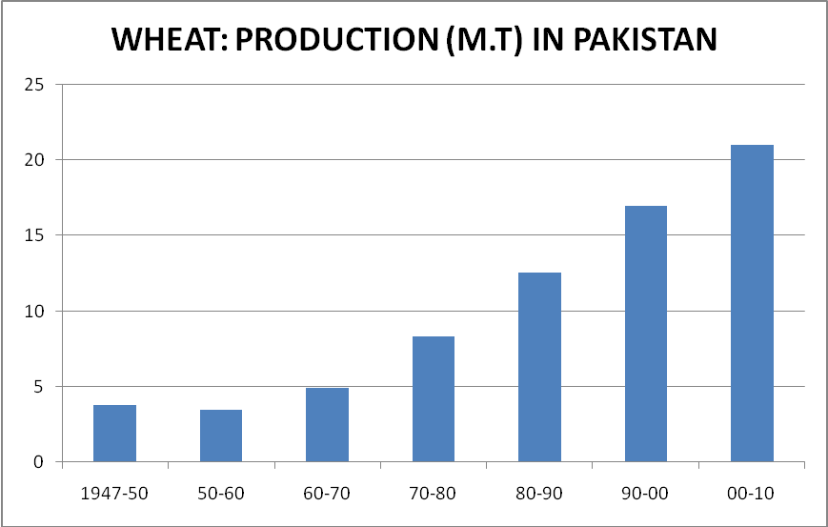

Annexure 2
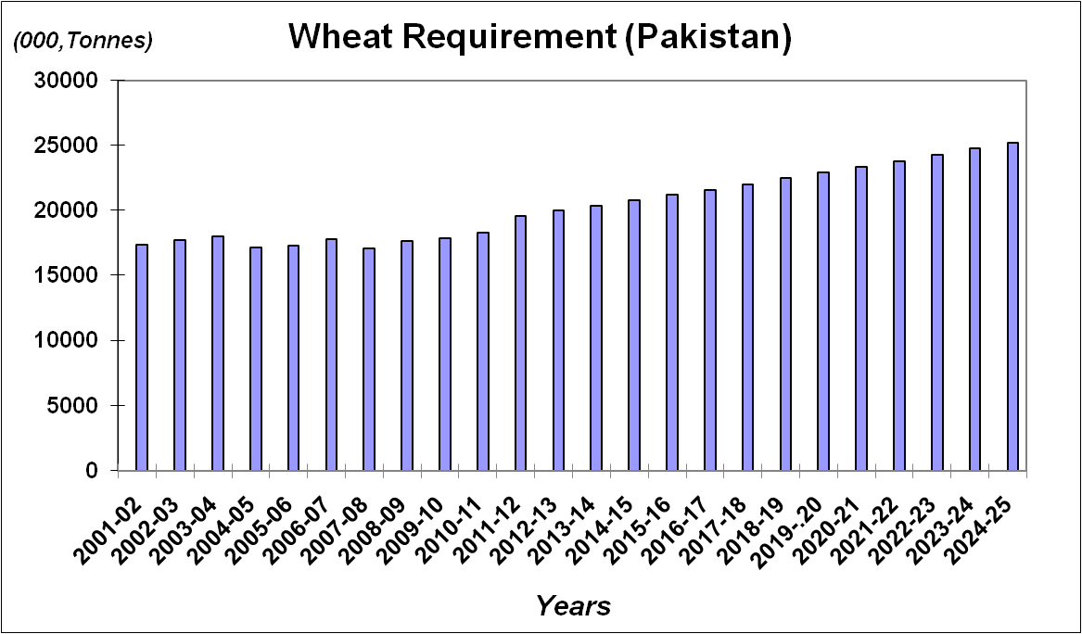

Note: Total Wheat Requirement = Population*93.0 Kgs/Head/Annum from 2007-08 to 2024-25+10% of Total Production for seed, feed and wastage.
Annexure 3
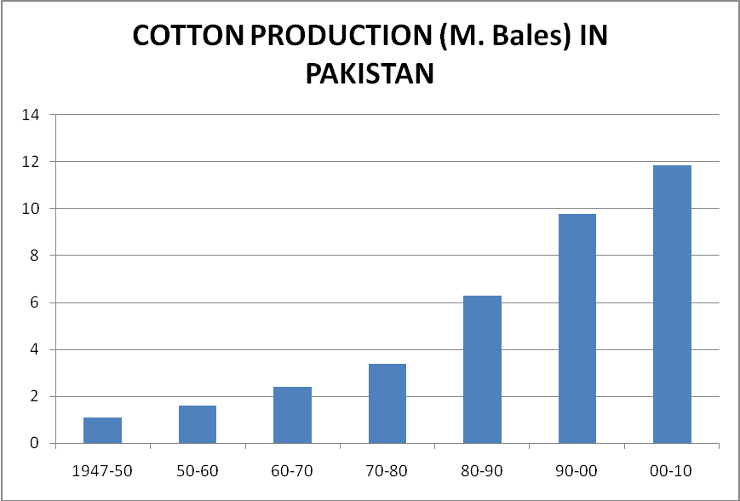

Annexure 4

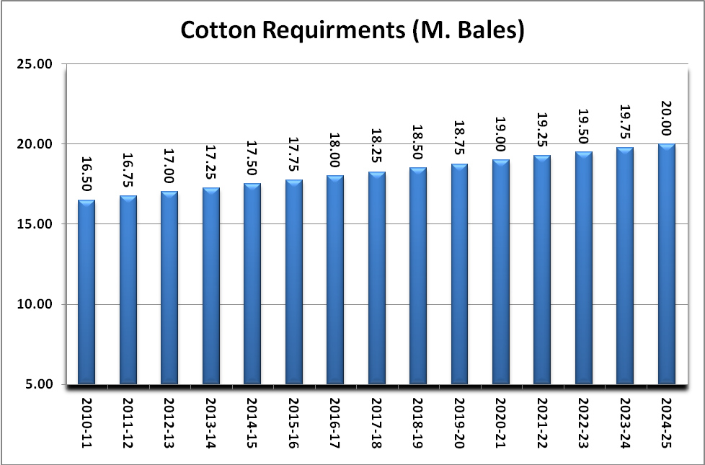

Annexure 5

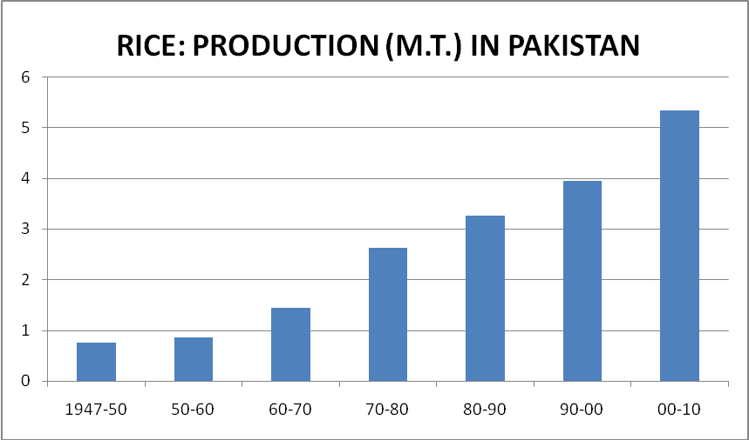

Annexure 6
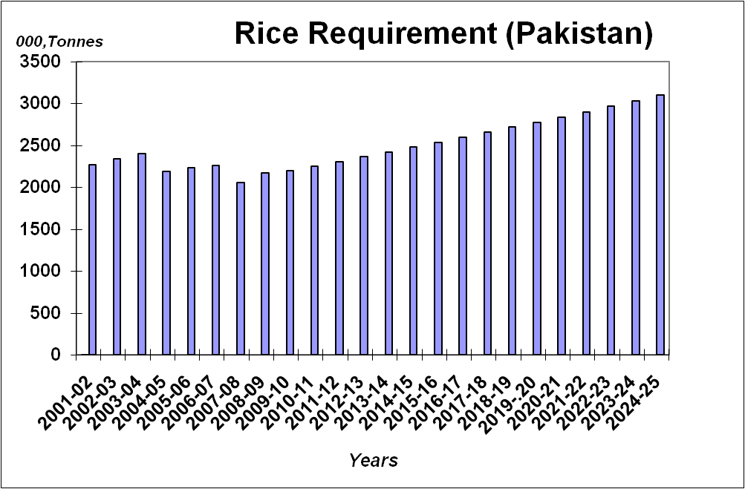

Note: Total Rice Requirement = Population*10.68 Kgs/Head/Annum from 2007-08 to 2024-25+10% of
Total Production for seed, feed and wastage.

Annexure 7
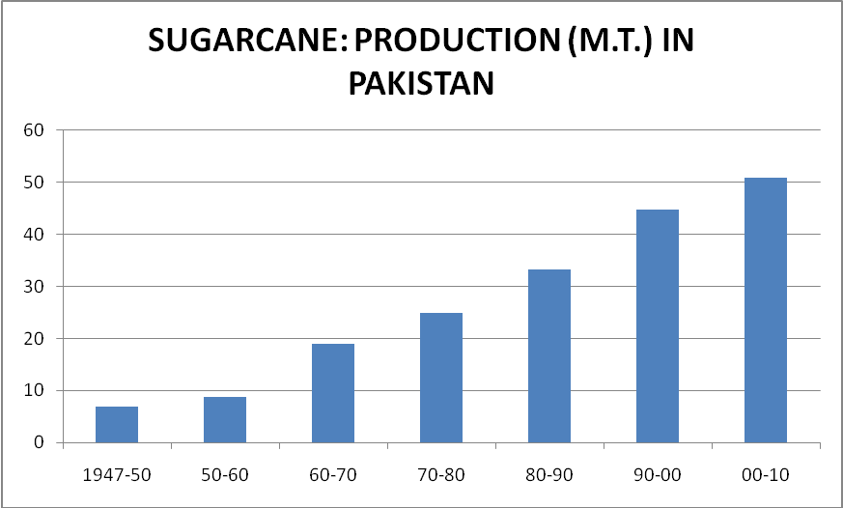

Annexure 8
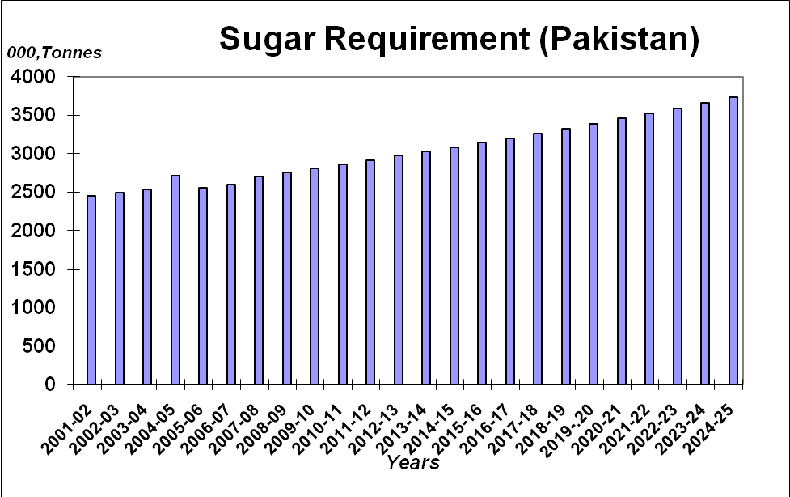
Note: Total Sugar Requirement = Population*23.0 Kgs/ Head/Annum from 2007-08 to 2024-25

Annexure 9

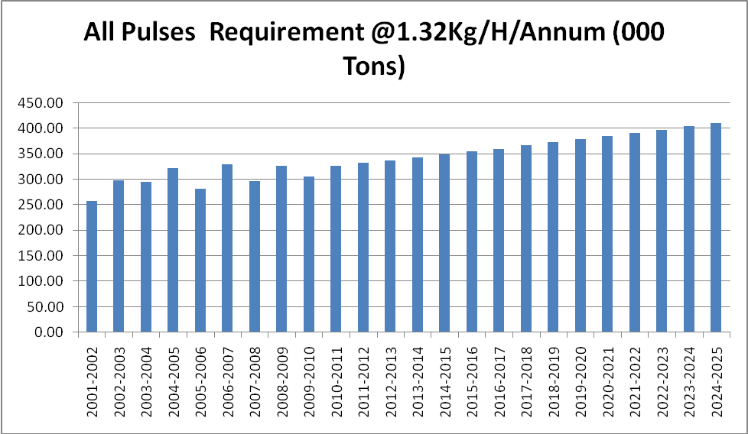

Annexure 10
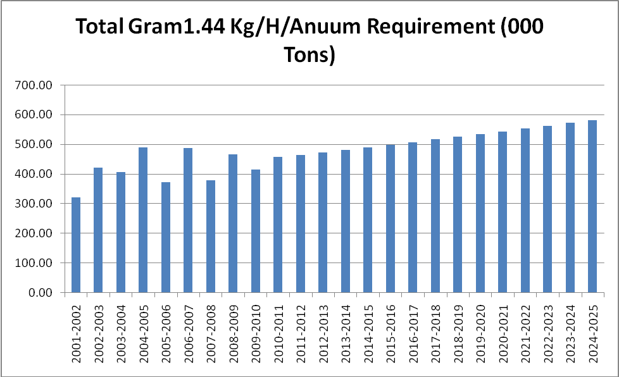

Annexure 11

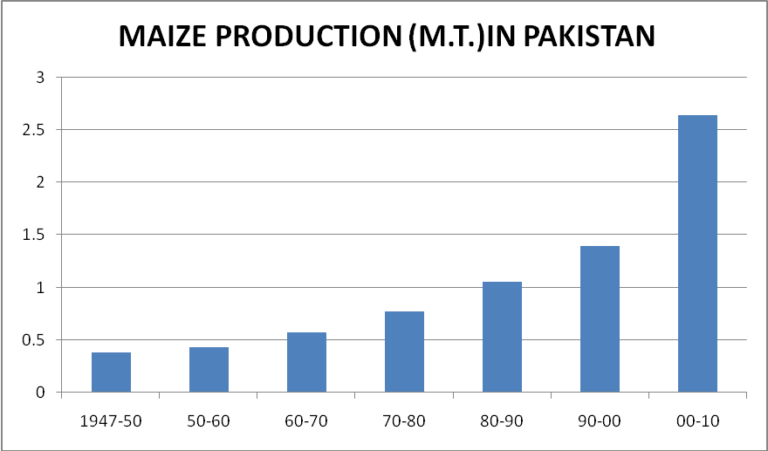

Annexure 12
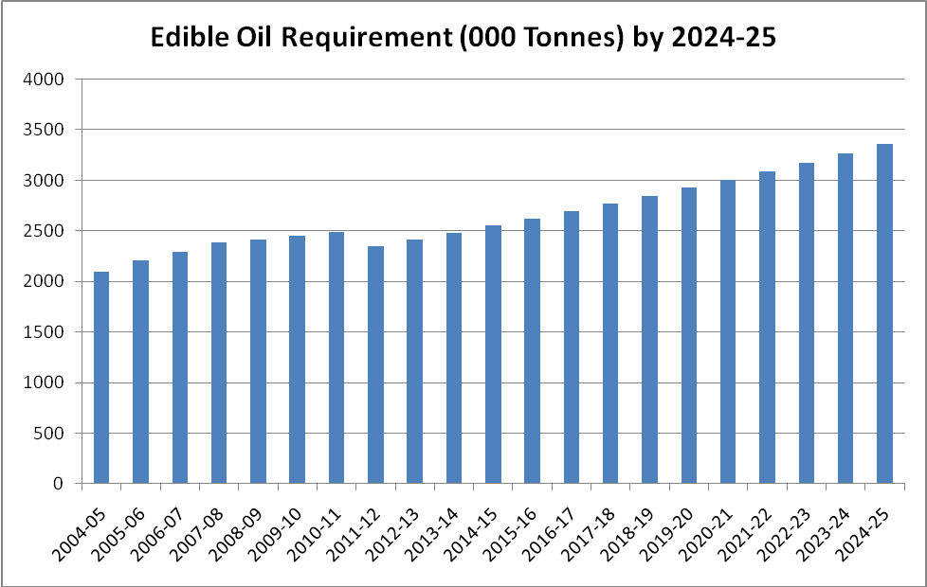

Annexure 13

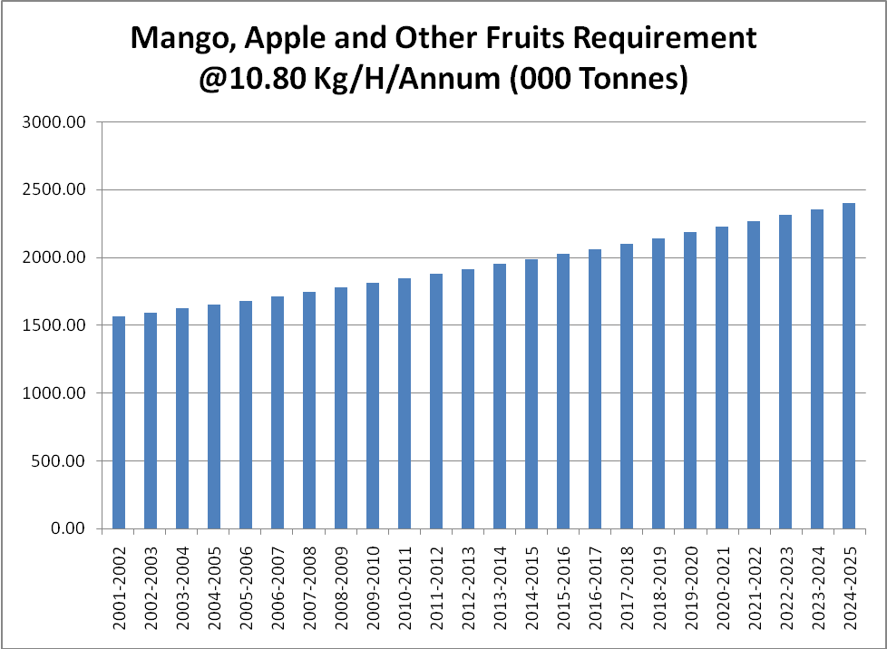

Annexure 14
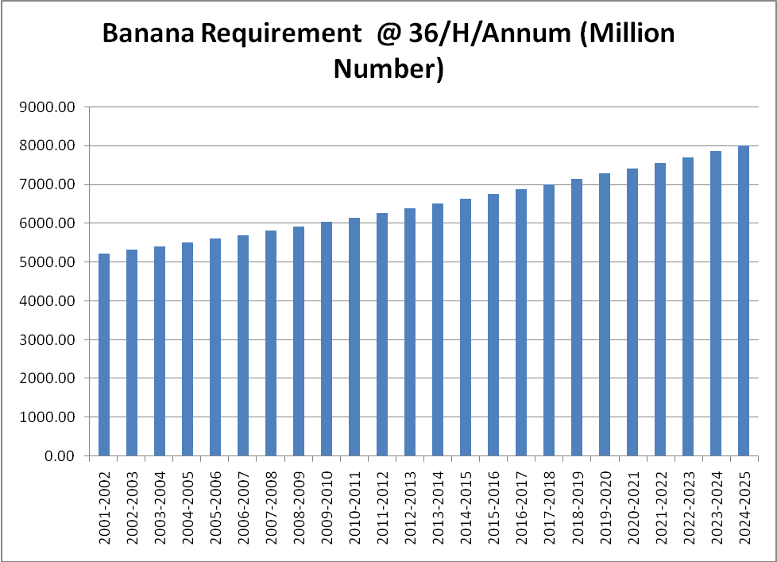

Annexure 15
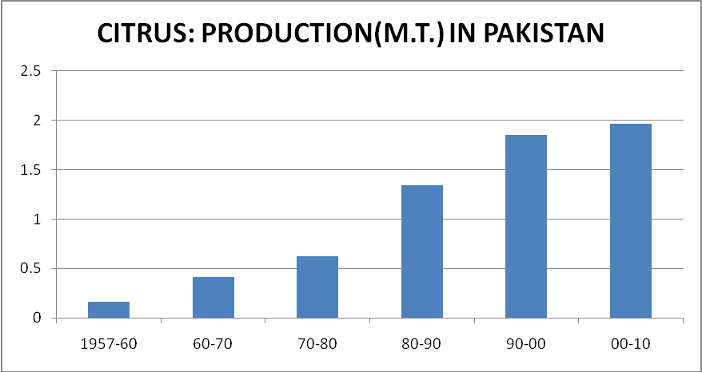

Annexure 16
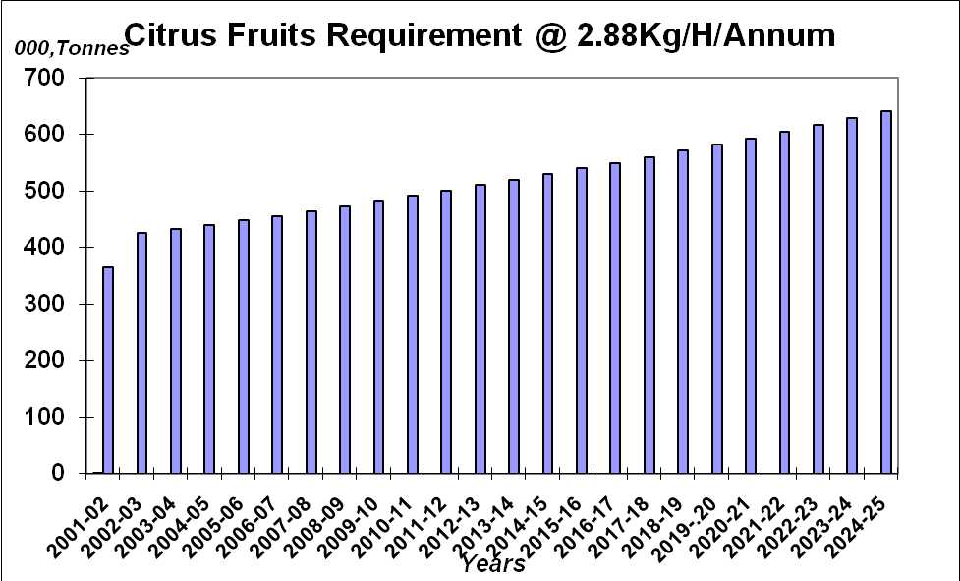

Annexure 17

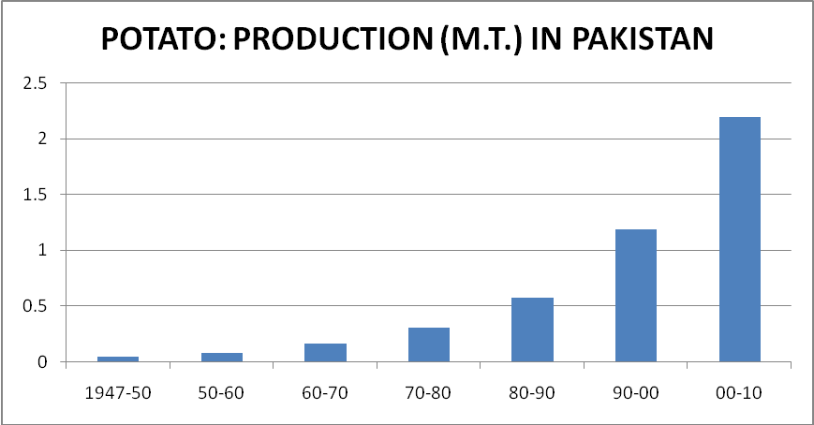

Annexure 18

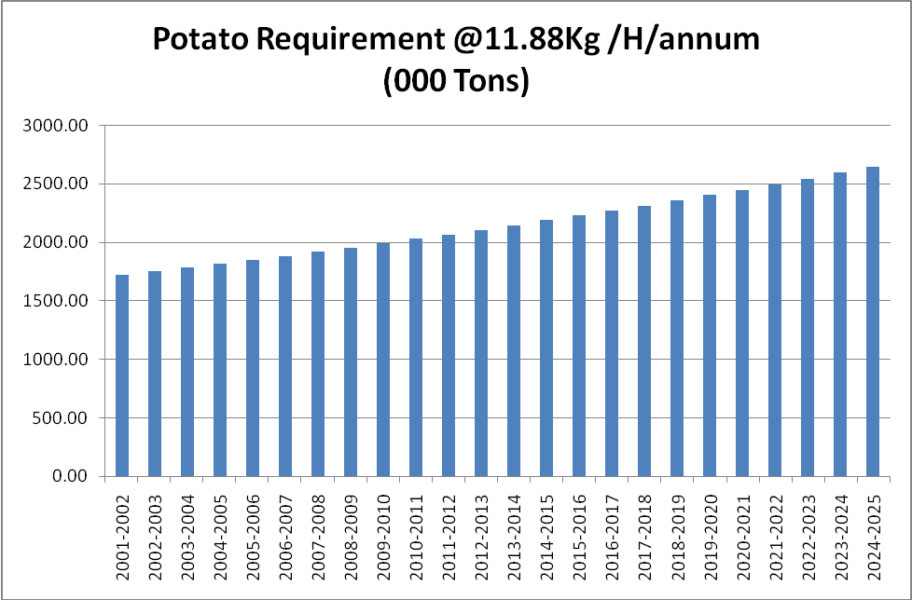

Annexure 19
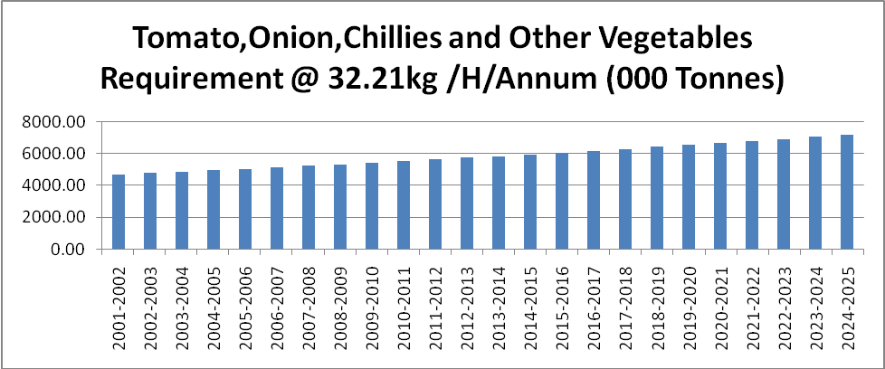
Annexure 20
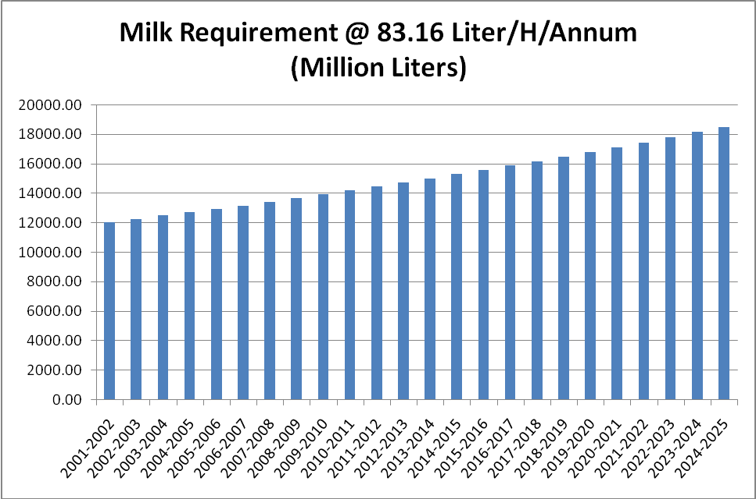
Annexure 21
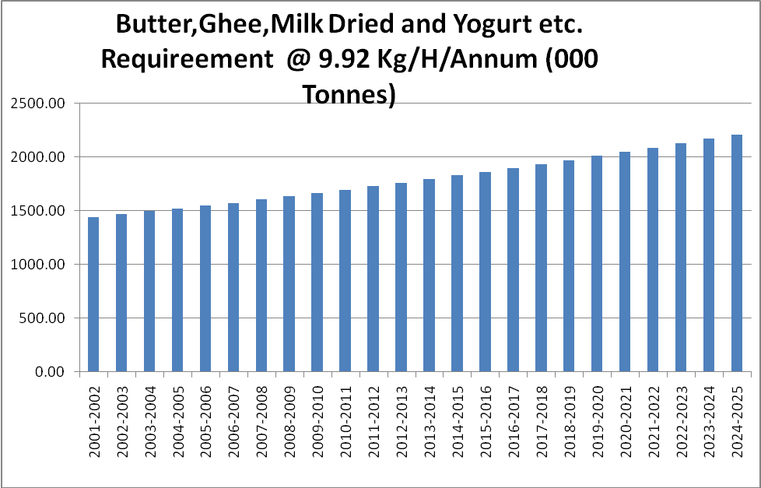
Annexure 22
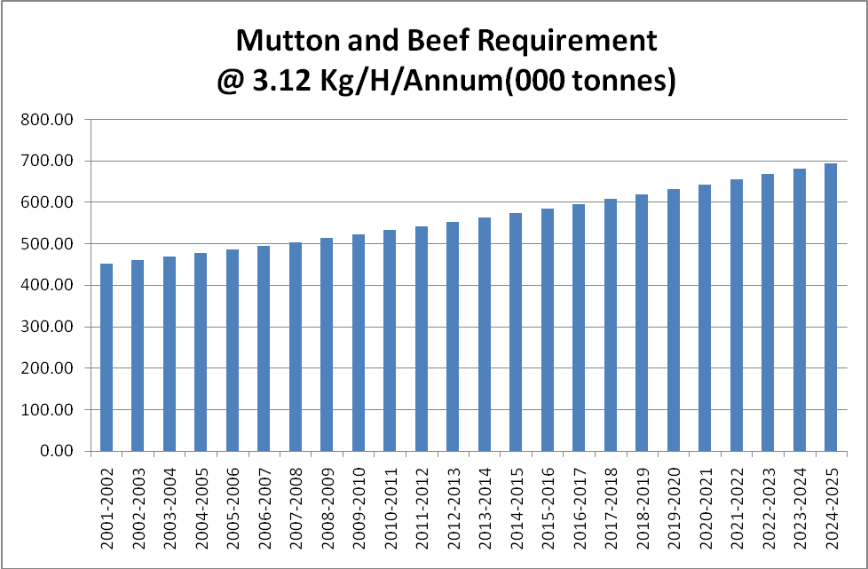

Annexure 23
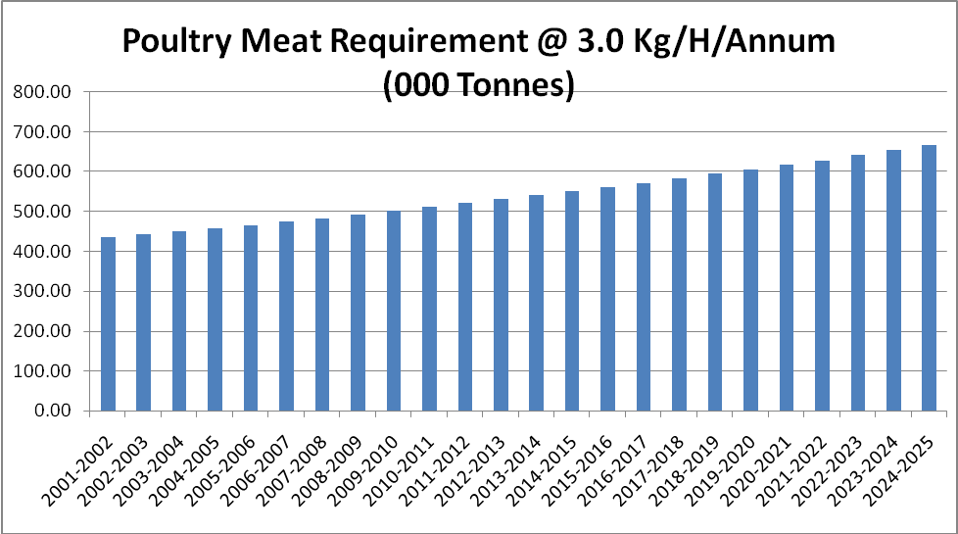
Annexure 24
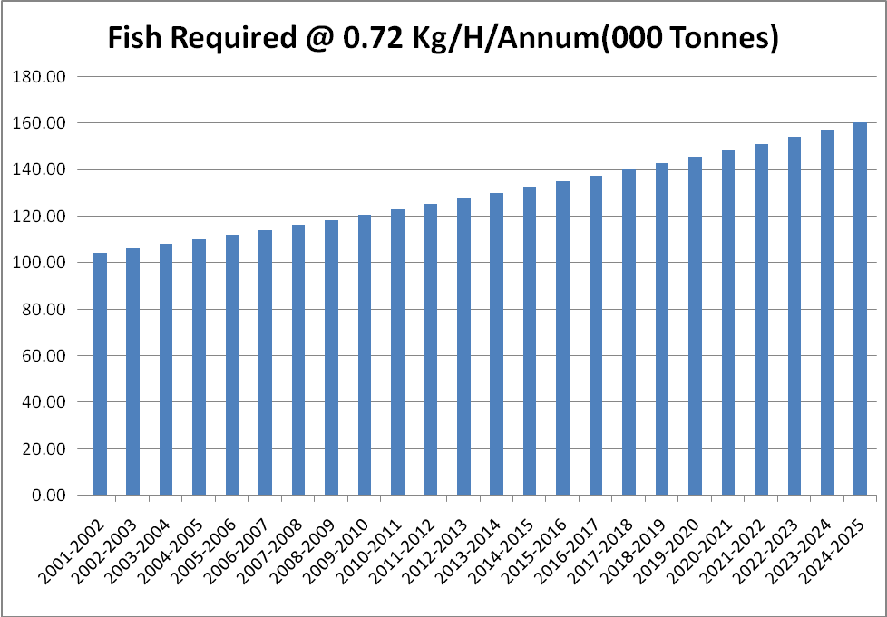

Annexure 25
Soil Type and Value Added Products of Different Fruits
Fruits | Soil Type | Products
Citrus | Well drained loamy soil tendency towards alluvial soil, pH 6.5-7.5 | Pectin, Jam, Jellies, Vinegar, Concentrate, Carbonated Drink, Nectar, Candy
Apple | Well drained loamy soil,  pH 5.5-6.5 | Jam, Jellies, Preserve, Vinegar, Pectin, Concentrate, Juice, Carbonated Drink, Nectar, Osmo-Dehydrated
Grapes | Sandy loam, pH 5.5-7.0 | Drink, Vinegar, Dehydrated (Raisin) Nectar, Carbonated Drink
Guava | Heavy clay to light sandy loam soils, pH 4.5-8.5 | Pectin, Jam, Jellies, Concentrate, Squash , Nectar, Juice, Dried Guava, Freeze Dried Guava, Puree, Guava Tea, Candy, Syrup, Pulp, Leaf Powder & Volatile Flavors
Lemon | Well drained loamy soil tendency towards alluvial soil, pH 6.5-7.5 | Squash, Marmalade, Juice, Carbonated Drink, Candy, Lemon Peel Volatile Oil. Concentrate, Lemon Instant Powder, Pickle
Litchi | Deep clay like alluvial soil,  pH 7.5-8.0 | Drink, Juice, Jam, Jellies
Mango | Well drained loamy soil  pH 7-8 | Drink, Jam, Jellies, Squash, Juice, Preserve, Pickle, Amchoor, Kernel Oil, Roll, Paper, Pulp, Nectar, Dehydrator Slices, Kasundi, Chutney
Olive | Deep fertile soil. Usually grown on hilly rocky areas pH 7-8 | Pickle, Oil, Preserve
Peach | silt loam-sandy loam pH 6.0-7.5 | Jam, Jellies, Preserve, Vinegar, Pectin, Concentrate, Juice, Drink, Nectar, Osmo-Dehydrated, Juice
Pomegranate | Wide range of soils, Calcareous alkaline or acidic soils | Syrup, Juice, Dehydrated, Nectar
Apricot | Well drained loam soil pH 6-7 | Jam, Jellies, Preserve, Concentrate, Chutney, Carbonated Drink, Nectar, Osmo-Dehydrated
Strawberry | Sandy loam soil, pH 5.8-6.2 | Powder, Syrup, Jam, Jellies, Preserve, Drink
Musk Mellon | Sandy loam–loam, fertile and well drained, pH 5.8-7 | Musk Melon Seeds, Juice. Jam
Water melon | Sandy loam–loam, fertile and well drained, pH 5.8-7 | Drink, Juice Blend
Ber | Sandy loam soil, pH 4.5-9.2 | Jam, Pickle, Chutney and Preserve
Fig | All types of soil with good drainage, Relatively salt tolerant | Dried, Jam, Squash and Bakery Foods
Grapes | Sandy loam pH 5.5-7.0 | White Wine, Vinegar, Raisins, Jam, Jelly, Squash
Phalsa | Sandy loam-clay loam pH 6.1-6.5 | Juice, Jam, Nectars, Syrup , Squashes and Cakes /Muffins
Date Palm | Light sandy loam soil, pH 4.5-8.0 | Date Pectin, Dietary Fiber, Syrup, Jams, Table Jellies, Soft Cheeses, Yoghurts, Date Desserts, Sweets, Bread, Date Powder, Date Shake
Jaman | Deep clay to light sandy loam soil, pH 5.6-6.0 | Fermented Beverages, Non-Fermented Beverages, Jam, Jellies, Seed Powder, Squash
Papaya | Well drained sandy loam,  pH 5.5-6.7 | Papain Enzyme, Candies, Chips Jam, Jelly, Soft Drink, Ice Cream Flavoring, Pickles, Papaya Pulp Powder, Crystallized and Canned Fruits
Avocado | Loamy soil, pH 6.2-6.5 | Paste, Syrup, Oil, Soap, Pickles
Pear | Sandy loam soil, pH 4.5-9.2 | Juices, Jam, Canned Fruit, Candies
Plum | Well drained loamy-clay loamy, pH5.5-6.5 | Juice, Jam, Nectar, Squashes, Chutney

Annexure 26

Soil Type and Value Added Products of Different Vegetables
Vegetables | Soil Type | Products
Onion | Sandy loam –loam, fertile and well drained  pH 6-8 | Onion Powder, Granulated, Ground, Minced, Chopped , vinegar, roasted,  Onion whole peeled , Diced , Sliced
Potato | Sandy loam-loam pH 6-8 | Chips, powder, starch, French fries, wedges, hash brown, lattices, chunky, croquettes, crispy slices, rosti, potato footballs, potato wafers, potato granules, wine, alcohol, vodka, sticks, dehydrated, frozen, flakes, pellets, liquid glucose, shoestring fry
Carrot | Sandy loam –loam, fertile and well drained, pH 6.5-6.8 | Juice, preserve, pickle, grits, shreds, pulp, soup, carrot oil, hydrosol, macerated oil, CO2 extract, carrot root powder, skin care products, paraben free shampoo, fermented, conditioners, cleansers, carrot flour, jam, pasta, cookies, biscuits, ready to eat line, baby carrots, julienne, sticks, chutney, Slices, jelly, marmalade, macroons, cake, salad, puddings, carrot puree, lombardo compost
Tomato | Loam-clay loam  pH 6.5-8.0 | Ketchup, Paste, puree, powder, concentrate, Tomato sauce, Juice, Baked cherry tomato, pasta, salsas, soup, dried, canned tomatoes, stewed sauce, crushed, diced
Turmeric | Sandy Loam- clay loam  well drained, pH 6.0-7.5 | Turmeric powder,
Cucumber | Loam fertile and well drained, pH 6.0-7.0 | Salad, pickle, juice, skin care cosmetics like cleanser, moisturizer, cream etc., medicines
Ginger | Loam well drained, pH 6.0-7.0 | Pickle, powder, preserve, volatile oil, herbal medicines, Juices
Bitter gourd | Loam, fertile and well drained, pH 6.0-7.0 | Pickle, dehydrated, drink, powder
Bottle gourd | Loam, fertile and well drained, pH 6.0-7.0 | Yogurt, Powder, Chutney, Kheer, Gravy, Soup
Tinda Gourd | Silt loam-loam well drained, pH6.0-7.0 | Pickle, roasted
Sponge gourd | Loam-clay loam well drained, pH 6.0-7.0 | Powder, candy, soap
Ash gourd | Loam, fertile and we’ll drained pH 6.0-7.0 | Dried seed powder, Halwa, Paste, Juice
Vegetable marrow | Loam-clay loam well drained pH 6.0-7.0 | Mix, Soap, Pickles, Salad, Preserve
Radish | Sandy loam-loam well drained pH 6-7.5 | Pickle, dried, salad, powder
Cauliflower | Sandy loam-clay loam  pH 6.5-7.0 | Dehydrated, pickle, frozen, powder
Turnip | Sandy loam-loam well drained pH 6-7.5 | Dehydrated and pickle
Sweet potato | Fertile and well drained sandy loam soil pH 5.6-6.5 | Powder, sugar, bakery products, chips and pies, canned
Garlic | Sandy loam –loam, fertile and well drained pH 6.2-7 | Powder, pickle, medicines, sauce, capsules, freeze dried, Garlic Parsley Noodles, loaf, minced
Peas | Sandy loam-loam  Well drained pH 6.0-7.0 | Preserve, soup, dehydrated, canned, pea protein powder, frozen
Okra | Loam- clay loam pH 6.0-8.0 | Pickles, Dried, chips, canned, coffee(caffeine free)
Brinjal | Loam- clay loam pH 5.0-6.0 | Pickle, Fried
Chillies | Sandy loam-clay loam, well drained pH 6.0-7.0 | Granules, powder, Sauce, pickled chilies, paste, chilies oil
Spinach | Sandy loam-Clay loam  pH 5.8-7.2 | Dried, Frozen, Canned, Tofu (Japan), Powder
Cabbage | Sandy loam-clay loam, well drained pH 6.5-7.0 | Salad, vegetable mix, dried, frozen, pickle, canned
Coriander | Loam-clay loam pH6.0-7.5 | powder, oil, ground spices, Sauce, Cosmetics
Fenugreek | Loam-clay loam pH6.0-7.5 | Powder, tea, essential oil

Annexure 27
Key Activities of Supply Chain Management

Annexure 28

Flow Chart of Supply Chain Management of Fruits and Vegetables

LIST OF PANEL MEMBERS

The following panel members have contributed to formulate these foresights.
1 | Dr. Mudassir Asrar | Chairperson, Pakistan Council for Science and Technology, Islamabad
2 | Dr. Noor-ul-Islam | Director General Agriculture (Research)  Ayub Agricultural Research Institute, Jhang Road, Faisalabad  Ph: 041-9201671, 9201672  Mob: 03007686552  e-mail: dgaraari@yahoo.com
3 | Dr. Tariq Mahmood | Director General  Pakistan Council for Science and Technology, Islamabad
4 | Dr. Mubarak Ali | Chief Executive Officer  Punjab Agricultural Research Board  3rd Floor, Zarai Taraqiati Bank Building, 47- The Mall Lahore  Ph: 042-37232744, 37247591-2  Mob: 0322-4490772  e-mail: ceparb@punjab.gov.pk
5 | Prof. Dr. Muhammad Younas | Chairman  Dept of Livestock Management, Chairman, Faculty of Animal Husbandry, University of Agriculture Faisalabad  Ph: 041-9200161-170 Ext. 3206  Mob: 0345-7778494  e-mail: myounas07@gmail.com
6 | Prof. Dr. M. Irfan-ul-Haq | Chairman  Department of Plant Pathology, University of Arid Agriculture Rawalpindi, Pakistan.  Ph: 051-9290239, 051-9062620  Mob: 0333-5193255  e-mail: irfan52@uaar.edu.pk
7 | Dr. Akbar Shah Mohmand | Sr. Director  Crop Sciences Institute, National Agricultural Research Center, Park Road Islamabad  Ph: 051-9255207  e-mail: asmohmand@hotmail.com
8 | Dr. Aamer Irshad | Chief, Food and Agriculture  Planning Commission of Pakistan, Room No.502 Islamabad  Ph: 051-9201981  Mob: 03465310053  e-mail: aamer_irshad@yahoo.com
9 | Mr. Tahir Makhdoom | Chief Editor, Agriculture Times  Office No. 2, 2nd Floor, Larebe Centre, G-9 Markaz,  Karachi Company, Islamabad.  Ph: 03335131121  e-mail: makhdoom124@gmail.com
10 | Dr. Ghulam Mustafa Awaisi | Chief Research & Development  Guard Agricultural Research & Services Pvt. Ltd. Guard Group of Companies, 8th Kilometer Raiwind Road, Lahore  Tel: 042- 35320643  shahzad@guardrice.com
11 | Dr. Muhammad Arshad | Professor, Institute of Soil Chemistry and Environment Scinces, University of Agriculture  Faisalabad.
12 | Mr. Akram Khalid | Sr. General Manager  Pakistan Horticulture Development & Export Company  30-N, Model Town Extension  Lahore  Ph: 0321-5494411  e-mail: akhalid@phdec.org.pk
13 | Dr. Muhammad Mushtaq Ahmad | Food Technologist  Post Harvest Research Center, Ayub Agriculture Research Institute Faisalabad  Cell: 0300-7290045  e.mail: drmushtaq786@gmail.com
14 | Mr. Rashid Nadeem Bhaur | WGF TF Project  Pakistan Council for Science and Technology, Ministry of Science & Technology, Islamabad

